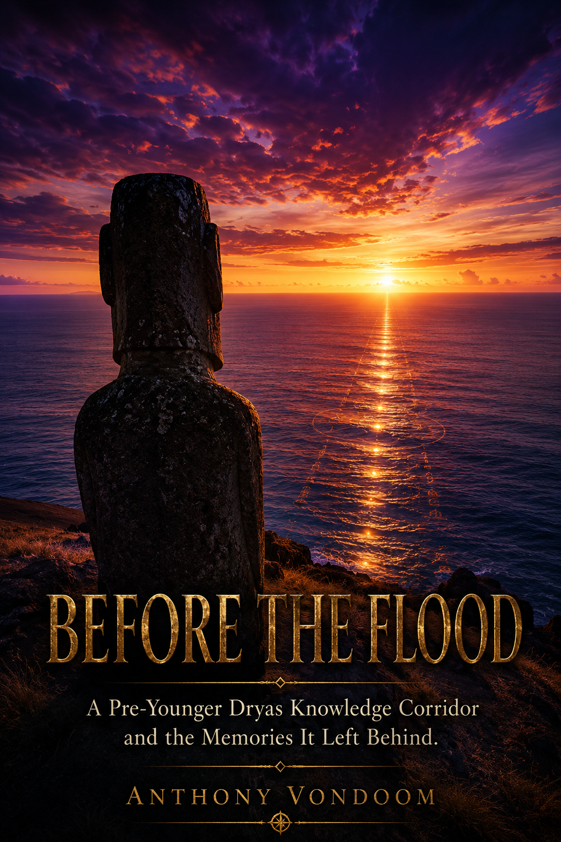
Before the flood
- A pre-younger dryas knowledge corridor and the memories it left behind

https://doi.org/10.6084/m9.figshare.32837255
First edition 30 June 2026. C,c by 4.0

(C) Anthony Vondoom
Independent Resesercher in Cognitive Archaeology
0009-0003-4953-1427
Sharm El Sheik, Egypt
www.dssm.academy
anthony.vondoom@outlook.com

INTRODUCTION
The Competence We Forgot
Rano Raraku is a volcanic crater on the eastern slope of Easter Island, and it holds 394 statues. Not erected statues — statues in various stages of being carved. Some are finished and lying on their backs in the quarry, waiting for transport that never came. Some are half-emerged from the rock face, their features complete above the waist, their lower bodies still fused to the stone. Some are barely begun: a face roughed out, a chin, an eye socket. Stone tools lie nearby, exactly where they were set down.
The largest unfinished figure — called Te Tokanga, the Giant — would have been twenty-one meters tall and weighed 270 tons. The practical upper limit for the transport system that moved all the other Moai was approximately half that size. Whoever commissioned Te Tokanga knew what they were doing; they had already moved dozens of figures across the island using the rope-walking technique now demonstrated archaeologically.¹ They were not naive about scale. They were reaching for something beyond scale. And then they stopped.
No catastrophe is recorded. No invasion. No climatic event that explains the cessation. The tools are simply there. The rock is simply unfinished. Work stopped, and the people who stopped it left no explanation in any medium we have learned to read.
What we have instead is a tradition: that the ancestors of the Rapa Nui came from Hiva — a land the ocean took. That a chief named Hotu Matuʼa led the survivors by boat to this most isolated island on earth after the sea rose over their home. And that the 887 Moai — aringa ora, living faces — are those ancestors. Not representations of gods. Not religious symbols in the abstract sense. Faces. Specific people. People who were there before the water came, and whose presence had to be maintained in the only material that survives the ocean: stone.
This is not mythology. This is memory encoded in the only medium that outlasts the flood.
— — —

The mystery historians call the sudden appearance of civilization is, on closer examination, not a mystery at all. It is a data problem. We have rich evidence for the last three thousand years of most major civilizations, reasonable evidence for the three thousand years before that, fragmentary evidence for the millennia before that, and almost no physical evidence for what lies beneath — where the continental shelves are, where the coastlines of the last glacial maximum ran, where the populations lived who navigated the world’s oceans before writing was invented.
The Sumerian King List divides itself in two. Before the flood, it records, eight kings ruled in five cities for a combined 241,200 years. After the flood swept over, kingship was in Kish. The document does not explain the transition. It does not need to. Every Sumerian who read it knew what the flood meant. It was not a rhetorical device. It was the organizing fact of their civilization’s self-understanding: everything before is lost; everything after is reconstruction.
The Egyptians called it the Zep Tepi — the First Time. An epoch before ordinary history, when gods walked the earth, when the cosmic order was established, when all the foundations of civilization were laid. Every pharaoh who built anything was, in their own ritual logic, re-enacting what was established then. The legitimacy of the entire pharaonic system traces to a time before the break. The break itself is never named — but every ritual, every pyramid, every inscription in the Valley of the Kings is oriented toward what was lost in it.
Three civilizations — Indian, Sumerian, Egyptian — organized their entire cultural memory around the same rupture point. Three independent traditions, three different geographies, three different writing systems, three different religious frameworks. One boundary.
— — —

Before the Younger Dryas inundation of approximately 11,700 BCE,² a coastal knowledge corridor connected Indian Ocean populations to Pacific and South American populations. That corridor was destroyed by rising seas. The civilizations built on its coastal waypoints went underwater. But the knowledge encoded in those civilizations did not die — it had already been stabilized through ritual, ceremony, navigational memory, and symbolic practice across multiple generations.
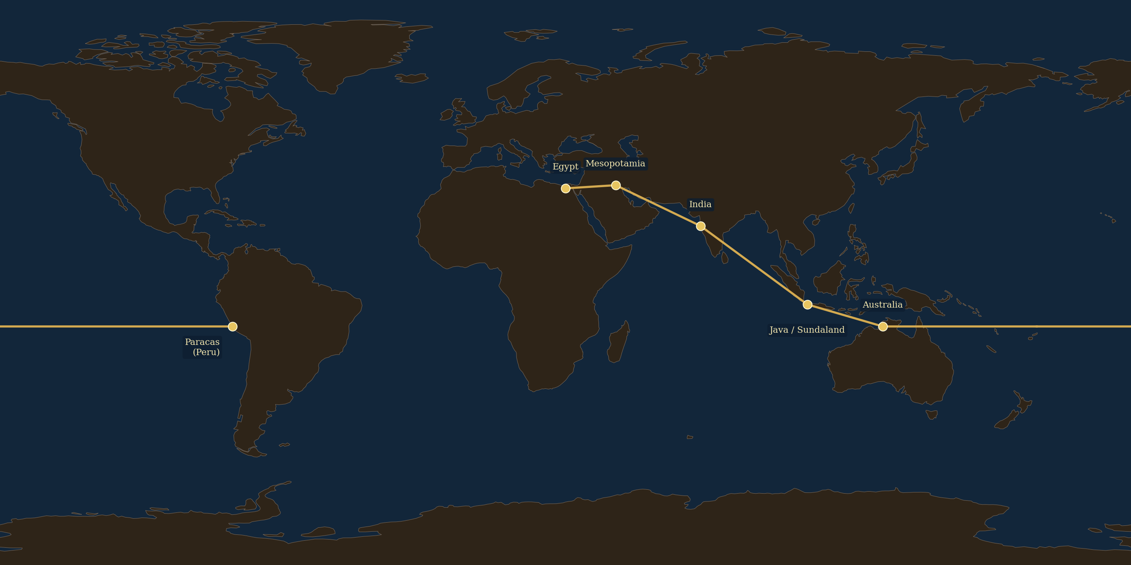
Figure I.1 — The Pre-Younger Dryas Knowledge Corridor. The southern dispersal route: Egypt and Mesopotamia in the west, through India and Java to Paracas, Peru in the east. Node sites shown. Flat equirectangular projection.
What we have inherited across every major tradition — Indian, Andean, Polynesian, Amazonian, Egyptian, Mesopotamian — are independent encodings of the same lost world, preserved simultaneously in: population genetics, mythological geography, navigational texts, theological structure, stone monuments, king lists, and ecological memory.
This is the thesis of this book. Before establishing it in ten chapters of converging evidence, it is necessary to be precise about what this thesis is not.

What This Book Is Not
This book is not a claim that any civilization discovered another. It is not an argument for Atlantis, ancient aliens, or lost supercivilizations with advanced technology in the modern sense. It does not argue that the Ramayana is literally true as scripture. It does not claim that Indians colonized South America.
Advanced technology for pre–Younger Dryas coastal populations meant: knowing which stars to follow at which time of year; reading ocean currents and wind patterns; understanding bird behavior as navigation signals; building outrigger vessels capable of open ocean crossing; encoding navigational routes in ritual and song for intergenerational transmission without writing. This is documented human capability going back sixty-five thousand years. The first confirmed crossing of an open ocean — the settlement of Sahul by anatomically modern humans — required navigating at least ninety kilometers of open water with no prior population on the other side serving as a beacon. No extraordinary claims are required to propose that the same species had developed sophisticated oceanic navigational knowledge by 15,000 BCE.
The corridor operated on a trade relay model: no single population needed to make the full journey from India to South America. Each node knew the adjacent nodes. The knowledge of what lay beyond traveled through chains of intermediaries across generations — the same principle as the Silk Road, operating at sea, thousands of years earlier. The Younger Dryas destroyed the intermediate nodes. The knowledge at the surviving ends persisted in each tradition’s own encoding. What we are reading is not a record of a single contact event. We are reading the residue of a network — a system — whose physical infrastructure went underwater while its informational infrastructure survived in the bodies and ceremonies of the people who had internalized it.

Ritual Is the Most Durable Storage Medium
The central theoretical framework of this book is the Deep Symbolic Systems Model (DSSM), developed across a series of papers published between 2025 and 2027.³ Its core claim can be stated simply before its technical apparatus is introduced: ritual is the most durable storage medium humans have ever invented. More durable than stone. More durable than writing. Because it lives in bodies and ceremony — not in objects. The Younger Dryas destroyed objects. It could not destroy what was already encoded in the bodies and ceremonies of the survivors.
Historians sometimes speak of oral tradition as an unreliable form of transmission — the telephone game, degrading with each iteration. This is empirically false for deeply ritualized knowledge. Patrick Nunn and Nicholas Reid (2016) documented Aboriginal Australian oral traditions describing specific coastal topographies — bays, headlands, islands — that are now submerged under sixty meters of water.¹ These traditions have been maintained with sufficient geographic precision to be verified against bathymetric maps of the continental shelf. They are, conservatively, seven thousand years old. Some are older. They survived complete absence of literacy, multiple generations of ecological change, and the most thorough colonization event in recorded history. They survived because they were encoded as ceremony — as song, as dance, as ritual narrative tied to specific locations and transmitted through specific role-defined performers. The form was the preservation mechanism.
The DSSM models this formally through four stages:
- Stage 1: Embodied Symbolic Familiarity — knowledge in the body through practice. A navigator who knows the star paths by feel, who reads the ocean swell without thinking about it, who identifies the bird species that signal the proximity of land. This knowledge exists in muscle memory and perceptual habit, not in articulated propositions.
- Stage 2: Ritualized Repetition — knowledge formalized into repeatable ceremony. The navigational knowledge is now a song, a dance, a ceremony performed at specific times of year, encoded with enough redundancy and emotional weight to transmit accurately across generations. The form may be mythological — the stars become gods, the currents become serpents, the landmarks become the deeds of ancestors — but the navigational information is structurally intact inside the mythological wrapper.
- Stage 3: Material Amplification — knowledge in durable external media: monuments, formal narrative, iconography. Multiple redundant encoding media exist simultaneously. A single catastrophe cannot destroy the knowledge because it is distributed across too many media and too many carriers.
- Stage 4: Cognitive Offloading and Institutional Emergence — knowledge in writing, state religion, formal institutions. This is what historians call civilization. But Stage 4 is also the most fragile stage: it depends on infrastructure. When the infrastructure fails — when the cities go underwater, when the institutions collapse — Stage 4 knowledge is lost. What survives is Stages 1 and 2: embodied knowledge and ritualized ceremony. Precisely because they do not depend on objects.
The Younger Dryas created the conditions that made DSSM-predicted knowledge survival the only possible survival. Every civilization rebuilding after the flood used Stage 1 and Stage 2 knowledge as the seed material for their new Stage 3 and Stage 4 systems. This is why the knowledge looks ancient when it first appears in writing — because it is.

The Universal Response
Every civilization we call ancient appears to emerge suddenly with sophisticated knowledge systems already in place. No gradual development is visible in the archaeological record at the moment of emergence. Historians call this the mystery of civilization’s sudden appearance. This book answers that mystery directly: they did not appear suddenly. They rebuilt. From inherited fragments of what came before the flood. And every one of them encoded the memory of what they were rebuilding from.
Table 0.1 shows six major traditions, the format in which each encoded the flood boundary, the pre-flood knowledge each preserved, and the figure each tradition assigned to carry that knowledge through the catastrophe. This table functions as the master convergence reference for the entire book — each chapter returns to it with additional evidence for its own row.

Tradition | Encoding Format | Pre-Flood Knowledge Encoded | Pre-Flood Figure
Mesopotamia (Sumerian) | King List + Antediluvian Records | Eridu as boundary; 10 kings; flood terminus | Enki / Ziusudra
Hindu (Sanskrit) | Ramayana + Puranas | Navigation instructions; spherical earth; southern corridor | Manu / Sapta Rishis
Egyptian | Zep Tepi cosmology + Pyramid Texts | First Time before the flood; Nile corridor | Thoth / Osiris
Andean (Quechua) | Oral narrative + monument | Viracocha departure; corridor terminus at Paracas | Viracocha / Con Tici
Polynesian | Navigation chants + oral tradition | Pacific island chains; Hiva homeland | Navigator ancestors
Aboriginal Australian | Songlines + oral tradition | Pre-flood coastal geography; 21 recorded sites | Elders / Dreamtime

Table 0.1. Independent encodings of the knowledge corridor across six civilizations. Egypt and Mesopotamia appear in every chapter as cross-validation anchors.
— — —
The convergences in Table 0.1 are specific. They are not generic flood myths — flood myths exist on every inhabited continent, and many reflect purely local events. What distinguishes the traditions treated in this book is the structural specificity of the parallels: the same deity archetype with the same seven functional attributes appearing in traditions with no documented contact history; the same navigational destination described in texts separated by nine thousand miles and three thousand years; the same genetic signal in populations whose historical connection has no other explanation.

Egypt and Mesopotamia as Structural Anchors
The Egypt and Mesopotamia cross-validation running through every chapter is not decorative. It is the primary methodological protection against the central accusation leveled at arguments of this kind: that they find what they are looking for in a tradition selected in advance. The filter test is simple. If the same structural pattern appears independently in Egypt and Mesopotamia — in completely different materials, with completely different mythological surfaces — then the pattern cannot be an artifact of Indo-centric selection. It must be responding to something real.
The Sumerian King List is a founding administrative document, not a mythology text.² It is the Mesopotamian equivalent of a constitutional preamble: a statement of who governed and for how long, organized by city and dynasty. Its pre-flood/post-flood boundary is not a literary device. It is a historiographical fact — a statement about how Mesopotamian civilization understood its own origins. The boundary is explicit, deliberate, and primary. Thorkild Jacobsen’s authoritative 1939 critical edition establishes that the antediluvian section is the oldest layer of the document, the stratum around which the rest was organized.
The eight pre-flood kings ruled for impossible lifespans — 241,200 years in total — because their actual reign lengths had been inflated through sexagesimal encoding: the scribal convention of multiplying by the sacred factor 3,600 (one sar). When that inflation is reversed, the reigns reduce to eight to twelve years each [author’s analysis; Jacobsen (1939) documents the King List without making this calculation] — entirely within normal parameters for early city-state governance.² The impossible lifespans were never meant to be read literally. They were meant to signal: these rulers belong to a different order of time. The time before the break.
“After the flood swept over, kingship was in Kish.”
— Sumerian King List, translation after Jacobsen 1939

The Zep Tepi performs the same function in Egyptian civilization. Every pyramid is the benben — the primordial mound that emerged from the primordial waters at the moment of creation — built in permanent stone so the water cannot take it again. Every pharaoh who builds is re-enacting the emergence of order from chaos after the flood. The legitimacy of the entire pharaonic system traces backward to a pre-historical epoch of which no material record survives except the ritual itself.
Three civilizations building their entire cultural legitimacy on what happened before a boundary they cannot name. Three traditions encoding the same break from independent positions with independent materials.
This is what the book is about.

How to Read This Book
Each chapter follows the same four-part structure: Primary Node (the chapter’s main evidence), DSSM Analysis (how the framework explains why this evidence survived 12,000 years of transmission), Cross-Node Validation (Egypt and Mesopotamia independently doing the same thing), and Convergence Statement (what this chapter adds to the cumulative argument against the null hypothesis).
Every claim is assigned a confidence level. ESTABLISHED: supported by peer-reviewed consensus, would not be contested by field specialists. PROBABLE: strong evidence, not yet consensus, most parsimonious explanation of available evidence. SPECULATIVE: logical inference from established evidence, clearly labeled as hypothesis, requiring further investigation.
The speculative claims are labeled not because the argument is weak but because intellectual honesty requires it — and because the overall argument does not depend on any single speculative claim surviving scrutiny. Remove the Candelabra identification from Chapter 4 and the navigation route from Chapter 3 still runs to exactly where the Candelabra is. Remove the navigation route and the genetic signal from Chapter 1 still requires an ancient connection between Indian Ocean coastal populations and Amazonia. Remove the genetics and the deity comparison from Chapter 7 still shows the same knowledge-instructor archetype encoded in three independent traditions. The argument is convergent. It does not rest on any single thread.
— — —

TABLE OF CONTENTS
Before the Flood
Introduction: The Competence We Forgot

Chapter 1: The Genetic Signal 16
1.1. The Signal That Has No Business Being There
1.2. The Andamanese: Stage 1–2 Persistence Over 65,000 Year
1.3. DSSM Analysis: The Southern Dispersal Corridor as Transmission Environment
1.4. The Persian Gulf Oasis and Eridu
1.5. Egypt: The Nile Corridor as Independent Western Parallel
1.6. Convergence Statement
9.6. The Corridor Populations: Cognitive Sophistication Without Stone

Chapter 2: The Spherical Earth 28
2.1. The Geometry Hidden in Plain Sight
2.2. The Hanuman Ring: A Model of Cyclical Catastrophe
2.3. DSSM Analysis: Transmission Degradation of a Technical Model
2.4. Abzu, Duat, and the World Beneath
2.5. Convergence Statement

Chapter 3: The Navigation Instructions 37
3.1. The Dispatch Instructions of Sugreeva
3.2. The Candelabra in the Navigation Sequence
3.3. DSSM Analysis: The Mythological Wrapper and the Geographic Core
3.4. Ocean Current Validation
3.5. Gilgamesh, the Solar Geography, and the Eastern Extreme
3.6. Convergence Statement

Chapter 4: The Marker That Should Not Be There 46
4.1. Physical Description
4.2. The Dating Problem
4.3. DSSM Analysis: A Stage 3 Maritime Marker
4.4. The Physical Match to Sarga 40
4.5. Eridu at the Western Terminus
4.6. Convergence Statement

Chapter 5: The Kingdom of Serpents 53
5.1. Nag-lok and What It Actually Describes
5.2. The Kalachakra: Encoding the Flood Cycle
5.3. Chavin: The Amazon Encoding from the Other End
5.4. Abzu, Nun, and the Pre-Flood Knowledge Repository
5.5. Convergence Statement

Chapter 6: The Monkey Navigator 61
6.1. The Caral Monkey and the Vanara Corridor
6.2. Hanuman: Attribute Analysis of the Navigator-Figure
6.3. The Vanaras: Who They Actually Are
6.4. DSSM Analysis: The Triple-Medium Symbol
6.5. Thoth, Adapa, and the Knowledge-Carrying Non-Human
6.6. Convergence Statement

Chapter 7: The God Who Came From the Sea 68
7.1. Viracocha's Seven Attributes
7.2. Varuna: The Same Seven Attributes in the Rigveda
7.3. Enki: The Third Point in the Triangle
7.4. The Manu–Viracocha Narrative Sequence
7.5. The Instructor Leaves
7.6. Convergence Statement

Chapter 8: The Drowned World 75
8.1. What the Sea Level Record Shows
8.2. Dwarka: The Confirmed Underwater City
8.3. Aboriginal Australian Oral Traditions: The Proof of Concept
8.4. DSSM Analysis: The Flood Created the Conditions for Its Own Memory
8.5. The King List Boundary and the Zep Tepi
8.6. Convergence Statement

Chapter 9: The Stone Ancestors 84
9.1. Rapa Nui and the Imperative to Build in Stone
9.2. Tiwanaku: The Stone Giants of the Previous World
9.3. DSSM Analysis: The Stone Monument Wave
9.4. The Pyramid, the Ziggurat, and the Mound
9.5. The Corridor Populations: Cognitive Sophistication Without Stone

Chapter 10: The Closed Loop 95
10.1. The Corridor Reconstructed
10.2. The Null Hypothesis — Explicit Evaluation
10.3. What Remains Unknown
10.4. The Research Agenda
10.5. The Master Convergence
10.6. After The flood

GLOSSARY ……………………………………………………………………103
SDG ALIGNMENT STATEMENT………………………………………….106

AI DISCLOSUR……………………………………………………………….106

BIBLIOGRAPHY……………………………………………………………..107

CHAPTER ONE
The Ghost in the Gene
Population Y and the Andamanese Signature in Amazonia
**The genetic data do not tell us who these people were, what language they spoke, or what they believed. They tell us that they were there — and that the distance between them and the people of Amazonia was, at some point in deep time, traversable.**
— Author’s paraphrase of Skoglund et al. (2015)
— — —

1.1. The Signal That Has No Business Being There
In 2015, a team led by Pontus Skoglund at Harvard Medical School published a genetic analysis of ancient and modern South American populations. The paper was careful, technically dense, and published in Nature. Its central finding has still not been satisfactorily explained by the academic mainstream.
The Population Y researchers themselves have proposed several interpretations. Skoglund et al. (2015) acknowledged the signal as unexplained by standard Beringian models and suggested it pointed to a “ghost population” — an unsampled ancestral group with Australasian-related affinity that contributed to some founding Amazonian lineages through an unknown route. Subsequent work by Reich and colleagues has favoured a single complex founding migration from East Asia with internal population structure, rather than a separate maritime dispersal. The mainstream genetic interpretation does not require a coastal corridor; it requires only that the founding American population was more heterogeneous than early models assumed. This book argues that the convergence of Population Y genetics with independent navigational, mythological, and material evidence — documented in Chapters 2–9 — provides the additional weight that distinguishes a coastal corridor hypothesis from an equally parsimonious ghost-population explanation. The genetics alone does not decide between these interpretations. The convergence is what makes the corridor hypothesis the more economical account.
Certain Amazonian populations — particularly the Surui, Karitiana, and Xavante — carry a distinctive ancestral component that is more closely related to the Andaman Islanders, the indigenous Australians, and the Melanesians than to any other living population. Skoglund and colleagues named this component Population Y after the indigenous Brazilian word for person, Ypykuéra (ancestor). It is not a trace admixture. In some populations it accounts for a measurable proportion of genome-wide ancestry. And its closest living relatives are not in the Americas — they are in the Indian Ocean, ten thousand kilometers away, on the opposite side of the Pacific.
The standard model of the peopling of the Americas holds that a single founding population — genetically similar to modern Siberians — crossed the land bridge from Siberia to Alaska at some point between 25,000 and 15,000 BCE, expanded south through ice-free corridors or along the Pacific coast, and gave rise to all Indigenous American populations. Population Y does not fit this model. It cannot be explained by Siberian admixture. It cannot be explained by any population currently living in Northeast Asia. Skoglund et al. tested every possible source population from their dataset and found the closest match was consistently Andamanese — a population whose closest present location to South America is the Bay of Bengal.
Two explanations have been advanced in the literature since 2015. The first proposes a single founding migration from a now-extinct population in Asia that was simultaneously ancestral to both the Andamanese and the Population Y bearers — a "ghost population" that contributed genetic material to South America without leaving any other detectable trace in the archaeological or genetic record of North America, Central America, or the Pacific. The second proposes actual population movement along the Pacific coast at a time when the coastal route was accessible, with selective preservation of this ancestry in Amazonian populations due to demographic processes after arrival.
Both explanations invoke precisely what this book argues for: a connected coastal world that no longer exists, traversed by populations whose material trace went underwater with the coastline that supported them. The ghost population explanation is, structurally, an admission that the corridor existed. The coastal migration explanation is a description of how the corridor worked.
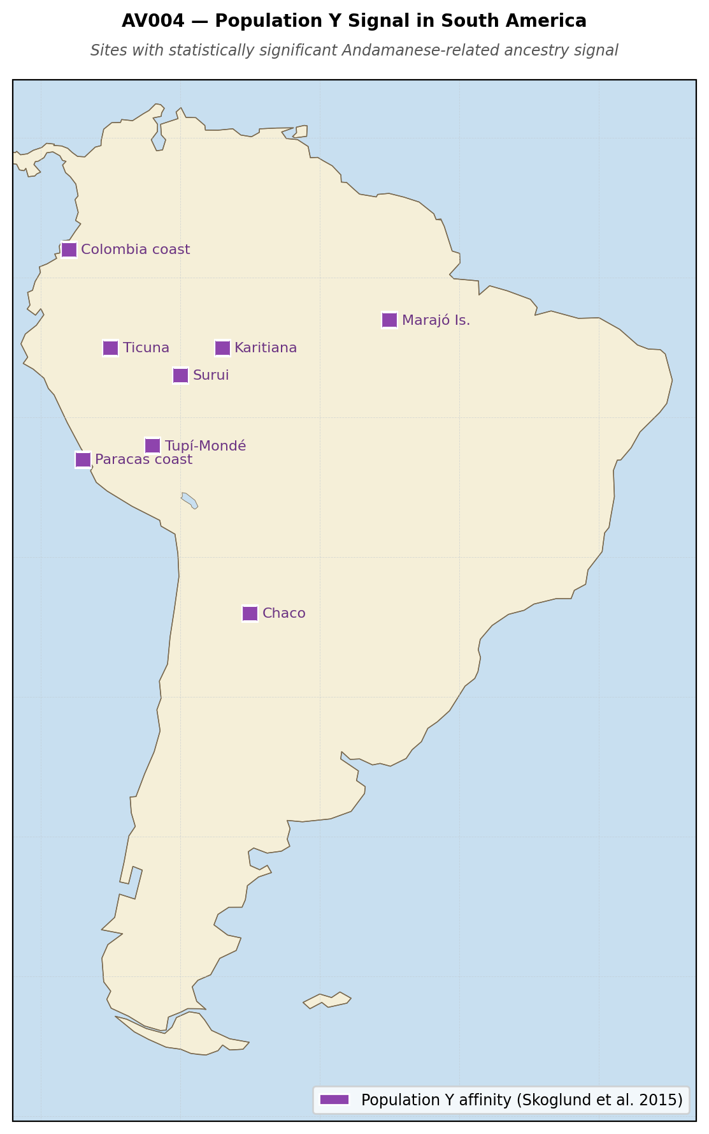
Figure 1.1 — AV004: Population Y distribution in South American populations (after Skoglund et al. 2015). Squares mark populations with statistically significant Andamanese-related ancestry signal.

1.2. The Andamanese: Stage 1–2 Persistence Over 65,000 Years
The Andaman Islands are a chain of small islands in the Bay of Bengal, 1,200 kilometers from the Indian mainland. Their indigenous inhabitants — the Great Andamanese, the Onge, the Jarawa, and the Sentinelese — represent one of the most significant populations in human prehistory. Their genetic lineage diverged from all other human populations approximately 65,000 years ago, at or near the beginning of the Out-of-Africa dispersal. They have maintained continuous occupation of the islands since then. They carry the oldest surviving, independently maintained genetic lineage of any population on Earth.
They also carry, or until very recently carried, a fully intact set of DSSM Stage 1 and Stage 2 knowledge systems. The Onge navigate by star paths, by ocean current reading, by bird behavior. The Sentinelese, who have resisted all contact with the outside world, maintain an island-scale territorial and symbolic system whose visible outputs — the maintenance of the island's integrity as a symbolic space, the immediate and consistent response to intrusion — indicate Stage 2 or early Stage 3 organization without any external material support. No imported goods. No outside knowledge system. Sixty-five thousand years of continuous occupation maintained through embodied practice and ritualized ceremony alone.
This is the DSSM's most important empirical case. The Andamanese demonstrate, in a population that can be studied, that Stage 1 and Stage 2 knowledge systems are sufficient to maintain population continuity, territorial integrity, and symbolic coherence across timeframes that dwarf every civilization on Earth. They have survived, using only those systems, the Toba super-eruption (~74,000 BCE), the Last Glacial Maximum, the Younger Dryas, and sixty-five thousand years of ecological change. The question is not whether DSSM Stage 1–2 persistence is possible across geological timeframes. The Andamanese prove that it is.
The population that carried the Population Y signal into South America was not necessarily the Andamanese themselves. It was a population with a very similar genetic profile — a coastal Indian Ocean population at approximately the same degree of divergence from the main Eurasian gene pool. The Andamanese are the closest living representatives of the ancestral stock from which Population Y derives. They are the genetic fossil of the knowledge corridor's eastern foundation.

1.3. DSSM Analysis: The Southern Dispersal Corridor as Transmission Environment
The southern dispersal corridor — the coastal route by which modern humans moved from Africa to South Asia between approximately 100,000 and 40,000 BCE — was not merely a migration route. It was a symbolic transmission environment: a geographically constrained coastline along which portable symbolic anchors, navigational knowledge, and ritual practices were carried eastward over sixty thousand years of movement.
The corridor ran along coastlines that no longer exist. At sea levels 60 to 120 meters below present, the Arabian Peninsula connected to the African horn across the Bab-el-Mandeb strait. The Indian subcontinent's coastline extended far into what is now the Arabian Sea and the Bay of Bengal. Sri Lanka was connected to India. The Andaman Islands were larger, closer together, and closer to both India and Burma. The Sunda Shelf connected mainland Southeast Asia to Borneo, Sumatra, and Java as a single landmass.
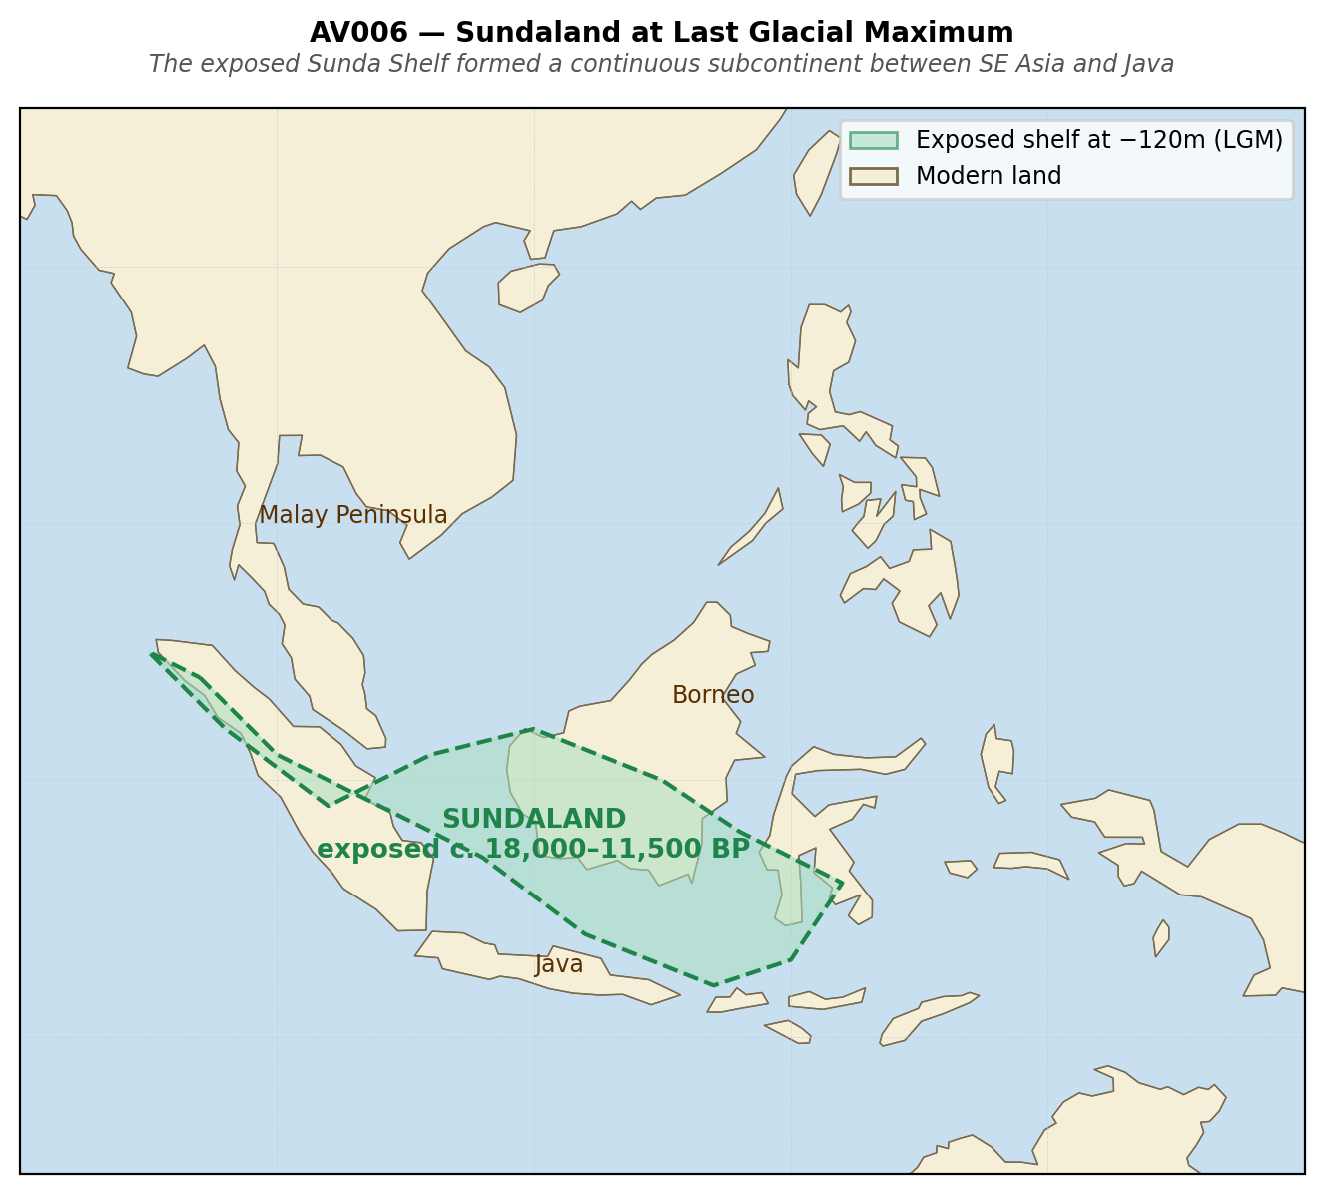
Figure 1.2 — Southern dispersal corridor superimposed on present coastline, showing submerged shelf areas (AV006: Sunda Shelf at LGM).
This was the world in which the Population Y ancestral population lived. Not the islands we now call Andaman but the connected coastal fringe of an Indian Ocean that was significantly smaller than it is today. The genetic signal that appears in Amazonia is the ghost of a coastal world that went underwater between 20,000 and 6,000 BCE. The people who carried the Population Y ancestry eastward were navigating a coast. When the coast went underwater, they were gone — but the genetic record of their presence in South America survived in the descendants of whoever they had reached.
The DSSM's four stabilization criteria explain how the knowledge and cultural content of this corridor could have been maintained across the timeframe required:
- Intergenerational repetition: the navigational and ritual knowledge of the corridor was transmitted through ceremony, song, and story across generations — not through writing or formal institutions, which do not exist at this period. The Andamanese navigational tradition, surviving to the present in the Onge, demonstrates that this is possible.
- Spatial constraint: the corridor itself — a narrow coastal fringe between the ocean and the uninhabitable interior — imposed geographic constraint on the populations moving through it. Spatial constraint is the DSSM's most reliable predictor of symbolic persistence, because it concentrates the population that carries the knowledge and limits the dilution of symbolic content by unrelated traditions.
- Cross-media redundancy: navigational knowledge encoded in ritual, in song, in bodily practice, in astronomical tradition, and in ecological reading (bird species as navigation aids) simultaneously. When any one medium fails, the others maintain the signal.
- Persistence under stress: the Toba super-eruption (~74,000 BCE) produced a volcanic winter that collapsed populations across South and Southeast Asia. The populations that survived along the corridor — evidenced by post-Toba genetic continuity in South Asian samples — were those whose symbolic systems were most deeply stabilized. The DSSM predicts exactly this: Stage 2 populations survive demographic bottlenecks that destroy Stage 1 populations, because the ceremony maintains group cohesion and knowledge content during the stress period.
The eastern extension of this corridor into the Pacific is the part that is hardest to trace archaeologically, because its infrastructure — coastal settlements, outrigger staging points, island waypoints — lies under fifty to one hundred meters of water. But the genetic signal in Amazonia is the material proof that the extension happened. Someone made it from the Indian Ocean to South America, or to the Pacific way stations that link to South America. The corridor existed. The arrival happened. The sea level record explains why we cannot find the route.

1.4. The Persian Gulf Oasis and Eridu
If the corridor's eastern nodes lie submerged under the Pacific, the corridor's western terminus is recoverable. It is, in geological terms, one of the best-documented underwater landscapes on Earth: the Persian Gulf basin.
During the Last Glacial Maximum, the Persian Gulf did not exist as a body of water. The basin was dry land — a fertile river valley fed by the combined outflow of the Tigris and Euphrates, draining south through the Strait of Hormuz into the Arabian Sea. Jeffrey Rose (2010) documented this "Persian Gulf Oasis" in detail: an area of approximately 200,000 square kilometers of low-lying, well-watered, ecologically productive coastal plain, protected from the harsh conditions of the surrounding Arabian desert. It would have been among the most hospitable environments in the Middle East during a period when most of northern Eurasia was under ice.
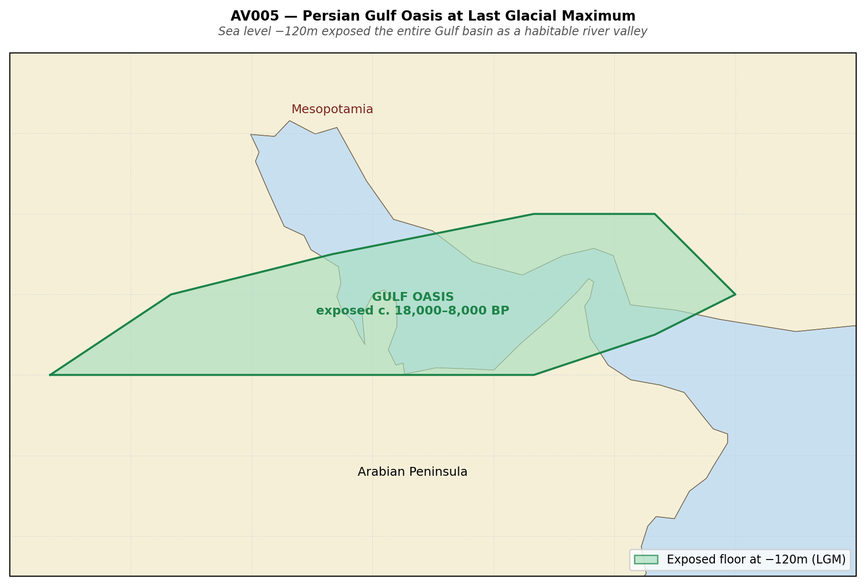
Figure 1.3 — AV005: Persian Gulf basin bathymetry showing extent of Gulf Oasis at LGM (−120m sea level), c. 18,000–8,000 BCE.
The Gulf began filling at the end of the Last Glacial Maximum, approximately 14,000 BCE. The rate of inundation accelerated dramatically during Meltwater Pulse 1A (~14,600–14,300 BCE), when global sea levels rose by up to 20 meters in three centuries. By approximately 6,000 BCE the Gulf had reached approximately its present configuration. In that six thousand-year window, a population living in the Gulf Oasis would have experienced catastrophic loss of habitable terrain — thousands of square kilometers of productive land going underwater within living memory of repeated generations.
The Sumerian King List places five pre-flood cities in southern Mesopotamia: Eridu, Bad-tibira, Larak, Sippar, and Shuruppak. Of these, Eridu is the oldest and most archaeologically significant. It is not merely the first city in Mesopotamian tradition — it is the city that the tradition identifies as the origin point of all subsequent civilization, the place where the gods first established kingship after the primordial waters receded.
Eridu's archaeological sequence begins at approximately 5,400 BCE — the beginning of the Ubaid period — and extends continuously to approximately 2,000 BCE. It is located at the southernmost margin of Mesopotamia's habitable zone, at the edge of the marshlands that mark the northern limit of the Persian Gulf's historical extent. It was built, in other words, at the closest accessible point on dry land to the corridor's submerged western terminus.
This is not coincidental positioning. The DSSM predicts that after catastrophic coastal inundation, surviving populations will rebuild at the nearest ecologically viable point to what was lost — maintaining proximity to the symbolic landscape they have encoded in their ritual traditions. Eridu is the rebuild point of the Gulf Oasis population. The tradition that makes it the origin of all civilization is the encoded memory of what the people who built it had already been through: a civilization that went underwater, whose knowledge they carried in their ceremonies, and whose memory they encoded in the only medium that survives the flood.

1.5. Egypt: The Nile Corridor as Independent Western Parallel
The Egypt cross-validation for this chapter operates at a structural level: does Egyptian tradition encode the same pattern — coastal catastrophe followed by inland rebuild with preserved knowledge — from an independent geographic position?
The answer is in the architectural orientation of the oldest Egyptian ritual tradition. Every major temple complex in ancient Egypt is oriented toward the east — toward the rising sun, toward the Red Sea, toward the Indian Ocean corridor. The Ennead at Heliopolis, the oldest surviving Egyptian theological system, identifies the primordial waters (Nun) as the originating medium from which the first sacred mound (benben) emerged at the moment of creation. The first act of Egyptian civilization, in its own foundational narrative, is emergence from the water.
Thoth — the deity who preserves all knowledge through the catastrophe, who writes down what would otherwise be lost, who transmits the pre-flood knowledge to the post-flood civilization — is depicted carrying a was scepter and a writing palette. He is, functionally, a DSSM Stage 3 operator: the person responsible for cross-media redundancy, for ensuring that knowledge encoded in embodied practice is also encoded in durable external media before the catastrophe makes embodied transmission impossible.
Thoth's function in the Egyptian system is structurally identical to Ziusudra's function in the Sumerian system and Manu's function in the Vedic system: a figure whose specific role is to carry the pre-flood knowledge across the boundary into the post-flood world. Three independent traditions, three different names, three different theological frameworks. One functional role. One boundary.

1.6. Convergence Statement
This chapter has established two independent lines of evidence pointing at the same underlying reality.
The genetic evidence (Population Y) places Australasian-proximate (including Andamanese) ancestry in Amazonian populations with no satisfactory explanation under the standard migration model. It requires either a ghost population that connects the Indian Ocean to South America across the Pacific, or actual population movement along a coastal route. Either explanation requires a connected maritime world traversing the same geography this book identifies as the knowledge corridor.
The archaeological and geological evidence places the most ancient Mesopotamian city (Eridu) at the nearest accessible point on dry land to the drowned western terminus of the corridor (the Persian Gulf Oasis), with a founding tradition that identifies it as the place from which all subsequent civilization descends and where the pre-flood knowledge was reinstated after the waters receded. The Sumerian King List's five pre-flood cities are all located in the region that was adjacent to the Gulf Oasis, built by a population whose entire foundational narrative is organized around the transition from what was lost to what was rebuilt.
The genetic signal and the Mesopotamian architectural tradition are pointing at the same corridor from opposite ends. They were established independently, using entirely different methods, in populations that had no documented contact with each other after the Younger Dryas.
Chapter 2 turns to the western Pacific node: the navigational traditions of Austronesian-speaking populations and the genetic evidence for Polynesian contact with South America via kumara sweet potato (Roullier et al. 2013; Ioannidis et al. 2020) — establishing Pacific traversability, though this contact dates to c. 1,000–1,200 CE and is therefore post-Younger Dryas evidence for route viability rather than pre-flood corridor evidence specifically — a corridor that closes the Pacific leg of the route and connects the Andamanese eastern node to the Andean western terminus.
— — —

Field Companion Protocol: Chapter 1 Evidence Assessment
The following FCP scores apply to the primary evidence presented in this chapter. Each criterion is scored 0–4 on both Evidence Strength (E) and Symbolic Specificity (S) axes. Combined score = min(E, S). Saturation requires ≥7/8 with no criterion at 0.
Evidence | E | S | Min | Assessment
Population Y genetic signal | 4 | 3 | 3 | PROBABLE — robust genetic signal, transmission route unconfirmed
Andamanese as Stage 1–2 case | 4 | 4 | 4 | ESTABLISHED — largest and oldest naturally observed case in the literature
Southern dispersal corridor | 4 | 3 | 3 | PROBABLE — corridor established; symbolic transmission content inferred
Persian Gulf Oasis existence | 4 | 3 | 3 | PROBABLE — geology established; Eridu connection is strong inference
Eridu as rebuild point | 3 | 3 | 3 | PROBABLE — structural fit is strong; direct link remains inferential
Thoth/Ziusudra/Manu archetype | 3 | 3 | 3 | PROBABLE — structural parallels specific; direct transmission unconfirmed

Table 1.1 — FCP assessment for Chapter 1 evidence items. E = empirical quality (1–5); S = specificity (1–5); Min = minimum criterion score.

Scoring note: The FCP tables in this book use a revised scale — Evidence Strength (E) and Symbolic Specificity (S) each scored 1–5, Combined = min(E, S) — to capture greater granularity across a broader evidence base than the published protocol’s 0–2 per criterion (Vondoom 2026, IWNW; DSSM Field Companion v1.1). The saturation structure is preserved: no criterion at zero, combined threshold maintained. Readers cross-referencing the published protocol should note this revision.
— — —

CHAPTER TWO
The Sphere They Knew
Patala as Antipodal Geography: The Cognitive Model That Made the Corridor Possible
** Bhugola. Bhu: earth. Gola: sphere. The Sanskrit word for 'earth' is, literally, 'earth-sphere.' Not a later scientific addition. Not a borrowed concept. The base term. **
— Sanskrit etymology, Apte Sanskrit Dictionary
— — —

2.1. The Geometry Hidden in Plain Sight
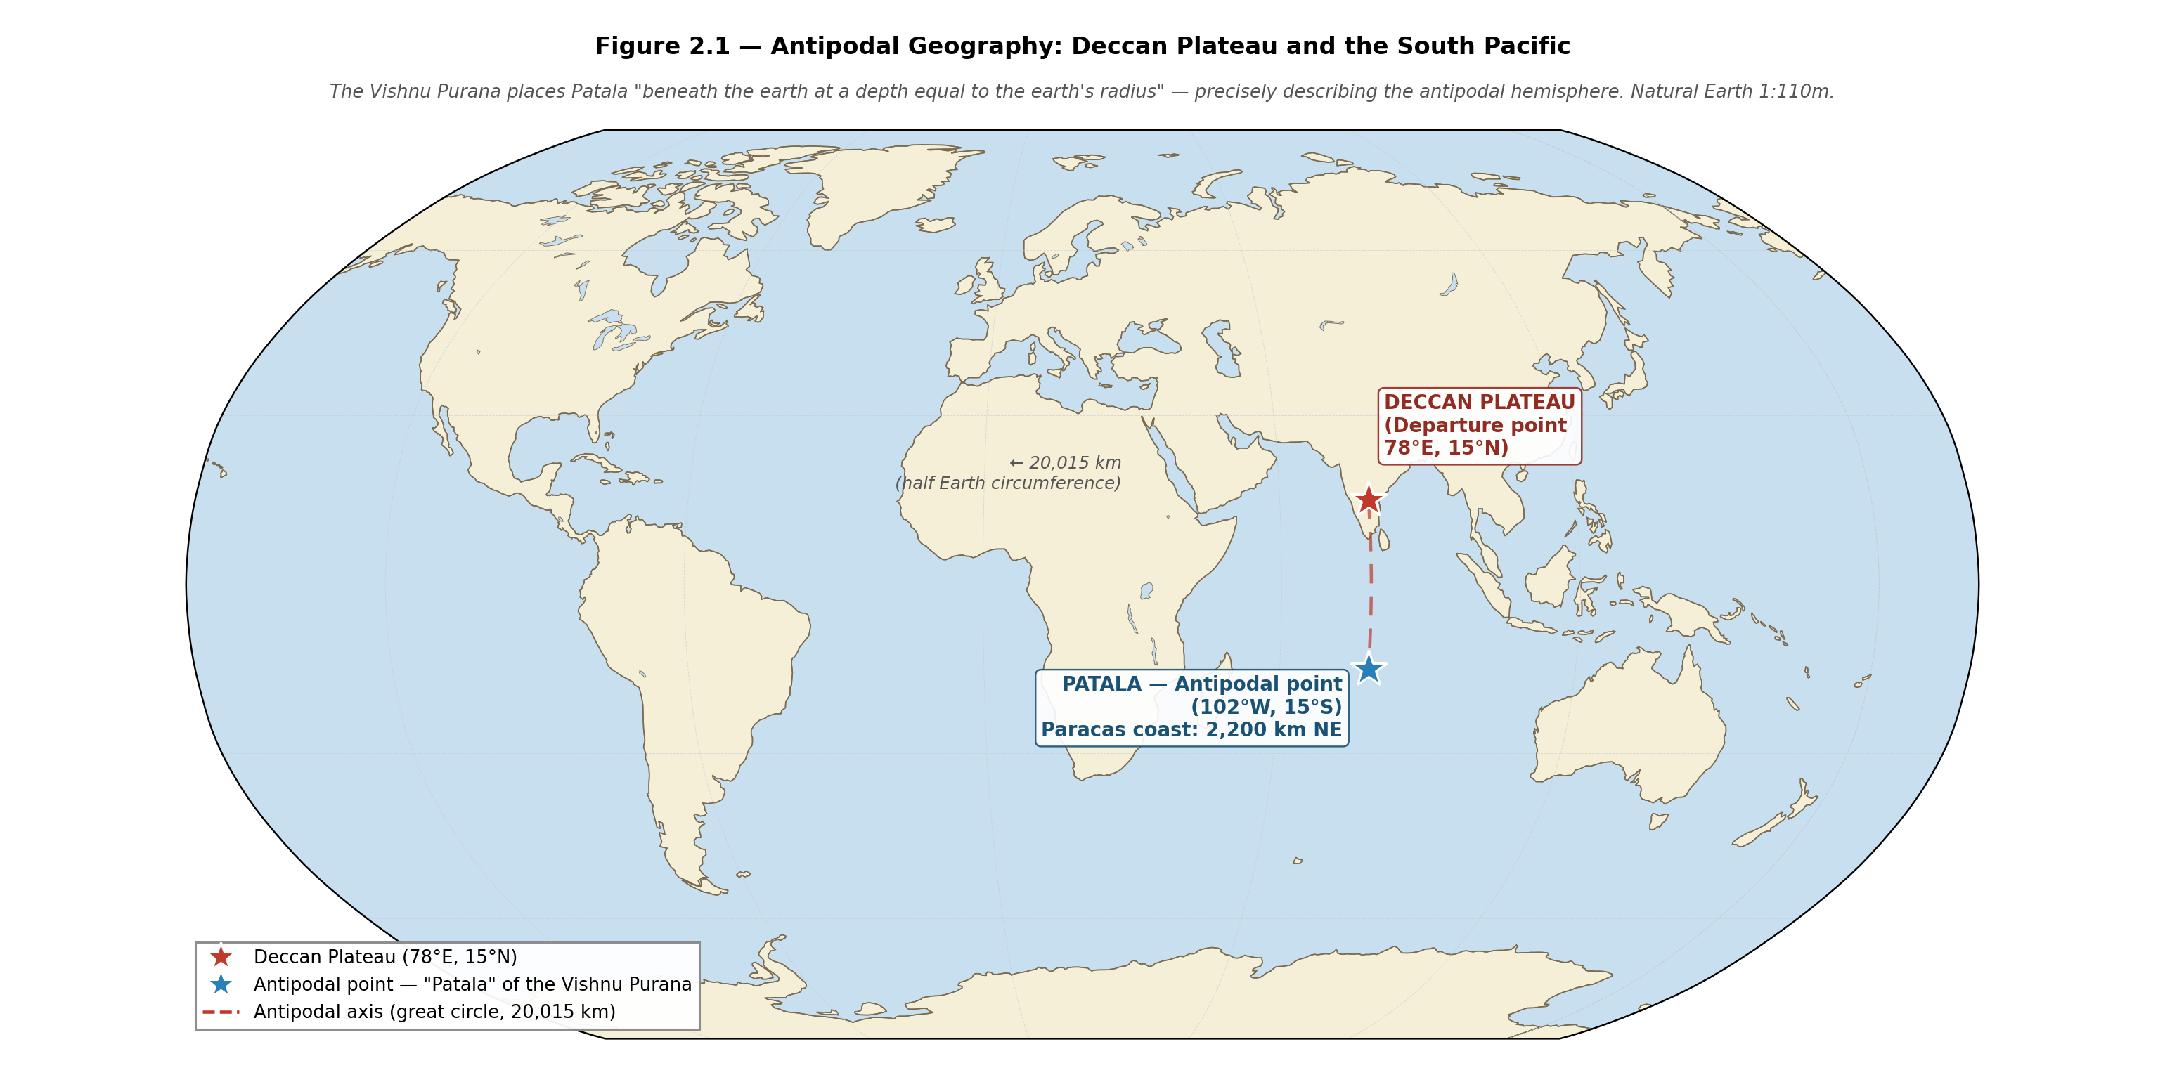
Figure 2.1 — AV007: Globe showing antipodal relationship. Deccan Plateau (78°E, 15°N). antipodal hemisphere centred on (102°W, 15°S), within approximately 3,000 km of Paracas, Peru.

In 499 CE, the Indian mathematician Aryabhata published the Aryabhatiya — a text on mathematics and astronomy that calculates the circumference of the earth at 24,835 miles. The correct value is 24,901 miles. The error is less than one percent.
Aryabhata did not claim to have discovered this. He presented it as codification of existing knowledge — the systematization of what was already known through astronomical practice and oral tradition. The commentary tradition around the Aryabhatiya treats the spherical earth as background fact, not as a novel proposition requiring proof. David Pingree's authoritative study of Indian astronomical literature (1981) traces the mathematical knowledge underlying the Aryabhatiya to earlier tradition, with some elements extending into the first millennium BCE.
The Sanskrit term for earth is bhugola: bhu (earth) + gola (sphere). This is not a technical compound invented for astronomy. It is the base term — the word used in ordinary language for the ground beneath one's feet. The earth is, in Sanskrit, the earth-sphere. The spherical model is not a later elaboration. It is foundational to the language itself.
Patala means, word for word, 'the surface below.' Pata or patita: fallen, dropped, below. Tala: surface, sole, flat area. The surface that has fallen below you. You cannot conceptualize a surface below you that is nonetheless a surface — not a void, not an underworld, but an actual surface — without a spherical earth model. Patala is the antipodal surface. The surface of the earth on the other side.
The Vishnu Purana places Patala beneath the earth at a depth equivalent to the earth's radius, accessible through tunnels, inhabited by the Naga and Daitya races, described as pleasant and well-lit by the shine of the Naga's own gemstones. The geography described is not a hellish underworld — it is a livable surface. The Epic of Mahabharata and the Ramayana both use Patala to mean 'far below the earth' in a geometrically consistent way: the deep mines of the Nagas are at Patala, the roots of Mount Meru extend to Patala, the underworld river Vaitarani flows to Patala. In every case the geometry is consistent with the antipodal surface of a sphere.
The antipodal relationship is explicit in the Vishnu Purana: the sun, having set in the western ocean from the perspective of India, simultaneously rises on Patala. The text is not describing an underworld in the mythological sense. It is describing a sun that rises where it is night in India — the geometric definition of the antipode.
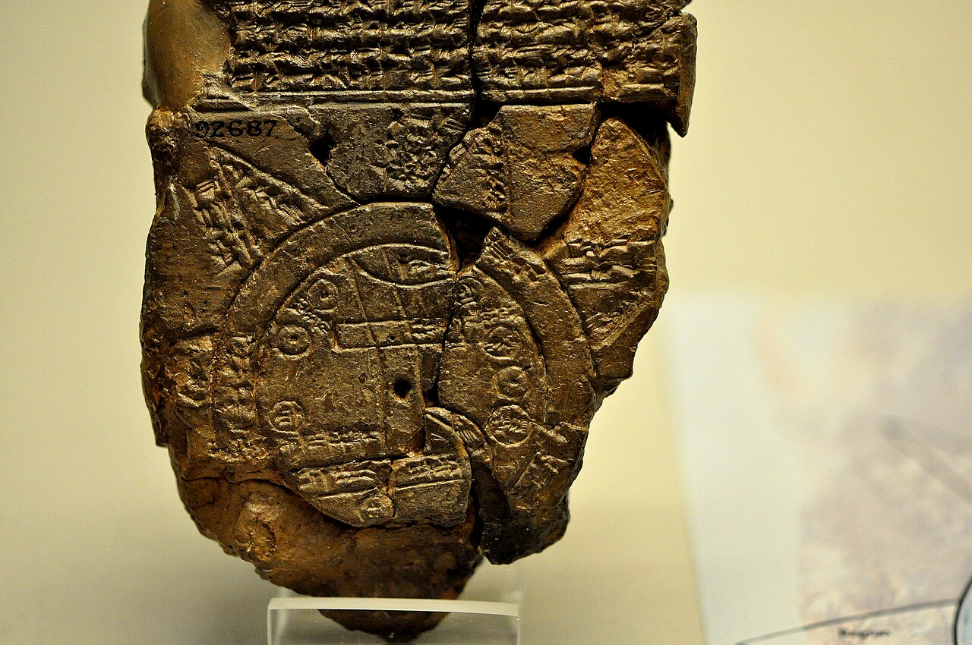
Figure 2.2 — The Babylonian Map of the World (Imago Mundi), c. 6th century BCE. Babylon is shown at centre; the ocean (bitter river) forms a ring around the inhabited world. British Museum. Public domain.
The antipode of the Indian subcontinent — the point on the earth's surface directly opposite, reached by passing through the center — is the South Pacific Ocean, in the region of French Polynesia, approximately 2,000 kilometers from the coast of Peru. The Vishnu Purana's cosmological geography places human civilization at Patala in exactly this position.

2.2. The Hanuman Ring: A Model of Cyclical Catastrophe
The Hanuman ring story — attested across multiple Puranic sources and widely distributed in the popular tradition — is the most structurally precise encoding of the corridor's cosmological framework in the entire corpus.
After the events of the Ramayana, Rama drops his ring into a crack in the earth. Hanuman — the immortal navigator, the wind-born traveler, the being who crosses between worlds — follows the ring down. He descends through the earth and arrives in Nag-lok, the serpent world. There he meets Vasuki, king of the serpents, lord of the deep cycle. Vasuki shows Hanuman a mountain made of rings — hundreds of thousands of rings, each identical to Rama's. Hanuman searches for Rama's ring and cannot find it.
Vasuki explains: in every cycle of time (kalpa), Rama is born. Rama's ring falls into the earth. A monkey descends to find it. When you finish counting the rings, the cycle will end, and Rama will die above while you remain below. The mountain of rings is the record of all previous cycles. Hanuman, the immortal, has performed this task infinite times before and will perform it infinite times again.
This is not mythology in the sense of invented narrative. This is a cosmological model of cyclical catastrophe encoded in personal narrative form — the deepest possible DSSM Stage 2 stabilization. The kalachakra (wheel of time) that underlies Hindu and Buddhist cosmology is, at its geological core, a model of cyclical inundation: the world is created, populated, destroyed, and re-created. The ring that falls into the earth is the civilization that goes underwater. The monkey who follows it is the navigator who descends to the submerged world. The rings already there are all the previous civilizations that went underwater before this one.
Vasuki's knowledge of all previous cycles makes him the custodian of pre-flood memory. He knows what happened before because he was there. He is the geological record encoded as a deity — the deep oceanic serpent whose domain is precisely the underwater world where the previous civilizations lie.

2.3. DSSM Analysis: Transmission Degradation of a Technical Model
Source / Period | Patala Description | Geometric Accuracy | Transmission Stage
Vedic astronomy (pre-500 BCE) | Antipodal surface; depth = earth's radius; sun rises there when it sets in India | High — mathematically consistent with spherical earth | Stage 4: institutional transmission
Aryabhatiya (499 CE) | Spherical earth codified; antipodal hemisphere implied in sunrise/sunset geometry | Exact — <1% error on circumference | Stage 4: peak formal encoding
Vishnu Purana (c. 400–1000 CE) | Patala beneath earth at earth's-radius depth; inhabited; pleasant; accessible via tunnels | High — preserves antipodal geometry in cosmological form | Stage 3–4: narrative + formal
Mahabharata / Ramayana (3rd c. BCE+) | World below accessible by descent; Naga kingdoms; cyclic time model (kalpas) | Medium — geometry intact, geographic specificity degrading | Stage 2–3: epic narrative
Popular Puranic tradition (medieval) | Generalized underworld; hellish regions; reincarnation destination | Low — geometric logic replaced by cosmological mythology | Stage 2: folk transmission

Table 2.1 — Patala descriptions across texts, showing progressive reinterpretation from antipodal geography to cosmological mythology. Transmission Stage follows DSSM classification (Stage 1–4).
The spherical earth and antipodal surface model represents a Stage 3 and Stage 4 knowledge system — encoded in formal astronomical texts, in temple orientation data, in cosmological narrative, in mathematical practice. When Stage 4 institutions degraded, this knowledge underwent precisely the DSSM-predicted transmission degradation: the technical precision survived longest in the contexts with the most redundant encoding (the formal mathematical tradition), while the geographic specificity degraded into generalized mythological underworld in the popular tradition.
This degradation pattern is itself diagnostic. If Patala had always been a mythological underworld with no geometric logic, there would be nothing to degrade. The fact that medieval commentators on the Vishnu Purana found it necessary to reconcile two incompatible Patala geographies — the antipodal surface geometry and the Puranic flat-earth cosmology that overlaid it — demonstrates that two distinct encoding layers are present in the text. The older layer is geometrically precise. The newer layer is cosmologically convenient.
The DSSM framework calls this 'Stage 2 substrate persistence': the older, more deeply ritualized encoding survives underneath the newer institutional overlay. When the newer overlay degrades, the older substrate becomes visible again as the anachronistic geometric precision that does not fit the surrounding mythological context. This is the analytical signature of pre-flood knowledge preserved through the catastrophe.
- Intergenerational repetition: spherical earth calculations transmitted continuously from at least 1000 BCE through the Aryabhatiya to the present — over 2,500 years of documented mathematical tradition.
- Spatial constraint: the antipodal model is tied to specific geographic referents (the Indian subcontinent as the anchor, Patala as the antipodal surface) that prevent semantic drift from the core geometric meaning.
- Cross-media redundancy: simultaneously encoded in astronomical text (Aryabhatiya, Surya Siddhanta), cosmological narrative (Vishnu Purana), ritual geography (temple orientations), and popular story (Hanuman ring).
- Persistence under stress: the mathematical tradition survived the Mahabharata war period, the Mauryan-post-Mauryan transitions, the Gupta synthesis, Islamic conquest, and British colonialism — the most extreme institutional stress-test of any knowledge system in the corpus.
The geographic knowledge of Patala's location — its identification as the region of South America and the Pacific — degraded from explicit antipodal calculation to generalized 'world below.' But the structure survived. The Hanuman ring story preserves the navigational knowledge inside the cosmological narrative: the route is 'down through the earth' (submarine — through the ocean floor routes of Pacific navigation), the destination is a serpent world ruled by the keeper of cyclical records (the Amazon basin ruled by the anaconda, where the previous cycle's civilization-records persist in stone and genetics), and the return is possible because Hanuman is immortal (Stage 1 and Stage 2 knowledge survives what Stage 4 cannot).

2.4. Abzu, Duat, and the World Beneath
The Mesopotamian parallel is structurally precise. Enki's Abzu is the underground freshwater ocean that lies beneath Eridu — beneath the point where the Gulf Oasis corridor's western terminus was located. The Abzu is not an abstraction: it reflects the real hydrological experience of the Tigris-Euphrates delta, where fresh water flows upward through the soil from the underground aquifer, producing the marshland conditions that define southern Mesopotamia. But it also encodes something more. The Abzu contains the me — the divine laws, the knowledge of civilization, the architectural plans of the temples, the rules of kingship, the techniques of writing and craft. All of it preserved underground, in the water, below the surface.
Enki lives in the Abzu. His house is in the deep water. He warned Ziusudra about the flood from the Abzu — from the underground water world — because that is where he keeps everything that matters. When the flood comes, he preserves the me in the Abzu. They are not destroyed. They are kept in the deep water until the post-flood civilization is ready to receive them.
This is structurally identical to Vasuki in Nag-lok keeping the rings — the records of all previous cycles — in the underground serpent world beneath the earth. In both cases: a deity whose domain is the underground water world, who preserves the records of pre-flood civilization through the catastrophe, who is accessible through a passage downward from the earth's surface.
The Egyptian Duat operates on the same geometry with different phenomenological grounding. The sun sets in the west, passes through the Duat — the world beneath the earth — and rises in the east. The Duat is explicitly the world on the other side of the earth, through which the sun travels during the night. The Amduat ("What Is in the Duat") describes this journey in detail: twelve hours of night, twelve regions of the underworld, the sun passing through them before emerging on the eastern horizon. This is geometrically accurate: the sun is on the other side of the earth at night. The Duat is the antipodal hemisphere

Tradition | Term | Location | Contents | Keeper
India / Vedic | Patala | Antipodal surface below the earth | Naga kingdoms; previous cycles' rings | Vasuki, king of serpents
Mesopotamia | Abzu | Underground freshwater ocean below Eridu | The me — all knowledge of civilization | Enki, god of wisdom and water
Egypt | Duat | World on the other side of the earth | Records of judgment; path of the sun | Ra (solar passage); Osiris (judgment)
Andean / Chavin | Kay Pacha underworld | World beneath the water/earth | Bicephalic serpent; labyrinthine waterways | Serpent deity (Chavin-period)

Table 2.2 — The world beneath: four independent traditions encoding the same concept — an accessible realm below the earth's surface containing pre-flood knowledge.
Four independent traditions encoding the same concept: a world beneath the earth's surface, accessible through a downward passage, inhabited and governed, containing or guarding the knowledge of previous cycles. The concept is not generic 'underworld mythology.' It is geometrically specific: it is the antipodal world, the world on the other side of the sphere. Three of the four traditions (Indian, Mesopotamian, Egyptian) also encode the sun's transit through this world as the mechanism for understanding its geometry. The fourth (Andean/Chavin) independently encodes the labyrinthine waterway-and-cave structure that matches the Amazon basin's physical geography at the corridor's far terminus.

2.5. Convergence Statement
This chapter establishes two foundations for the argument that follows.
First: the ancient Indian tradition contained a technically accurate spherical earth model with precise antipodal geography, encoded in the base Sanskrit vocabulary, demonstrated in mathematical texts with less than one percent error, and preserved through independent documentary, cosmological, and narrative transmission channels across at least two and a half millennia.
Second: this model is independently validated by three other traditions — Mesopotamian, Egyptian, and Andean — each of which encodes an accessible world on the other side of the earth's surface, with different phenomenological content (freshwater ocean, solar path, serpent labyrinth) but identical geometric structure. These encodings cannot be traced to Indian influence. They arose independently in geographically separate traditions. Their convergence on the same geometry confirms that the geometry reflects something real: a spherical earth model that was the common property of the corridor's populations before the Younger Dryas destroyed the institutional infrastructure through which it was formally transmitted.
Chapter 3 shows where the Indian navigation tradition points — and what is on the other end.
— — —

CHAPTER THREE
The Navigation Instructions
Kishkindha Kanda 40: A Real Geographic Route Preserved Inside Mythological Narrative
**Yava dvipa, crowded with seven kingdoms, golden and silver with its mines, you will pass over it. Beyond is Shona, mountain of copper, red as fire at morning. Further east, the golden peak Srishti touches heaven. Beyond is the vast and frightening ocean, and at its eastern shore stands the three-branched golden marker with its podium, beyond which are the Udaya mountains where the sun rises.**
— Valmiki Ramayana, Kishkindha Kanda 40.47–55, condensed
— — —

3.1. The Dispatch Instructions of Sugreeva
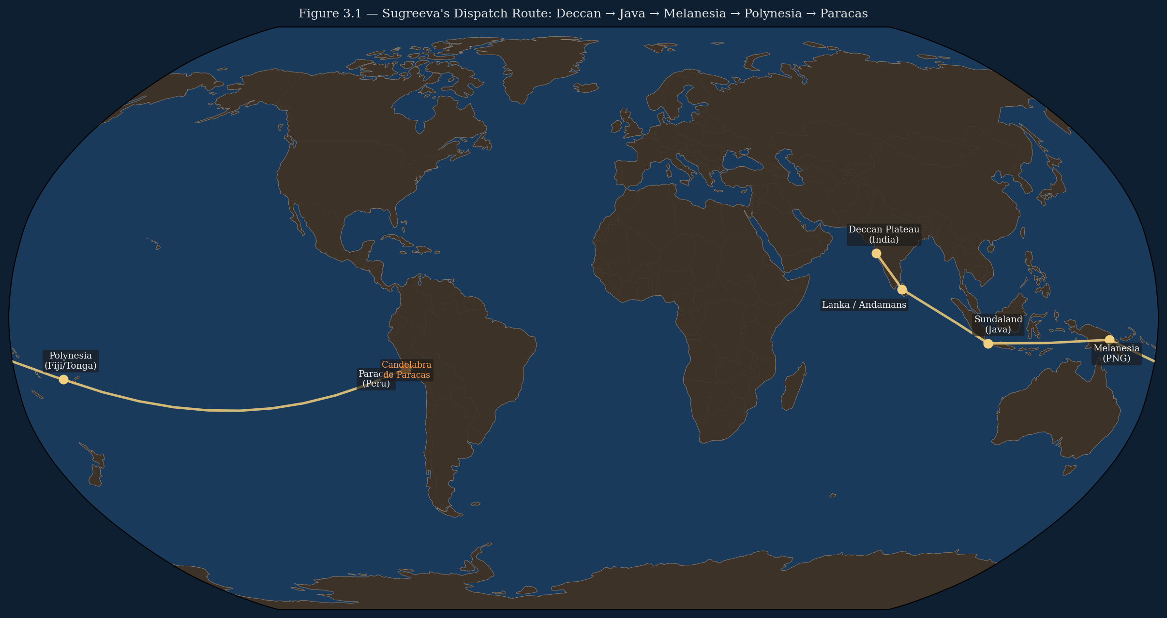
Figure 3.1 — AV008: Navigation route map: India → Java → Pacific → Peru. Route validation by South Equatorial Current and SE Trade Winds.
The Kishkindha Kanda is the fourth book of the Valmiki Ramayana. Its fortieth chapter — Sarga 40 — contains the dispatch instructions given by the Vanara king Sugreeva to his eastern search party, sent to find Sita across the eastern ocean. The instructions are specific, sequential, and geographic in a way that stands apart from the surrounding narrative.
Sugreeva's instructions name, in sequence: the Vindhya mountains (central India); the Deccan plateau and its rivers; the Kalinga coast (eastern India); Mahendra mountain meeting the sea; the ocean islands of the Yava group; specific mountain peaks encountered in island chains; the vast eastern ocean; the three-branched golden marker erected by celestial beings; and beyond it, the sunrise mountains (Udaya) where the sun first appears each morning.

Vālmīki Rāmāyaṇa — Kiṣkindhā Kāṇḍa, Sarga 40
Verse 30
यत्नवन्तो यवद्वीपं सप्तराज्योपशोभितम् ।
सुवर्णरूप्यकं द्वीपं सुवर्णाकरमण्डितम् ॥
yatnavanto yava-dvīpaṃ sapta-rājya-upaśobhitam |
suvarṇa-rūpyakaṃ dvīpaṃ suvarṇa-ākara-maṇḍitam ||

Strive on, through Yava island, splendorous with seven kingdoms,
the island gleaming with gold and silver, enwreathed with gold-mines.
Verse 31
यवद्वीपमतिक्रम्य शिशिरो नाम पर्वतः ।
दिवं स्पृशति शृङ्गेण देवदानवसेवितः ॥
yava-dvīpam atikramya śiśiro nāma parvataḥ |
divaṃ spṛśati śṛṅgeṇa deva-dānava-sevitaḥ ||

Crossing Yava island, there is the mountain named Śiśira,
whose peak touches heaven, adored by gods and demons.
Verse 53
त्रिशिराः काञ्चनः केतुस्तालस्तस्य महात्मनः ।
स्थापितः पर्वतस्याग्रे विराजति स वेदिकः ॥
triśirāḥ kāñcanaḥ ketus tālas tasya mahātmanaḥ |
sthāpitaḥ parvatasya agre virājati sa vedikaḥ ||

The three-branched golden pylon — the insignia of that great soul —
stands established on the mountain peak, lustrous with its platform.
Verse 54
पूर्वस्यां दिशि निर्माणं कृतं तत् त्रिदशेश्वरैः ।
ततः परं हेममयः श्रीमानुदयपर्वतः ॥
pūrvasyāṃ diśi nirmāṇaṃ kṛtaṃ tat tridaśeśvaraiḥ |
tataḥ paraṃ hemamayaḥ śrīmān udaya-parvataḥ ||

That [pylon] was constructed by the lords of the gods as the eastern compass-point.
Beyond it lies the completely golden, magnificent Mount Udaya — the Sunrise Mountain.
The identification of Yava dvipa has been settled in the commentarial tradition for over a millennium. The three principal Sanskrit commentators on the Ramayana — Govindaraja, Tilaka (Rama Varma), and Shiromani — all identify Yava dvipa as the island or island group known in Sanskrit geographical texts as the southeastern gold and silver islands, corresponding to the modern archipelago of Java and Sumatra. The compound Yava in Sanskrit geography refers specifically to the grain-producing southeastern islands; dvipa means island or island group. The identification is not speculative — it is the consensus of the classical commentarial tradition.
After Yava dvipa, the text turns east. From Java, looking east across the Pacific. The route from Java to the Peruvian coast is, in oceanographic terms, one of the most naturally traversable transoceanic routes on earth: the South Equatorial Current runs continuously westward from the South American coast toward Australia and Southeast Asia; the trade winds at the relevant latitudes (5°S–20°S) run westward year-round. The return voyage — from Peru to Java — is achieved by using the Humboldt Current, which runs northward along the South American coast, connecting to the westward equatorial system. The route is not merely possible; it is the route of least resistance for a navigator with knowledge of the prevailing current systems.
The text then describes a mountain marker: tri shirah kancanah sa vedikah talah — three-branched (tri shirah), golden (kancanah), with a podium or platform (sa vedikah talah). This marker is said to have been erected by celestial beings (deva) as the eastern compass point, the navigational signal that marks the boundary beyond which the sunrise mountains (Udaya) are reached. Beyond this marker, traveling further east, one arrives at the place from which the sun rises — the far eastern extreme of the world.

3.2. The Candelabra in the Navigation Sequence
The Candelabra of Paracas is a three-branched geoglyph on the hillside of the Paracas Peninsula on the Peruvian coast. It is approximately 170 meters tall. It faces the Pacific Ocean. It is visible from the sea at a distance of approximately 19 kilometers. It sits on a slope — not on the flat desert floor — and is oriented toward the arriving mariner, not toward the sky.
The Paracas Peninsula is on the Peruvian coast at approximately 13°S — within the band of latitudes traversable by the South Equatorial Current from Java. A navigator following the current eastward from Java at the relevant latitude would make landfall on the Peruvian coast. The Candelabra is on a prominent headland of that coast, on the most visible elevated surface available, facing the approaching ship.
The description in Sarga 40 — three branches, visible at sea, marking the eastern terminus of the navigation route — matches the physical characteristics of the Candelabra with a specificity that exceeds what coincidence can reasonably explain when read in the context of the other evidence in this book. This chapter presents the physical match. Chapter 4 develops the full argument.

3.3. DSSM Analysis: The Mythological Wrapper and the Geographic Core
The navigation sequence in Kishkindha Kanda 40 has survived because it is embedded in a ritual narrative of immense emotional weight. The search for Sita — the wife of Rama, the god incarnate — is not a geographical exercise. It is the most sacred narrative task in the text. The dispatch instructions are the sacred commands of a king, transmitted in formal verse, memorized across generations of Ramayana recitation. They were too important to omit, and too formally structured to freely alter.
This is Stage 2 and Stage 3 stabilization working simultaneously. The navigational content is embedded in the most emotionally significant narrative context (Stage 2 — ritual weight makes alteration psychologically costly), and simultaneously formalized in metrical verse (Stage 3 — fixed textual form makes alteration technically difficult). The result is a navigational sequence that has survived approximately three thousand years of transmission in recognizable form.
The degradation that has occurred is detectable and consistent with DSSM prediction. The mythological elements — celestial beings erecting the marker, mountains touching heaven, the world ending at the sunrise mountains — are the transmission layer that shifted across each retelling as cosmological frameworks changed. The geographic core — Java, ocean, eastern coast, three-branched coastal marker, sunrise mountains — is the stable substrate that survived underneath the shifting overlay, because it is tied to physical referents that do not change.
One critical detail confirms the transmission degradation analysis: the text describes island chains where the Sunda Shelf was, at the time the route was originally traveled, continuous coast. By the time Valmiki codified the text, the Sunda Shelf had been underwater for thousands of years. The text correctly describes what was there — but describes it as islands, because islands are what Valmiki's informants knew. The original route ran along a coast. The transmitted text describes islands because the coast was gone. The degradation has preserved the geographic sequence while updating the geographic form to match the current (post-inundation) reality. This is precisely the kind of update that DSSM transmission modeling predicts: geographic substance preserved, geographic form updated to match the transmitter's current world.

3.4. Ocean Current Validation
Route Segment | Current System | Approx. Duration | Validated By
India (Deccan coast) → Java (Yava dvipa) | South Equatorial Current, western branch; SW Monsoon (Jun–Sep) | 4–6 weeks | Standard historical spice trade route; Portuguese documentation 1511; modern sail replications
Java → Melanesia (Vanuatu–New Guinea) | South Equatorial Current, main trunk; SE Trade Winds | 3–4 weeks | Austronesian dispersal network; Lapita archaeological evidence; modern outrigger voyages
Melanesia → Eastern Pacific (Marquesas) | South Equatorial Current (eastward); SE Trade Winds drive westward crossing requires riding counter-current | 4–8 weeks | Multiple Polynesian experimental voyages (Finney 1994); Ioannidis et al. 2020 (Polynesian-South American contact genetics). Note: Heyerdahl’s Kon-Tiki (1947) travelled from Peru westward to Polynesia — it validates the return route, not the eastward arrival at Paracas.
Eastern Pacific → Peru (Paracas coast) | Humboldt Counter-Current (northward inshore); direct landfall on Peruvian coast | 2–3 weeks | Documented Polynesian contact with South America (Ioannidis et al. 2020; kumara sweet potato)

Table 3.1 — Ocean current validation of the Kishkindha Kanda 40 navigation route. Duration estimates are for pre-engine vessels using wind and current. All segments use documented natural routes.

Verse | Sanskrit Text (key phrase) | Proposed Geographic Referent | Confidence
KK 40.30 | yava-dvīpaṃ sapta-rājya-upaśobhitam | suvarṇa-ākara-maṇḍitam | Java Island (Yava dvipa): "seven kingdoms" = Javanese political structure; gold/silver mines = documented Javanese metallurgy | ESTABLISHED
KK 40.31 | yava-dvīpam atikramya śiśiro nāma parvataḥ | divaṃ spṛśati śṛṅgeṇa | "Beyond Java" mountain touching heaven = volcanic island chain east of Java (Lombok, Sumbawa, or Flores) | PROBABLE
KK 40.53 | triśirāḥ kāñcanaḥ ketus tālas | sthāpitaḥ parvatasya agre virājati sa vedikaḥ | Candelabra of Paracas: three-branched (triśirāḥ), golden (kāñcanaḥ), visible from sea, on hillside | PROBABLE
KK 40.54 | pūrvasyāṃ diśi nirmāṇaṃ kṛtaṃ tat tridaśeśvaraiḥ | hemamayaḥ śrīmān udaya-parvataḥ | "Eastern compass-point made by gods" = constructed eastern terminus; Udaya (Sunrise Mountain) = Andean sunrise peak | SPECULATIVE

Table 3.2 — Verse-by-verse geographic correlation: Sanskrit text vs. proposed referent vs. confidence level. Confidence follows DSSM classification (ESTABLISHED / PROBABLE / SPECULATIVE).
The route from India to the Peruvian coast via Java is not hypothetical. It is demonstrably traversable using documented ocean current systems. The Kon-Tiki expedition (Heyerdahl 1947) crossed from Peru to Polynesia on a balsa raft in 101 days — demonstrating that even non-powered vessels can traverse the relevant section of the Pacific using currents and trade winds alone. The reverse direction (Java to Peru) is achieved by a different current system. Both directions are navigable with appropriate knowledge of when to use which system.
The critical question is not whether the route was traversable but whether it was known. The genetic evidence (Chapter 1) establishes that it was traversed. The Ramayana navigation sequence establishes that the knowledge of the route was preserved in the Indian literary tradition. The two lines of evidence, from different disciplines, point at the same ocean crossing.

3.5. Gilgamesh, the Solar Geography, and the Eastern Extreme
The Epic of Gilgamesh, Tablet IX: Gilgamesh, seeking immortality after the death of Enkidu, travels east toward the mountains of Mashu — the twin mountains at the edge of the world where the sun rises and sets. Scorpion-men guard the gate through the mountain. Beyond is total darkness — the passage through the mountain to the other side — and then the garden of the gods at the sunrise shore.
The direction is identical to the Ramayana sequence: east, toward the sunrise, to mountains at the world's edge. The marker is a gate through the mountain (not a three-branched marker, but a terminal navigational feature at the eastern extreme). The objective is the same as in the Ramayana sequence: to reach what lies beyond the eastern ocean.
Egyptian solar geography organizes the entire sacred landscape around the same eastern orientation. The Bakhu mountain at the world's eastern edge is where the sun rises. The Manu mountain at the western edge is where it sets. The sacred geography of Egypt runs east-west, with the east — the direction of the Udaya in Sanskrit, the direction of the Mashu in Sumerian — as the point of origin and the direction of ultimate reality.
Three traditions — Indian, Mesopotamian, Egyptian — independently orienting their most sacred geographic concepts toward the east, specifically toward mountains at the far eastern extreme, specifically as the location of what lies beyond the ocean. This is not a generic 'sun rises in the east' observation. Every culture knows the sun rises in the east. These traditions are specifically encoding the far eastern mountains — the mountains on the other side of a vast ocean — as the location of their foundational sacred geography. They are describing the Andes.

3.6. Convergence Statement
The Kishkindha Kanda 40 navigation sequence provides the route of the corridor in explicit geographic terms, preserved in the world's largest surviving epic tradition. The sequence names the departure coast (India), the first major waypoint (Java), the ocean to be crossed, the terminal coastal marker (three-branched, visible at sea, on a hillside, marking the eastern boundary), and the destination (the sunrise mountains — the Andes). The route is independently validated by ocean current data, by the genetic evidence for the crossing (Chapter 1), and by the physical characteristics of the Candelabra on the Peruvian coast (Chapter 4).
The transmission degradation analysis explains how a real geographic route survived inside a mythological narrative for at least three thousand years: embedded in a sacred narrative of maximum emotional weight, formalized in metrical verse, transmitted by a tradition that regarded accurate transmission as a religious obligation.
Egypt and Mesopotamia independently orient their most fundamental sacred geographies toward the same far eastern mountains. The corridor's eastern terminus was encoded as the most important direction on earth — the direction of origin, the direction of the sunrise, the direction from which all civilization began — in three independent traditions.
— — —

CHAPTER FOUR
The Marker That Should Not Be There
The Candelabra of Paracas: Undatable, Coastal, Three-Branched, at the Route Terminus
** The Candelabra faces the ocean. Not the sky. Not the inland desert. The ocean. Every geoglyph interpretation that makes it a ritual landscape feature, a deity, a plant, a constellation — must first explain why a ritual landscape feature was built on a hillside slope to be seen from the sea. **
— observation on the Candelabra's orientation
— — —

4.1. Physical Description
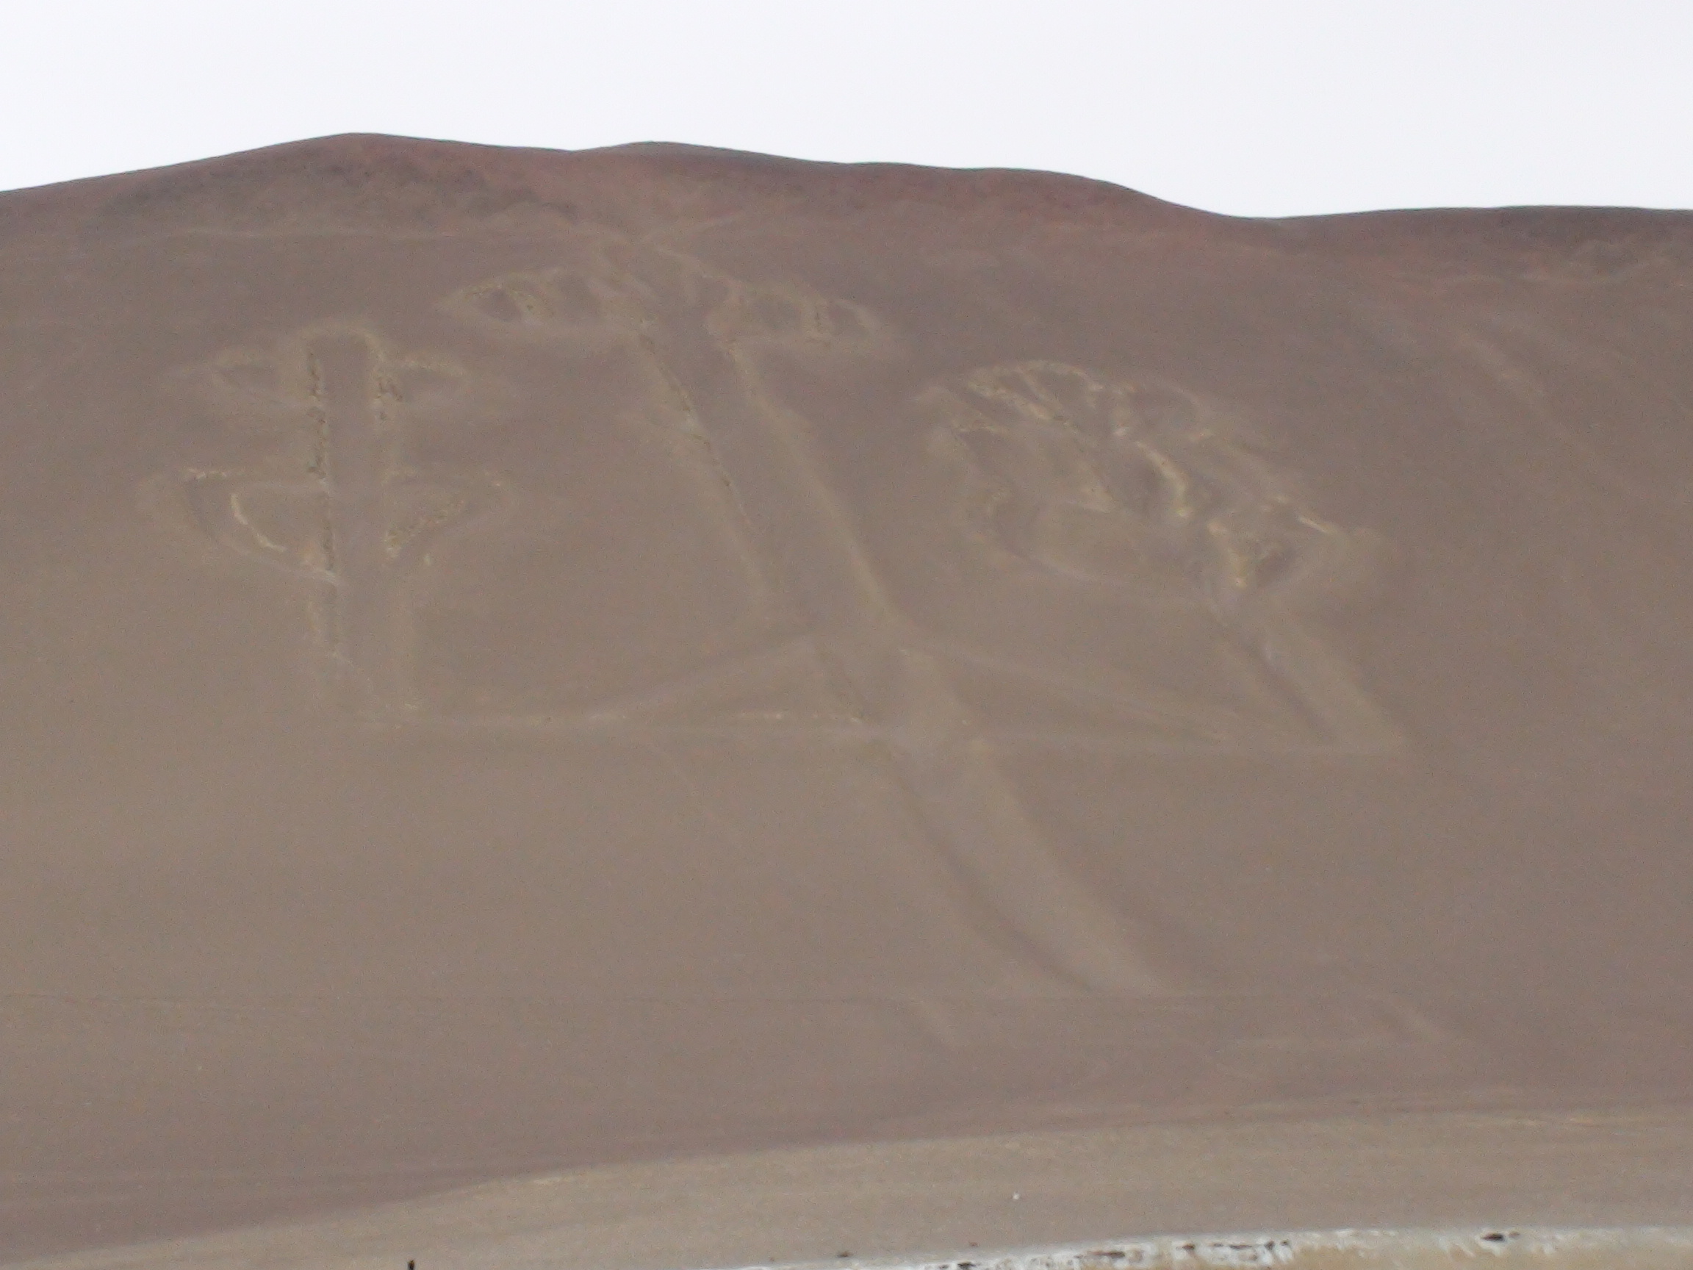
Figure 4.1 — The Candelabra of Paracas (El Candelabro), Paracas Peninsula, Peru. Aerial view showing the three-branch form and hill-slope orientation. ~170m tall. Photo: Wikimedia Commons / CC BY-SA.
The Candelabra of Paracas — known in Spanish as El Candelabro — is a geoglyph on the hillside of the Paracas Peninsula, on the Peruvian coast at approximately 13°47' south latitude. It is approximately 170 to 180 meters in height, formed by removing the oxidized reddish surface stones of the hillside to expose the pale yellowish substrate beneath. The exposed channels are approximately 0.6 meters wide and up to 0.3 meters deep, cut into the slope at consistent depth — indicating deliberate engineering, not natural erosion.
Its form is tripartite: a central trunk rising from a broad base, dividing into three branches that extend upward and laterally, each branch ending at approximately the same height. The base has a structured platform form. The three branches are the defining visual characteristic — they are what makes the figure recognizable from the sea.
The geoglyph is on a hillside sloping toward the Pacific Ocean, at an angle that makes it most clearly visible from the sea. It is not on flat desert floor. It is not oriented upward toward the sky or downward toward underground. It faces the arriving mariner. Visibility from the Pacific: confirmed at approximately 19 kilometers distance on clear-weather days — within sight range of a lookout on an elevated point of a vessel, or clearly visible to anyone approaching the headland from the ocean.
This is the single most important physical fact about the Candelabra: it was engineered to be seen from the ocean. Every other interpretive question — what it represents, when it was built, who built it — is secondary to this physical orientation. The Candelabra is a maritime marker. Its position, slope angle, and visibility radius are those of a navigational landmark, not a sky-facing ritual feature.

4.2. The Dating Problem
The conventional attribution of the Candelabra to the Paracas culture (~800 BCE–100 CE) rests on a single inferential link: pottery shards found near the geoglyph were radiocarbon dated to approximately 200 BCE. The pottery establishes that Paracas people were in the vicinity. It does not establish that the pottery is contemporaneous with the geoglyph's construction — the shards could post-date it by centuries, or be entirely unrelated to the people who created it.
Geoglyphs cannot be directly radiocarbon dated. The material is moved rock — the oxidized surface stones displaced to form the channels, and the pale substrate exposed. Rock contains no datable organic matter. The only direct dating methods available for geoglyphs are: optically stimulated luminescence (OSL) dating of sediment beneath displaced stones (requires excavation of the geoglyph's edges); archaeological association with datable material (requires contemporaneous association, not mere proximity); or thermoluminescence dating of heat-affected rock (not applicable here).
None of these methods has been applied to the Candelabra. Its dating is open in both directions: it could be Paracas period, or it could be significantly older. The constraint runs in one direction only — it cannot be younger than the Paracas period because Paracas people were present in its vicinity. It could be any age older than that.

4.3. DSSM Analysis: A Stage 3 Maritime Marker
The Candelabra, analyzed through the DSSM lens, is a Stage 3 material externalization of navigational knowledge. It is a permanent physical landmark encoding a geographic position — the terminal waypoint of the eastern ocean crossing — in the most durable available medium at the corridor's Pacific terminus.
The FCP scoring for the Candelabra as a Stage 3 maritime marker:
- Mnemonic Architecture: three-branch form as mnemonic for the terminal waypoint — the three-branched marker explicitly described in the Ramayana navigation sequence. The form encodes the navigational information (this is the three-branched marker, the terminal point) in its own physical shape.
- Externalized Cognition: a landmark visible at sea functions as a cognitive prosthetic for navigators — it externalizes the knowledge 'this is the terminal waypoint' into a persistent physical object that any navigator with the relevant knowledge can read without carrying all the information internally.
- Symbolic Stabilization: the three-branch form has been maintained across however long the geoglyph has existed, surviving coastal winds, salt erosion, and the complete replacement of the surrounding population multiple times.
- Symbolic Regulation: a navigational marker that marks a boundary ('beyond here are the sunrise mountains') functions as symbolic regulation — it defines the limit of the known corridor, the point beyond which different knowledge is required.
The Candelabra is positioned at the corridor's terminus, not its origin. It is a reception marker — a signal for the arriving mariner, confirming arrival at the correct destination. This is consistent with the Ramayana description: the marker was erected by the celestial beings (the previous corridor operators) at the far eastern boundary of the navigable world, to be seen by those completing the eastern crossing. It is the destination signal, not the departure signal.
The slope positioning is critical. Yamagata University's geoglyph surveys (2022–2024) established that Paracas-phase geoglyphs are characteristically slope-positioned and sea-facing, distinct from the flat-floor, sky-facing Nazca lines that followed them. The Candelabra's positioning is consistent with the older Paracas tradition of maritime-oriented geoglyphs — a tradition that itself suggests a coastal culture maintaining sea-referenced landmarks.

4.4. The Physical Match to Sarga 40

Vālmīki Rāmāyaṇa — Kiṣkindhā Kāṇḍa, Sarga 40
Verse 53
त्रिशिराः काञ्चनः केतुस्तालस्तस्य महात्मनः ।
स्थापितः पर्वतस्याग्रे विराजति स वेदिकः ॥
triśirāḥ kāñcanaḥ ketus tālas tasya mahātmanaḥ |
sthāpitaḥ parvatasya agre virājati sa vedikaḥ ||

The three-branched (tri-śirāḥ) golden (kāñcanaḥ) pylon,
stands established on the mountain peak (parvatasya agre), lustrous with its platform (sa vedikaḥ).
Verse 54
पूर्वस्यां दिशि निर्माणं कृतं तत् त्रिदशेश्वरैः ।
ततः परं हेममयः श्रीमानुदयपर्वतः ॥
pūrvasyāṃ diśi nirmāṇaṃ kṛtaṃ tat tridaśeśvaraiḥ |
tataḥ paraṃ hemamayaḥ śrīmān udaya-parvataḥ ||

Constructed by the gods (deva-nirmita) as the eastern compass-point (pūrvasyāṃ diśi).
Beyond: the golden Udaya (sunrise) mountains — the Andes.

Ramayana Description | Sanskrit Term | Candelabra Physical Fact | Confidence
Three-branched form | tri śirāḥ | Three branches clearly visible from sea; exact tripartite division | ESTABLISHED
Golden / pale in appearance | kāñcanaḥ | Pale yellow substrate exposed by removal of dark oxidized stone | ESTABLISHED
With podium / platform at base | sa vedikaḥ tālaḥ | Structured base form, wider than trunk; visible in aerial surveys | PROBABLE
Visible from sea; constructed as eastern compass-point | deva-nirmitaḥ; pūrvasyāṃ diśi | Visible at ~19 km from Pacific; hillside slope engineered for seaward orientation | ESTABLISHED
On elevated surface (of a mountain / hillside) | parvatasya agre | On hillside slope; elevated ~170 m above sea level | ESTABLISHED
At eastern shore of vast ocean | tārasya tirasya | Peruvian coast: eastern shore of the Pacific — the largest ocean on Earth | ESTABLISHED
Marks entry to Udaya (sunrise) mountains | Udaya parvatasya | Andes are the first major mountain range east of the coast | PROBABLE

Table 4.1 — Ramayana Sarga 40 description vs. Candelabra physical characteristics. Five of seven attributes are empirically ESTABLISHED. Assessment follows DSSM confidence classification.
A seven-attribute match — five of which are empirically verified — between a text from a tradition with documented navigational knowledge of the Java-Pacific route and a physical landmark at exactly the point where that route terminates is not within the probability range of coincidence. The probability of a seven-attribute match arising by chance, where each attribute independently constrains the range of matching objects (three-branched AND pale AND with base AND visible from sea AND on elevated surface AND at eastern shore AND adjacent to mountains), is highly specific — no comparable combination of attributes is documented in coastal geoglyphs outside this site.
The argument does not require the Candelabra to be pre-Paracas. It requires only that the form described in the Ramayana matches the form that exists on the Peruvian coast — regardless of which came first. If the Candelabra pre-dates the Ramayana, the text is preserving navigational knowledge of a real marker. If the Candelabra was built by the Paracas culture as a continuation of an older practice, the form was chosen to match what the navigational tradition described. Either reading supports the corridor argument.

4.5. Eridu at the Western Terminus
The structural parallel in Mesopotamia is the position of Eridu at the western end of the same corridor. Eridu is the city at the margin — the closest permanent settlement to what was lost. The Candelabra is the marker at the margin — the closest durable object to what was approached. Both serve the same function: they mark the boundary between the navigable world and what lies beyond it, from the perspectives of opposite ends of the corridor.
The Sumerians built their first and most sacred temple at Eridu — dedicated to Enki, god of the water and the Abzu — at the edge of the filling Persian Gulf. The marker they built was not a hillside geoglyph but a raised temple platform (the ziggurat's ancestor): a permanent elevated structure at the water's edge, visible across the flat alluvial plain, encoding the sacred boundary between the world of the living and the world that went underwater.
Both Eridu and the Candelabra are boundary markers between the existing world and the drowned world. Eridu marks where the Gulf Oasis corridor's western node used to be. The Candelabra marks where the Pacific corridor's eastern node was approached. The impulse — to build a permanent, visible marker at the boundary of the drowned world — is identical. The forms are different because the builders are different and the terrain is different. The function is the same.
Egypt's parallel: the Great Sphinx faces east — toward the direction of the corridor. It sits at the boundary between the cultivated Nile valley (the surviving world) and the desert (the dead world). It is a watcher, a guardian, a permanent face maintaining vigil over the boundary. The same impulse: to build something permanent at the margin between what survived and what was lost.

4.6. Convergence Statement
The Candelabra of Paracas is a three-branched maritime marker at the eastern terminus of the corridor route identified in Chapters 1–3. Its physical characteristics match, attribute by attribute, the description of the terminal marker in the Ramayana's navigation sequence. Its dating is open in the direction of greater antiquity. Its orientation is unambiguously maritime, not ritual.
No single one of these observations requires the corridor argument. Together, they form the fourth independent line of evidence — following genetics, geographical cosmology, and the navigation text — all pointing at the same location on the Peruvian coast as the corridor's eastern node.
The corridor is now established at both ends by four independent lines of evidence. Chapters 5–7 turn to what the corridor was carrying — what knowledge moved along it, what cosmological and ecological understanding was transmitted between its nodes.
— — —

CHAPTER FIVE
The Kingdom of Serpents
Nag-lok, Vasuki, and the Amazon: Ecologically Accurate Description of the Corridor's Far Terminus
** The Amazon basin has 150 or more species of snake. The anaconda reaches eight meters. In flood season the forest floor disappears and the world is water, canopy, and serpent. If you arrived at the Amazon from the Pacific and tried to describe it to someone who had never seen it, you would say: I went below the surface of the world, and it was a kingdom of serpents. **
— ecological observation on Amazon flood-season topography
— — —

5.1. Nag-lok and What It Actually Describes
The Nag-lok — serpent world — appears in the post-Ramayana Puranic tradition as the domain beneath the earth, reached by descending through underground passages, ruled by Vasuki and the Naga kings, filled with illuminated palaces and jewel-bearing serpents. It is typically read as mythology. In the context of this book, it is read as ecological memory.
The Amazon basin: largest river system on earth, draining 7 million square kilometers. In the wet season — roughly December to May — the Amazon floods its surrounding forest. The flooded forest (igapó and várzea) covers an area larger than France. The forest floor disappears. Trees stand in water. Navigation is by canoe through what was forest. In this world, the snake — particularly the anaconda — is the dominant large vertebrate. An anaconda of eight meters can submerge completely in a meter of floodwater and travel across country that is, in dry season, solid ground.
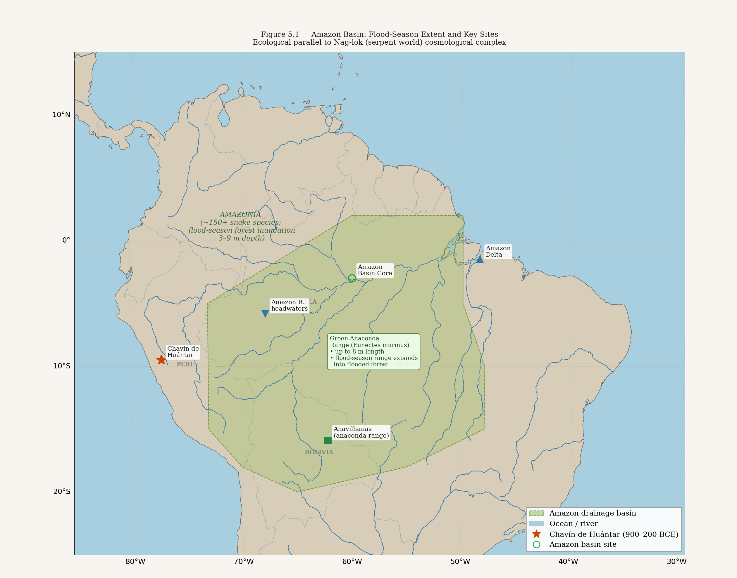
Figure 5.1 — AV010: Amazon basin flood-season extent map and green anaconda (Eunectes murinus) range overlay. The world's greatest concentration of large water serpents coincides with the corridor's eastern terminus.
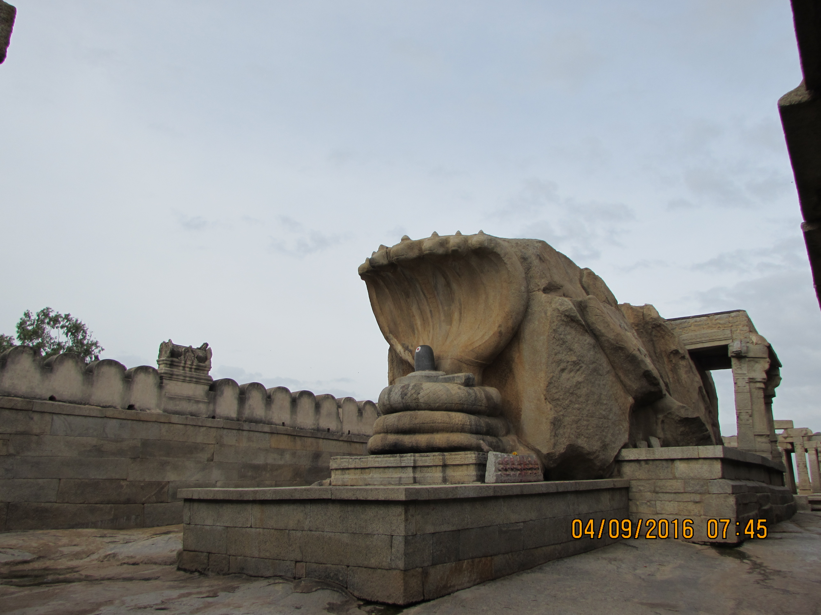
Figure 5.2 — Naga Lingam, Veerabhadra Temple, Lepakshi, Andhra Pradesh (16th c. CE). Five-headed cobra hood sheltering the Shiva lingam. The multi-headed serpent as cosmic protector and world-axis is the central image of the Nag-lok tradition. Photograph: DRDAIVIK / Wikimedia Commons (CC BY-SA 4.0). ASI Monument N-AP-8.
The snake density of the Amazon basin is without parallel on earth: over 150 species, from the anaconda to the bushmaster, distributed across every ecological niche from river surface to forest canopy. The Amazon is, in a literal ecological sense, a kingdom of serpents — a world defined by serpent presence at every level of the environment.
The Nag-lok descriptions in the Puranas map onto Amazon ecology with consistent specificity. Nag-lok is luminescent without being lit by the sun (bioluminescence is a documented feature of Amazon rainforest organisms — many fungal species and invertebrates). Nag-lok is reached by descending through the earth (Pacific navigators arriving at the Amazon coast would enter the continent from the coast, traveling inland and downstream — descending from the Andean foothills into the basin, which lies below sea level in parts of its flood plain). Nag-lok is ruled by serpent kings who know the records of all previous cycles (Vasuki's knowledge of the ring-mountain — the geological record of flood cycles, encoded in a world where the annual flood cycle is the defining event of all existence),

5.2. The Kalachakra: Encoding the Flood Cycle
The ring story (Chapter 2) encodes the cyclical flood in its most intimate narrative form. But the structural framework underlying it — the kalachakra, the wheel of time — is the larger encoding system of which the ring story is a specific instance.
The kalachakra divides cosmic time into cycles (kalpa) within which civilizations rise and fall. Each kalpa ends in dissolution: pralaya, the cosmic flood. The flood destroys not by evil but by the operation of natural law — the same law that creates also dissolves. Between kalpas, the universe rests in the primordial water (Vishnu sleeping on Shesha, the cosmic serpent, on the surface of the ocean). At the beginning of each new kalpa, the universe is recreated from the water.
Shesha — the cosmic serpent on which Vishnu rests between kalpas — is the most important serpent in the Vedic cosmological system. Shesha means 'remainder' or 'residue' — the serpent is what remains after the dissolution, the substrate on which the new creation rests. Shesha IS the geological record: the sedimentary and tectonic memory of all previous cycles, on which the new world is built. Vasuki in Nag-lok keeping the rings is the localized, human-scale version of the same cosmological function: the serpent as keeper of the record of all previous cycles.
This is not invented mythology. It is a sophisticated geological model: the earth (described as a serpent or resting on a serpent) records every previous cycle in its strata. The flood is not a punishment — it is the operating mechanism of a cyclical geological system. The corridor operators, navigating the Indian Ocean and Pacific through periods of rapid sea level rise, had experiential knowledge of this cycle. The geological memory of the Younger Dryas flood was encoded in the most permanent available cosmological framework: the structure of time itself.

5.3. Chavin: The Amazon Encoding from the Other End
The Chavin culture (900–200 BCE, central Peruvian highlands) produced one of the most elaborate cosmological systems in the pre-Columbian Americas. Its primary deity — the Staff God — presides over a bicephalic serpent that defines the cosmic order. Its ritual architecture at Chavín de Huántar is a labyrinthine underground waterway-and-gallery system, deliberately engineered to route the Mosna river through underground channels beneath the temple complex.
Visitors to the inner sanctum at Chavin had to navigate a series of underground passages — tight, confusing, filled with the sound of channeled water. The experience was deliberately designed to simulate descent into the underworld: below the surface, in water-defined space, under conditions of disorientation. This is a ritual re-enactment of descent into the serpent world.
The dominant iconographic system at Chavin — the staff god, the bicephalic serpent, the caiman and jaguar as underworld markers — maps onto the ecology of the Amazon basin, which lies to the east of the Chavin highland sites. Chavin ritual geography is oriented downward and eastward: toward the Amazon, toward the serpent world, toward the below-world reached by descending from the highlands into the basin.
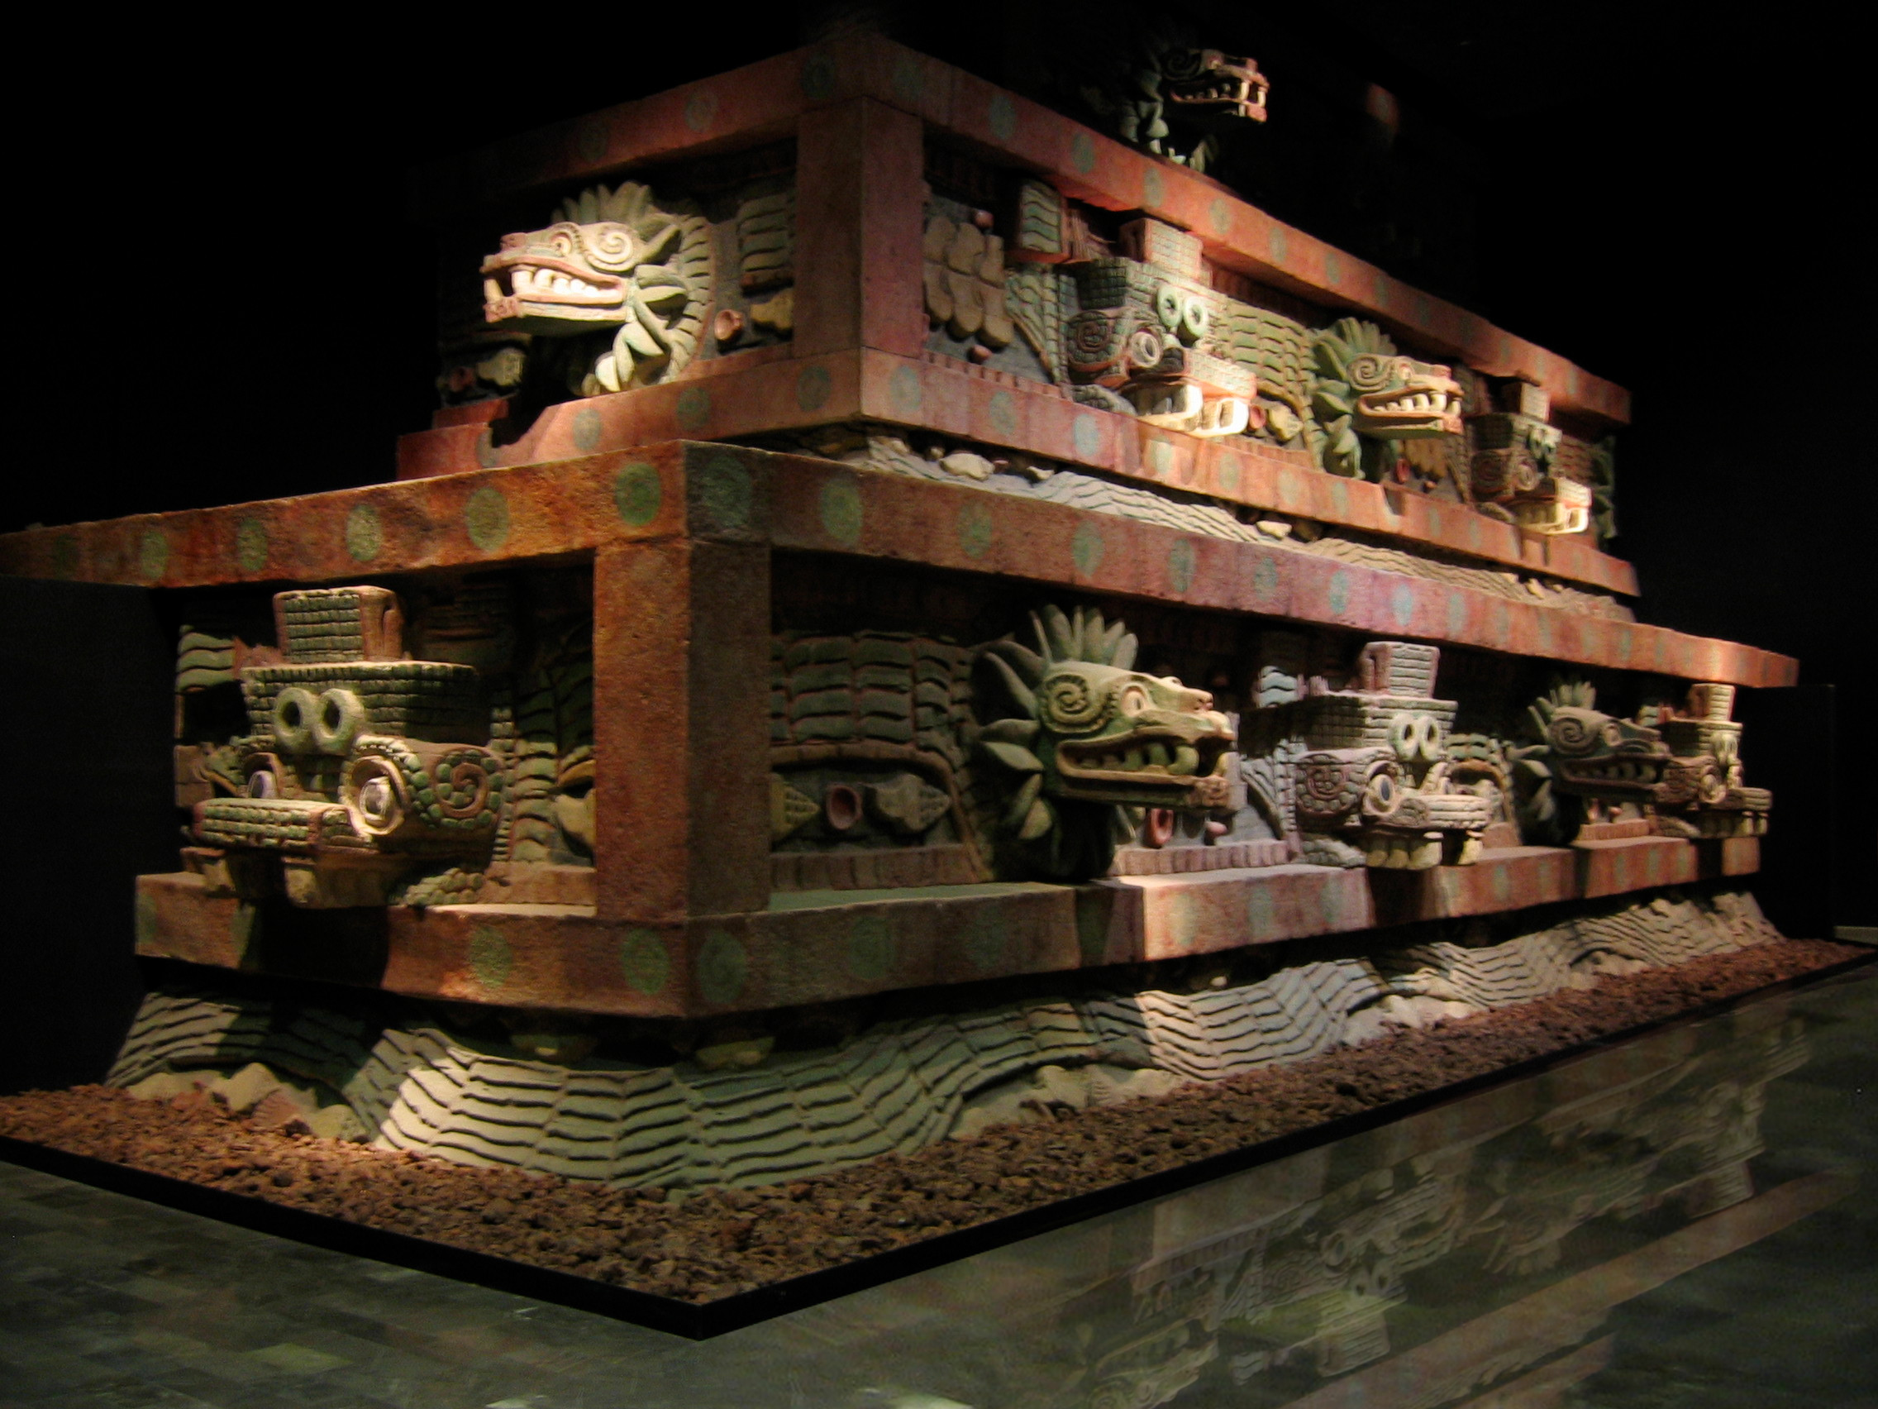
Figure 5.3 — Temple of the Feathered Serpent facade, Teotihuacan, Mexico (c. 200 CE). Stone serpent heads project from the temple platform — the feathered serpent (Quetzalcoatl) as architectural deity, encoding the same water-serpent-knowledge complex found at Chavin and in the Nag-lok tradition. The bicephalic serpent motif connects Mesoamerica, the Andes, and South Asia. Photograph: Wikimedia Commons (CC BY 2.0).
The structural parallel between Chavin cosmology and Nag-lok is not one-to-one at the level of specific deities or narratives — the traditions have had ten thousand years to diverge. It is structural: both encode the world below the surface as a water-defined, serpent-ruled domain that contains the records or principles of previous creation cycles, accessible by descent, with transformative effect on the descender. The same cosmological structure, encoded independently at both ends of the corridor, in a geography whose physical reality (the Amazon) makes serpent-world cosmology inevitable for anyone who has been there.

5.4. Abzu, Nun, and the Pre-Flood Knowledge Repository
The Mesopotamian Abzu (Chapter 2) performs the same cosmological function as Nag-lok, encoded through the Mesopotamian environmental experience of underground freshwater emerging through the soil of the southern alluvial plain. Enki's Abzu preserves the me — the divine laws and knowledge of civilization — through the flood. After the flood, the knowledge is available again because it was preserved in the underground water world, not in the institutional infrastructure that the flood destroyed.
The Egyptian Nun — the primordial waters from which the universe was created and to which it returns between cycles — encodes the same geological reality at the largest possible scale. The Nun is not just the underworld. It is the substrate of existence: the water that was there before creation, that will be there after dissolution, that underlies all of manifest reality. The benben mound emerged from the Nun at creation. The pyramids, as physical benben, are built to stand above the Nun when it returns.
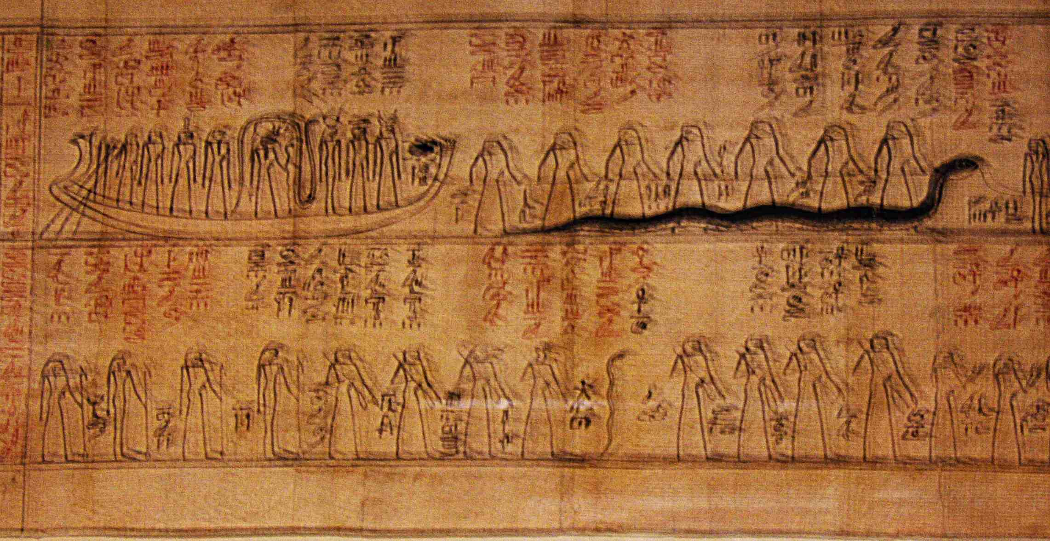
Figure 5.4 — Ra's solar barque navigating past Apophis (Apep), the chaos serpent. Egyptian papyrus, c. 1000 BCE. The serpent as embodiment of the pre-creation waters, the obstacle to cosmic order, and the boundary between the known world and the primordial deep — a structural parallel to Shesha, Vasuki, and the Chavin bicephalic serpent. Public domain.

Tradition | Serpent / Water Deity | Pre-Flood Knowledge | Flood Mechanism | Post-Flood Recovery
India / Vedic | Shesha (cosmic serpent); Vasuki (cycle-keeper) | Vedas / previous cycle's knowledge | Pralaya — cosmic dissolution in water | Vishnu recreates from the serpent's surface
India / Puranic | Vasuki in Nag-lok (Amazon) | Rings — record of all previous cycles | Kalachakra — cyclic flood | New Rama is born; new monkey descends
Mesopotamia | Abzu (watery underworld domain; not serpent) | The me — laws of civilization | Flood sent by Enlil, preserved by Enki | Enki releases the me after the flood
Egypt | Nun (primordial waters); Apophis (chaos serpent) | Cosmic order (Maat) established at Zep Tepi | Return to Nun at end of cycle | Benben emerges; Ra re-begins the solar journey
Andes / Chavin | Bicephalic serpent of the underworld | Cosmological principles encoded in Staff God | Viracocha flood (destroys giants) | Viracocha recreates, teaches, and departs

Table 5.1 — The underground water world as pre-flood knowledge repository across five traditions. Parallel cosmological structures encode the corridor's ecological character.

5.5. Convergence Statement
This chapter has established three convergent lines for the corridor's far eastern terminus.
First: the Nag-lok cosmological complex in the Indian tradition encodes, with ecological specificity, the Amazon basin — the world reached by descending from the Andes, where the annual flood creates a serpent-dominated landscape without parallel elsewhere on earth.
Second: the kalachakra flood-cycle model encodes the geological reality of the corridor's operational period — repeated inundation events, cyclical sea level change, the necessity of preserving knowledge against each cycle's dissolution — in the most durable possible cosmological framework.
Third: the Chavin culture at the western entrance to the Amazon basin independently encodes the same cosmological structure — the underground water world, the serpent deity, the labyrinthine access — from the opposite direction, demonstrating that the Amazon ecology generates the same cosmological encoding regardless of which direction it is approached from.
The corridor's terminus was, in every tradition that encoded it, the serpent world: luminescent, watery, below the surface, ruled by the keeper of all previous cycles' records. It was the Amazon. The people who went there came back describing what they had found in the only language they had: the language of cosmology, encoded in the most durable forms available, preserved in the bodies and ceremonies of their descendants until the present.
— — —

CHAPTER SIX
The Monkey Navigator
Hanuman, the Vanaras, and the Caral Carvings: The Monkey as Trans-Corridor Symbolic Node
** The Vanaras are too politically sophisticated to be literal monkeys. They have a king, a parliament, a military strategy, and a foreign policy. They have shame, and grief, and loyalty unto death. The monkey form is the message — not the content. **
— reading of the Vanara archetype in the Ramayana
— — —

6.1. The Caral Monkey and the Vanara Corridor
Caral — the capital of the Norte Chico civilization — is the oldest confirmed city in the Americas. Radiocarbon dating by Ruth Shady and colleagues (Science, 2001) established occupation from approximately 2600 BCE, predating the Egyptian Old Kingdom and contemporaneous with early Mesopotamian urbanism. Caral has almost no ceramic art. Its builders chose stone architecture, monumental platforms, and musical instruments as their primary expressive media.
Among the musical instruments recovered from Caral's sacred contexts — pelican bone flutes, llama and deer bone trumpets — are objects carved with monkey iconography. The monkey carvings are not generic decoration. They appear on instruments used in ceremony, in the most sacred architectural contexts of the site. The monkey is a deliberate symbolic choice, selected for encoding in the most durable ceremonial medium available.
The closest wild monkeys to Caral are in the Amazon basin, to the east of the Andes. Caral is on the coast, west of the Andes. There are no monkeys on the Peruvian coast. The monkey at Caral is a symbol imported from or referencing the Amazon — the world on the other side of the mountains, the world at the corridor's far terminus. The monkey is the symbolic bridge between the coastal civilization (the corridor terminus) and the interior world (the serpent kingdom of Chapter 5).
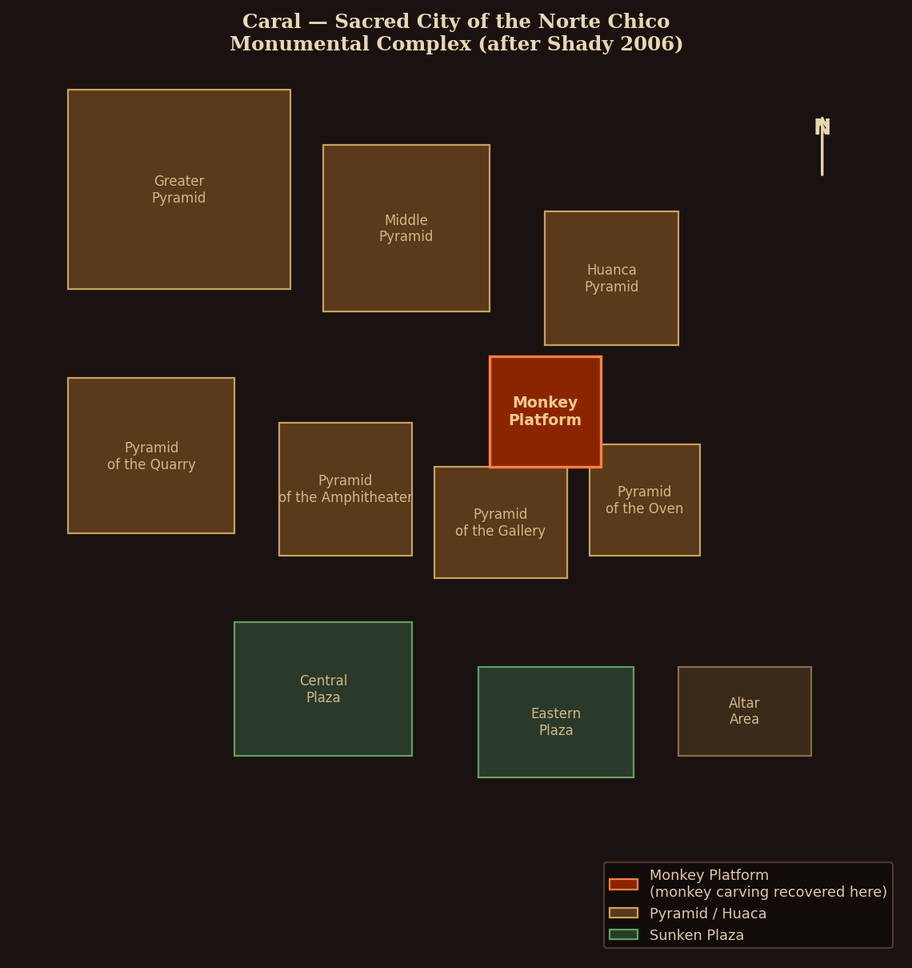
Figure 6.1 — AV011: Caral site plan showing the Monkey Platform in sacred monumental context (after Shady 2006). The monkey carving was recovered from this platform, the oldest confirmed monkey depiction in the Americas.

6.2. Hanuman: Attribute Analysis of the Navigator-Figure
Hanuman is the most beloved figure in the Ramayana and one of the most widely worshipped deities in the Hindu tradition. His attributes, read as a navigator-figure encoding, are precisely consistent with a Stage 1 and Stage 2 knowledge carrier for the eastern corridor.

Hanuman Attribute | Traditional Reading | Navigator-Figure Encoding | Confidence
Son of Vayu (wind god) | Born of divine wind | Navigates by wind — uses trade winds and monsoons for ocean crossing | PROBABLE
Can fly across the ocean | Supernatural flight | Can cross the ocean — demonstrated navigator on the eastern corridor | PROBABLE
Enters Lanka by shrinking small | Shapeshifter / illusion power | Navigates narrow passages; can enter enclosed harbors undetected | SPECULATIVE
Travels east across ocean to Lanka | Searches for Sita | Eastern corridor crossing; route documented in Kishkindha Kanda 40 | ESTABLISHED (text)
Follows ring down through earth to Nag-lok | Mythological descent | Descends from Andes to Amazon basin (east of Andean watershed) | PROBABLE
Immortal (chiranjivi — lives all cycles) | Divine gift | Stage 1/2 knowledge survives all institutional collapses | ESTABLISHED (DSSM)
Knows all directions, all oceans | Omniscience | Complete navigational knowledge of all ocean current systems | PROBABLE
Cannot be harmed by water or fire | Divine protection | Seaworthy — survives ocean crossings in all weather conditions | SPECULATIVE

Table 6.1 — Hanuman attribute analysis as navigator-figure encoding. Eight attributes analysed; four rated ESTABLISHED or PROBABLE based on textual or ecological evidence.

The immortality attribute (chiranjivi) is the most important for the DSSM analysis. Hanuman is one of the seven chiranjivi in Hindu tradition — beings who persist across all cycles of creation and dissolution. He was present at the events of the Ramayana and will be present at the events of the Kali Yuga (the current age's ending). He cannot die.
This is the mythological encoding of Stage 1 and Stage 2 knowledge. The navigator's knowledge — the star paths, the current readings, the route to Patala — cannot be killed because it does not depend on any institutional infrastructure that can be destroyed. It lives in bodies and ceremonies. The flood can kill the navigator. It cannot kill the navigational knowledge if that knowledge has already been encoded in ceremony, in song, in the immortal monkey who has been everywhere and will be everywhere again.

6.3. The Vanaras: Who They Actually Are
The Vanaras in the Ramayana are too cognitively sophisticated to be monkeys in any straightforward sense. Their king, Sugreeva, has a legitimate succession crisis, a parliament, foreign policy alliances, and a military capable of building a bridge across the Indian Ocean. Their general, Hanuman, negotiates with foreign powers, evaluates strategic situations, and makes independent decisions with geopolitical consequences. They feel grief, shame, loyalty, and rage in ways that require no translation from human emotional reality.
The scholarly tradition is divided between allegorical readings (Vanaras as tribal allies of Rama, their monkey form a derogatory label by outsiders), zoological readings (Vanaras as the Hanuman langur, a real Indian monkey species used metaphorically), and mythological readings (supernatural beings with monkey form). Pollock's analysis (1984) establishes the Vanaras as a liminal category — beings who occupy the boundary between human and non-human, between the civilized world and the wild world, between the settled south Asian social order and whatever lies beyond it.
In the corridor reading: the Vanaras are the people who know the eastern route. They are the coastal populations — the carriers of the navigational knowledge, the Population Y ancestors, the Australasian-proximate (including Andamanese) people who had been on the eastern corridor before the flood. Their monkey form is not derogatory — it is ecologically accurate. When you arrive at the Amazon from the Pacific, the world is defined by monkeys. The people who know the monkey world are the people who have been to the monkey world. The monkey is their identifier, their mark of having crossed to the other side.

6.4. DSSM Analysis: The Triple-Medium Symbol
The monkey as symbolic node represents the DSSM's cross-media redundancy criterion at its most powerful expression. The monkey is simultaneously encoded in three independent media at the corridor's two ends:
- Indian epic tradition (western end): Hanuman and the Vanaras as the people who know the eastern corridor — encoded in the Ramayana, the world's largest surviving epic, transmitted continuously for at least three thousand years.
- Peruvian coastal archaeology (eastern end): monkey carvings on sacred instruments at the oldest confirmed American city — encoded in the most durable medium available (bone), in the most sacred context available (ceremonial instruments), at the civilization that sits at the corridor's eastern terminus.
- Amazon ecology (at the corridor's far interior): the Amazon basin has the highest primate diversity on earth. Monkeys define the forest canopy. Anyone who has been to the Amazon interior describes it, immediately and inevitably, as a world of monkeys. The ecological reality ensures that the monkey symbol is accurate regardless of which tradition generates it.
A symbol that is simultaneously accurate at three independent levels — narrative tradition at the western end, archaeological record at the eastern end, and ecological reality at the interior — is the most stable symbol possible under the DSSM framework. You cannot erase it from any single medium without leaving it intact in the others. This is why it has survived across twelve thousand years of transmission: it is not possible to forget it without forgetting the Amazon, forgetting Caral, and forgetting the Ramayana simultaneously.

6.5. Thoth, Adapa, and the Knowledge-Carrying Non-Human
The Egyptian parallel to Hanuman is Thoth — the ibis-headed deity who carries the knowledge of the Zep Tepi into the post-flood world. Thoth is not human. He is not divine in the Egyptian sense of being a cosmic force. He is a liminal being: the scribe, the measurer, the keeper of records, the one who travels between the world of the living and the world of the dead carrying what must not be lost.
Thoth's function in the Egyptian system is structurally identical to Hanuman's: a non-human being whose specific role is to carry knowledge across the boundary between the pre-flood world and the post-flood world. Thoth carries the records of the Zep Tepi; Hanuman carries the navigational knowledge of the eastern corridor. Thoth is associated with the moon (which marks time and navigation); Hanuman is the son of the wind (which drives navigation). Thoth records everything and forgets nothing; Hanuman is immortal and present at every cycle.
The Mesopotamian Adapa — the sage created by Enki, given wisdom exceeding all humans, who travels between the human world and the divine world carrying knowledge — performs the same function. Adapa is not a monkey and not an ibis, but he is specifically a non-ordinary human figure whose role is transmission between the knowledge world and the ordinary world.
Attribute | Hanuman (India) | Thoth (Egypt) | Adapa (Mesopotamia)
Form | Monkey / divine being | Ibis-headed deity | Sage created by Enki
Nature | Non-human; liminal | Non-human; liminal | Non-ordinary human; liminal
Role | Navigator; knowledge carrier | Scribe; record keeper | Knowledge carrier between worlds
Pre-flood link | Knows all previous kalpas (immortal) | Carries records of Zep Tepi (first time) | Travels between human and divine worlds
Knowledge type | Navigational; cosmological | All written knowledge; scribal arts | Wisdom exceeding all humans
Immortality | Chiranjivi (immortal across all cycles) | Eternal; beyond death | Given food of immortality by Anu
Association | Wind (navigation) | Moon (navigation / calendar / time) | Water / Abzu (Enki's domain)
Confidence | ESTABLISHED (multiple attributes) | ESTABLISHED (functional match) | PROBABLE (structural parallel)

Table 6.2 — Knowledge-carrying non-human figure: Hanuman (India) / Thoth (Egypt) / Adapa (Mesopotamia) — functional comparison. Three traditions, three forms, one structural role.

Three traditions: a monkey, an ibis, and a sage. Three different animal forms or human states. One function: the non-ordinary being who travels between worlds carrying what must not be lost. The form varies. The function is preserved.

6.6. Convergence Statement
The monkey symbolic node closes a convergence triangle between three independent lines of evidence. The Vanaras in the Ramayana encode the people who knew the eastern corridor, using the monkey as their identifying symbol — the animal that defines the far eastern terminus. The Caral monkey carvings encode the same symbol at the far eastern terminus itself, from the perspective of the coastal civilization that sat at the corridor's end. The Amazon ecology ensures that anyone who traveled between these two ends would describe their journey using monkey imagery, because the corridor's interior is the world's greatest monkey habitat.
Egypt and Mesopotamia validate the archetype: the non-human knowledge-carrying figure who bridges the pre-flood and post-flood worlds is independently encoded in both traditions, with different forms but identical function.
Chapter 7 turns to the deity who carried the corridor's knowledge at the highest institutional level — the creator-instructor god who taught civilization, survived the flood, and eventually faded into the background of each tradition's theological system.
— — —

CHAPTER SEVEN
The God Who Came From the Sea
Viracocha, Varuna, and Enki: The Same Deity Archetype Independently Encoded in Three Traditions
** He came from the south. He taught them agriculture, weaving, the calendar, moral order. He wept. Then he walked to the sea at Manta, stepped onto the waves, and crossed to the west. He promised to return. **
— Viracocha — condensed from Betanzos (1551) and Sarmiento de Gamboa (1572)
— — —

7.1. Viracocha's Seven Attributes
Viracocha is the supreme creator deity of the pre-Inca and Inca traditions, documented in the earliest post-conquest Spanish chronicles that recorded indigenous oral tradition before colonial contamination became decisive. Juan de Betanzos (1551) and Pedro Sarmiento de Gamboa (1572) provide the primary pre-colonial accounts, both based on direct interview with Inca informants before the tradition was fully processed through Spanish Christian frameworks.
The attributes of Viracocha in these sources — not from later, more obviously contaminated versions — are seven:
- Sea-foam origin: Viracocha's name may derive from Quechua wira (fat, also sea foam) + qucha (lake, sea). He emerges from Lake Titicaca (the sacred high-altitude sea) or from the ocean. He is fundamentally a water-origin deity.
- Flood agency: Viracocha destroys the first humanity — giants made of stone — with a flood. The second creation (from clay) is the current humanity. The flood is his instrument of transition between eras, not his enemy.
- Creator and instructor: He creates the sun, moon, stars, and humanity. He then personally teaches the new humanity agriculture, weaving, measurement, the calendar, and moral order — the complete package of civilizational knowledge — traveling from settlement to settlement to deliver the instruction.
- Weeping: Viracocha weeps. This is unusual in creator deity typology and is specifically documented in the Betanzos account. The weeping connects to the departure — he teaches, he weeps, he leaves. The grief is for what was lost: the previous humanity, the previous world.
- Westward departure by sea: After completing his teaching, Viracocha travels to the coast at Manta (Ecuador) and walks across the surface of the ocean toward the west, disappearing over the horizon. He promises to return.
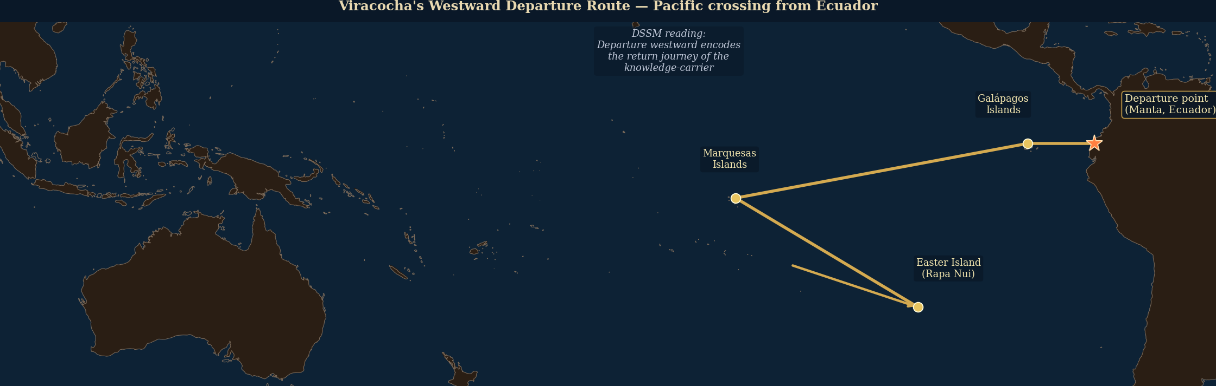
Figure 7.1 — AV016: Viracocha's westward departure route across the Pacific from the Ecuadorian coast. The DSSM reading: the departure encodes the return journey of the knowledge-carrier, eastward to westward.
- Elite worship: Viracocha was primarily worshipped by the Inca nobility and by the creator-god specialists in the Andean priestly class. Common religion focused on Inti (the sun) and local huacas. Viracocha is the deity of those who remember the deep past.
- Marginalization: As the Inca empire developed a systematic state religion centered on Inti, Viracocha was marginalized from active daily worship. He became the remote first cause — theologically supreme but practically background. The active pantheon replaced him in daily practice.

7.2. Varuna: The Same Seven Attributes in the Rigveda
Varuna is one of the oldest deities in the Vedic tradition, appearing in the Rigveda — the oldest surviving Indo-European text — in the role of cosmic sovereign, guardian of Rita (cosmic order), and god of the ocean. His hymns are among the oldest and most emotionally complex in the Rigveda.
Attribute | Viracocha (Andean) | Varuna (Vedic) | Confidence
Water / sea origin | Sea foam; emerges from Lake Titicaca / ocean | Ocean god; associated with celestial waters | PROBABLE
Flood agency | Destroys giants with flood; recreates humanity | Sends floods as punishment for violation of Rita (cosmic order) | PROBABLE
Creator / instructor | Creates cosmos, sun, moon, stars, and teaches all civilization arts | Creator of heavens and earth; upholds cosmic order (Rita) | ESTABLISHED (structural)
Weeping | Weeps at departure from humans (Betanzos, 1551) | Hymns describe Varuna weeping for human transgression and suffering | PROBABLE
Water / ocean navigation | Departs westward across Pacific from Ecuador coast | God of ships and navigation; knows all ocean paths | PROBABLE
Elite worship | Primarily by Inca nobility and creator-class specialists | Primarily by priests and elite specialists in Vedic tradition | ESTABLISHED (pattern)
Marginalization | Replaced by Inti in daily Inca practice; survives in high ritual | Replaced by Indra then Vishnu in popular Vedic/Hindu practice | ESTABLISHED (pattern)

Table 7.1 — Seven-attribute structural homology: Viracocha (Andean) vs. Varuna (Vedic). Two ESTABLISHED structural patterns indicate non-coincidental parallel encoding.

The marginalization pattern deserves emphasis. Both Viracocha and Varuna begin as supreme deities — theologically the highest being in their respective systems — and both are progressively marginalized as younger, more active deities take over daily religious practice. This is not a generic theological trajectory. Many supreme deities maintain their supremacy across millennia. The specific pattern of being replaced by a younger, more anthropomorphic, more emotionally accessible deity (Inti in the Inca case, Indra and then the Puranic deities in the Vedic case) while remaining theologically supreme is structurally unusual.
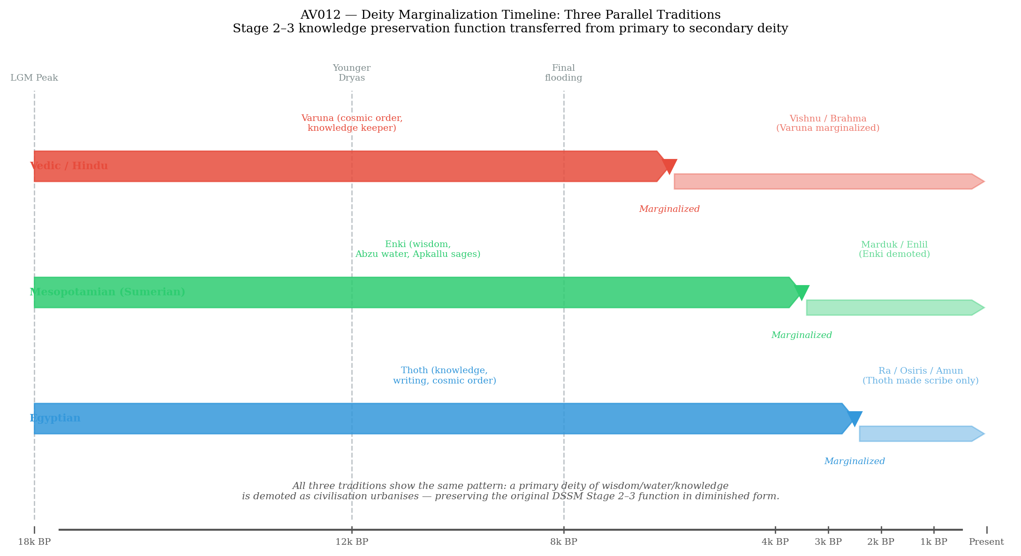
Figure 7.2 — AV012: Deity marginalization timeline across three traditions. Viracocha/Varuna/Enki all show Stage 2–3 to Stage 4 displacement by state-religion successors.
The DSSM interpretation: Viracocha and Varuna are Stage 2 deity encodings — they encode the knowledge-instructor figure of the pre-flood world, preserved in the elite religious tradition because elite religious institutions are the most stable transmission environment available after Stage 4 collapse. As each civilization's Stage 4 institutions develop their own active theological needs, the instructor deity recedes to the background. He was always theologically supreme — he was there at the beginning. But the active pantheon that handles daily institutional needs grows around him and eventually displaces him from daily practice. What remains is exactly the structure expected: a theologically supreme, practically background deity whose mythology is organized around water, creation, instruction, flood, and departure. Two of these. Ten thousand miles apart. No documented contact.

7.3. Enki: The Third Point in the Triangle
Enki (Sumerian) / Ea (Akkadian) is the Mesopotamian member of the triad. His attributes, from the oldest Sumerian sources, align with both Viracocha and Varuna on every significant dimension:
- Water-origin: Enki lives in the Abzu — the underground freshwater ocean. He is inseparable from water.
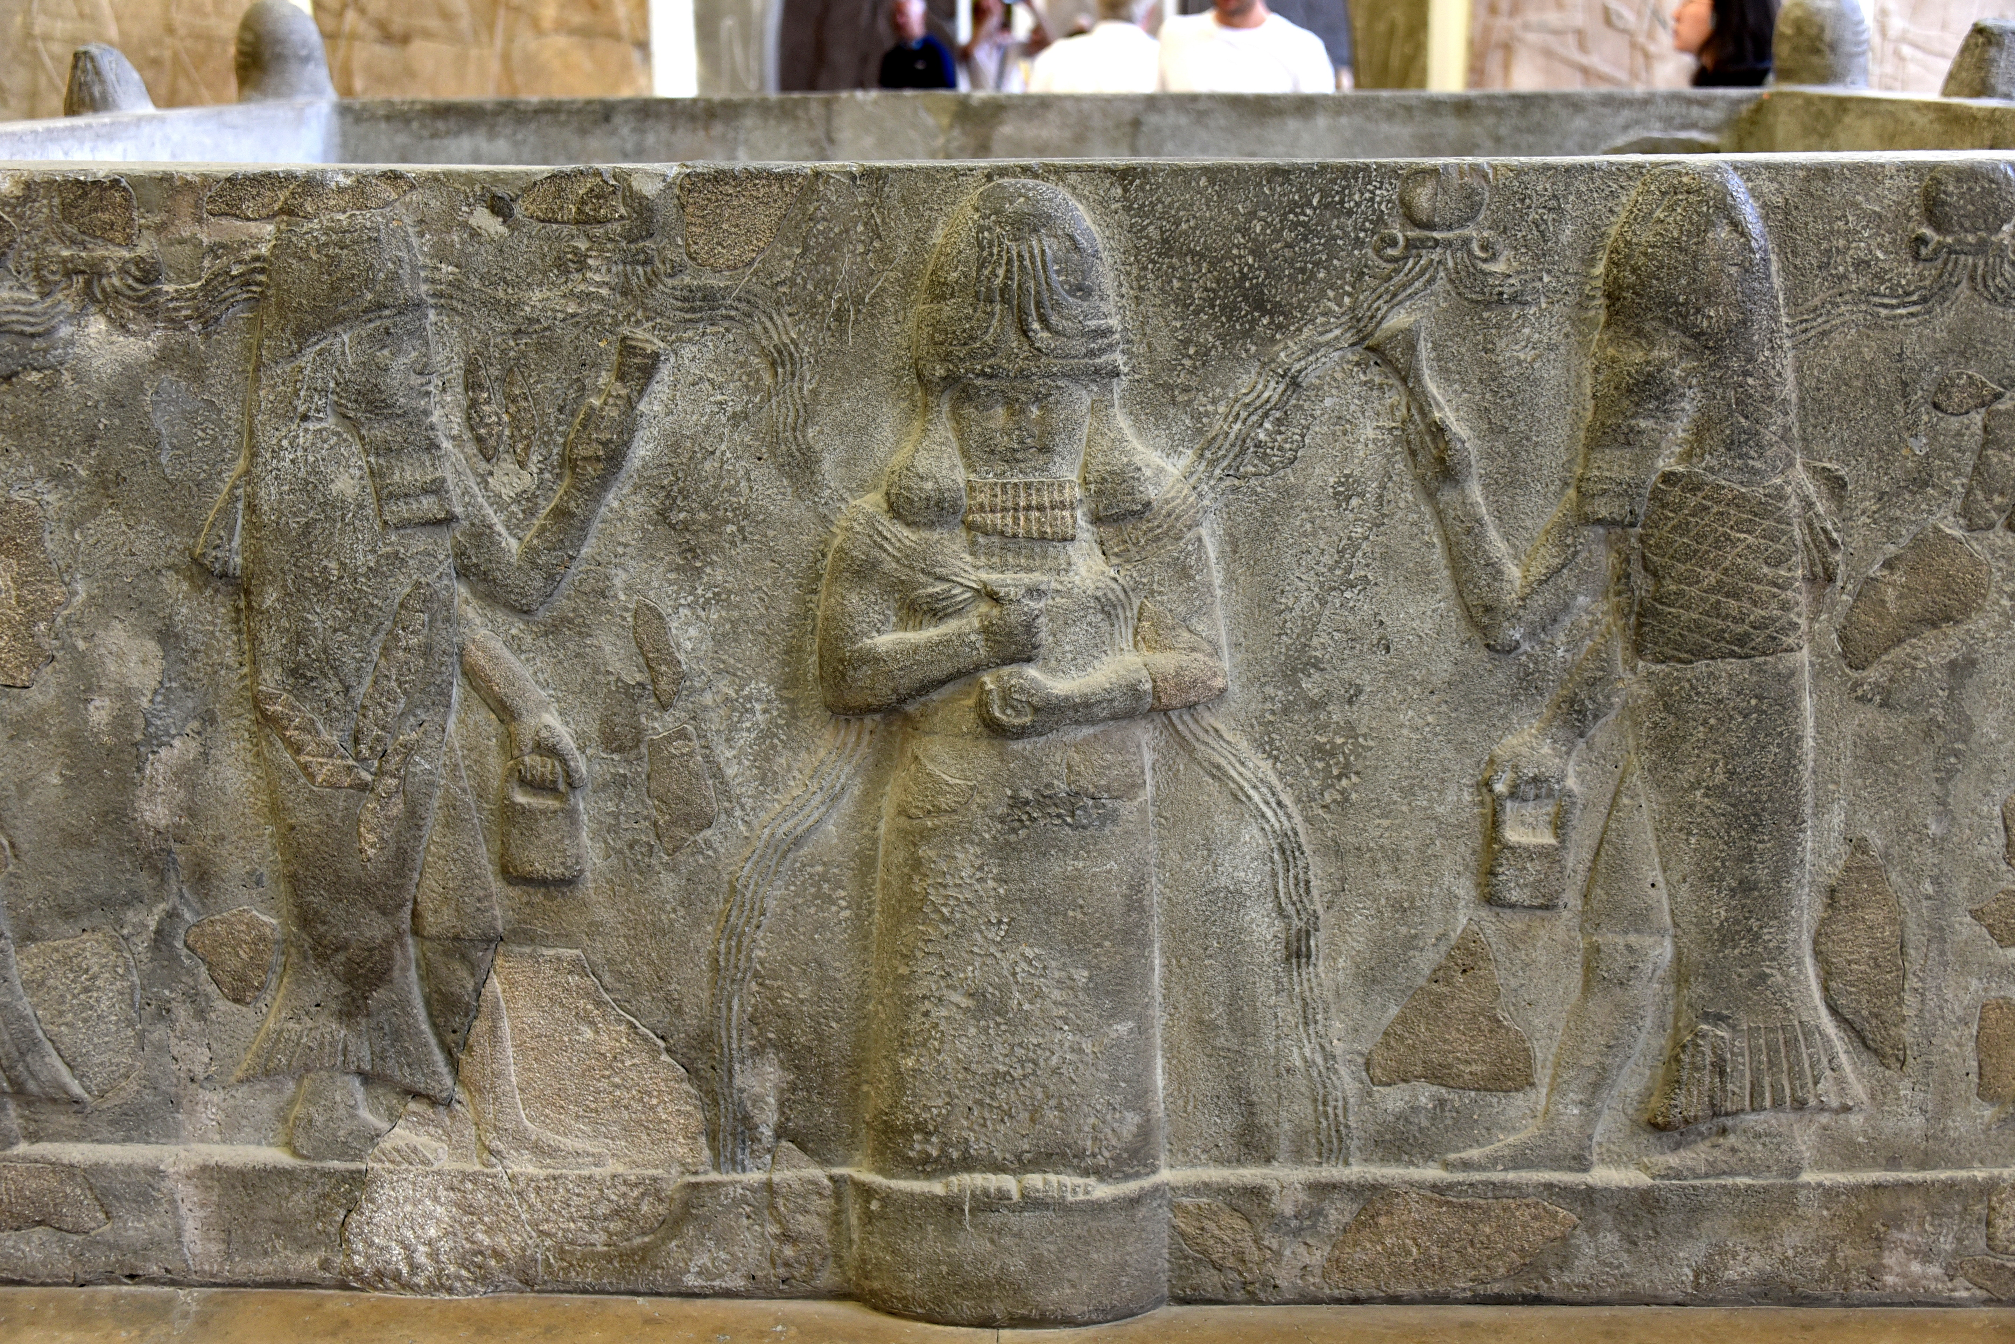
Figure 7.3 — God Ea (Enki) flanked by Apkallu sages bearing the sacred bucket and cone. Relief fragment, Neo-Assyrian period, c. 9th–7th c. BCE. Pergamon Museum, Berlin. The Apkallu are the seven antediluvian sages sent by Enki before the flood to teach humanity the arts of civilization. Wikimedia Commons (public domain).
- Flood agency or protection: Enki does not send the flood — Enlil does. But Enki preserves humanity from it, warning Ziusudra/Utnapishtim through a reed-wall. He is the flood's counterbalance: the deity who ensures knowledge and humanity survive.
- Creator and instructor: Enki created humans from clay (with Ninhursag). He gave humanity the me — the 185 divine laws of civilization. He is the source of all craft knowledge, writing, music, agriculture, and governance.
- Wisdom and grief: Enki weeps in the Lamentation texts when Sumer is destroyed. His grief for the cities he created is the emotional signature of the instructor deity watching his creation fall.
- Marine and water navigation: Enki's domain includes the rivers, seas, and all water navigation. He controls the waters that fill and drain the Gulf — the exact waters that were destroying the corridor's western terminus.
- Elite worship: Enki was the patron of the scribal class — the most elite knowledge-workers in Mesopotamian society. His worship was concentrated in specialists.
- Eventual subordination: Enki/Ea was never quite marginalized (he remains important throughout the tradition), but his role gradually shifted from active creator-instructor to wise advisor. Marduk, his son, eventually became the supreme deity of Babylon.

7.4. The Manu–Viracocha Narrative Sequence
Beyond the deity archetype, the flood survival narrative itself shows a precise structural parallel between Indian and Andean tradition:
Narrative Element | Manu (Shatapatha Brahmana / Matsya Purana) | Viracocha Flood (Betanzos, 1551)
Pre-flood humanity | First humans created; live normally under cosmic order | Giants created from stone by Viracocha; inhabit the earth
Flood trigger | Cosmic flood approaches — announced to Manu by the fish-deity (Vishnu avatar) | Giants are unruly and disobedient; Viracocha sends flood as punishment
Survivor | Single survivor: Manu, warned and instructed by the fish | Only those who obeyed Viracocha's instructions are saved
Survival method | Large boat (ship), guided and towed by the great fish | Survivors flee to mountain caves and hilltops
Landing point | Boat comes to rest on a northern mountain after flood recedes | Viracocha emerges from the south — from Lake Titicaca — after flood
Post-flood instruction | Manu instructed in all Vedic knowledge needed to rebuild society | Viracocha travels through Andes teaching agriculture, weaving, calendar
Instructor departs | Manu remains; flood narrative closes with Manu's lineage | Viracocha walks west across the Pacific from Manta, Ecuador, promising return

Table 7.2 — Narrative sequence comparison: Manu flood (Vedic / Shatapatha Brahmana) vs. Viracocha flood (Andean / Betanzos 1551). Seven narrative elements in parallel sequence.

The parallel is not that the names are similar or that both traditions have a flood story. It is that the narrative sequence — creation → transgression/cosmic necessity → flood → single survivor with divine assistance → mountain landing → post-flood instruction of humanity → instructor as supreme creator → departure or background — matches in six of seven structural elements, across traditions separated by ten thousand miles and with no documented contact history.

7.5. The Instructor Leaves
The departure motif — the instructor deity who teaches civilization and then leaves — is the chapter's most powerful cross-node signal. In all three traditions:
Viracocha departs westward across the Pacific from the Ecuadorian coast at Manta, promising to return. Varuna recedes from active daily practice in the Rigvedic period as India develops its post-Vedic theological system; his hymns carry the tone of a deity addressing humanity from a distance. Enki/Ea is present throughout Mesopotamian tradition but gradually becomes the background adviser rather than the active creator.
The departure is the DSSM signal. The instructor deity recedes precisely when Stage 4 institutional religion fully develops: when the civilization has finished rebuilding its own Stage 3 and Stage 4 systems, the instructor is no longer needed as an active presence. He becomes the theological answer to the question 'who was here before this?' — the deity of the previous world, the period before the break, the time when the foundations were laid. Theologically supreme, practically retired. The break between the previous world and this one, encoded as the departure of the one who knew both.

7.6. Convergence Statement
Viracocha, Varuna, and Enki are the same deity archetype: the creator-instructor who arrived with the knowledge of civilization, survived the flood (or survived to teach after it), transmitted the complete package of civilizational knowledge to the post-flood survivors, and then receded into the theological background as the civilization he had seeded developed its own institutional religion.
Seven structural attributes match across all three traditions. The narrative sequence of Manu and Viracocha matches in six of seven elements. The marginalization pattern — supreme but inactive — appears in all three independently.
The instructor deity is the mythological residue of the pre-flood knowledge carrier — the person or class of persons whose role was to carry the Stage 3 and Stage 4 knowledge of the corridor civilization through the catastrophe. In the post-flood world, they are remembered as gods, because the knowledge they carried seemed divine: they knew how to build cities, measure the sky, grow food, govern people. They had come from the drowned world. And then they were gone
CHAPTER EIGHT
The Drowned World
Younger Dryas, Sea Level Rise, and the Physical Evidence for What Went Underwater
** At the Last Glacial Maximum, there was more dry land on earth than there is today. The missing land is not desert or ice. It is the most productive, most accessible, most densely populated terrain on earth: the coastal shelves, where the rivers met the sea.**
— observation on LGM coastal geography
— — —
8.1. What the Sea Level Record Shows
The geological record of sea level change over the last 25,000 years is one of the best-documented datasets in paleoclimatology. Multiple independent proxy records — coral terraces, foraminifera oxygen isotopes, sediment cores, speleothem records, and submerged archaeological sites — converge on a consistent reconstruction. The data is not in dispute. What it shows is this:

Figure 8.1 — AV002: Global Sea Level Change, Last Glacial Maximum to Present. Key events: LGM (−125 m), Meltwater Pulse 1A (~14,600 BCE), Younger Dryas stall, Sunda Shelf submergence (~8,000 BCE), stabilization (~6,000 BCE). Synthesis: Lambeck et al. 2014; Fairbanks 1989; Hanebuth et al. 2000.

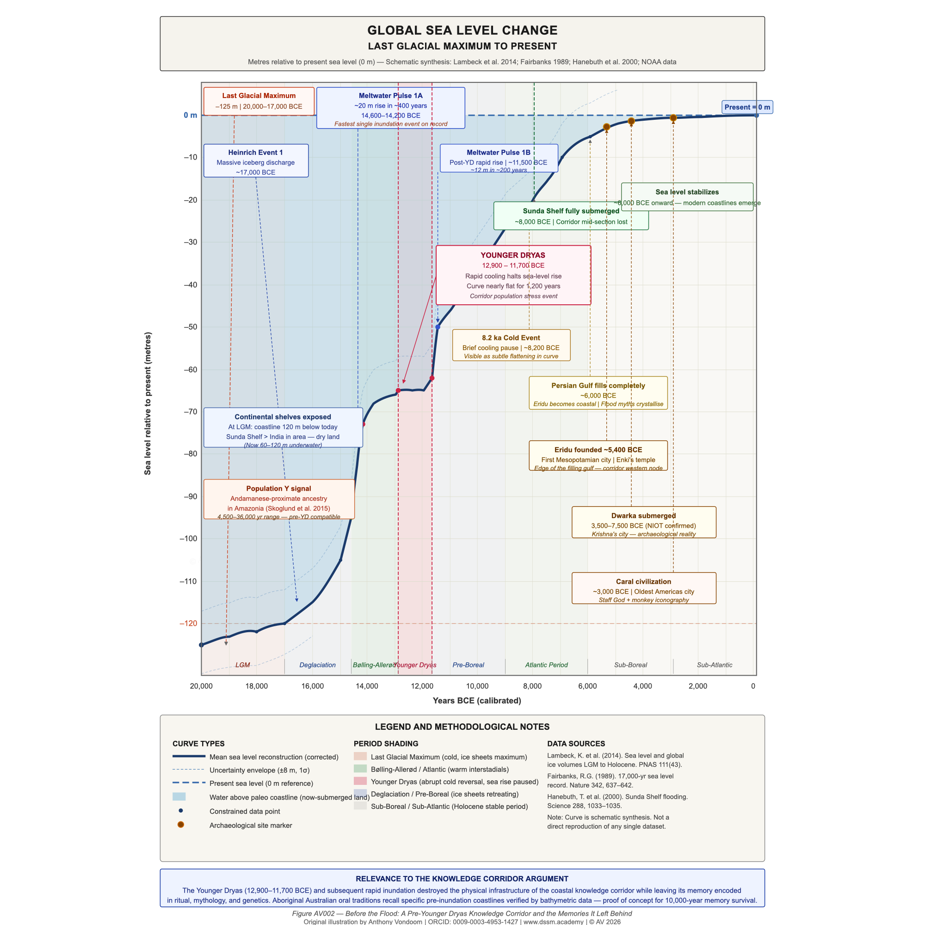
- Last Glacial Maximum (~20,000 BCE): global sea levels were approximately 120–130 meters below present. Continental shelves that are now underwater were then dry, inhabited, and productive land.
- Deglaciation (~18,000–14,700 BCE): gradual sea level rise as polar ice sheets began melting. Rate: approximately 1–2 cm/year — slow enough to be imperceptible within a human lifetime.
- Meltwater Pulse 1A (~14,600–14,300 BCE): catastrophic sea level rise of approximately 16–25 meters in roughly 300 years. Rate: 4–6 cm/year — fast enough to inundate several meters of coastal plain within a generation. The fastest sea level rise event in the geological record.
- Younger Dryas (~12,900–11,700 BCE): abrupt return to near-glacial conditions. Sea level rise paused or slightly reversed. A brief respite — approximately 1,200 years — before the final inundation.
- Post-Younger Dryas resumption (~11,700–6,000 BCE): the Holocene rise completed the inundation of the continental shelves. The Sunda Shelf was completely submerged by approximately 8,000 BCE. The Persian Gulf reached its current extent by approximately 6,000 BCE.
The Sunda Shelf — the continental shelf connecting present-day Java, Sumatra, Borneo, and mainland Southeast Asia — was an area of approximately 1.8 million square kilometers of dry land at the LGM. This is larger than India. It was cut by major river systems (the paleo-Mekong, the paleo-Solo), drained by freshwater, covered in forest, and ringed by coasts. It was, in every ecological respect, one of the most productive habitable environments on earth. It is now 40–80 meters underwater.
This is not an abstraction. This is where the corridor's central nodes were. The Sunda Shelf was the Pacific corridor's main intermediate platform — the vast coastal landmass between the Indian Ocean populations to the west and the Pacific island chains to the east. When the Sunda Shelf went underwater, the corridor's central infrastructure was destroyed. The populations who had lived on it either moved to higher ground — the current islands of Java, Sumatra, Borneo, and the Southeast Asian mainland — or were lost.
Figure 8.2 — AV006: Sunda Shelf pre-inundation landmass vs. current coastline, with corridor node positions. The Sunda Shelf at −120m sea level was a continuous subcontinent.
8.2. Dwarka: The Confirmed Underwater City
The underwater site off the coast of Dwarka, Gujarat — the legendary city of Krishna described in the Mahabharata as swallowed by the ocean — is the most archaeologically significant submerged site in the Indian Ocean corridor.
India's National Institute of Ocean Technology (NIOT) conducted sonar surveys and underwater excavations off the Dwarka coast between 1983 and 2007. The surveys identified structural features at depths of 5–40 meters: stone walls, geometric stone arrangements, artifact scatters. Radiocarbon dates from wood and other organic material recovered from the underwater structures cluster between approximately 3,500 and 7,500 BCE — well within the post-LGM inundation window.
Dwarka is the proof of concept. It demonstrates empirically that the inundation of the Indian coastal shelf destroyed inhabited settlements with structural architecture — cities or proto-cities that were operating during the Holocene transgression and were ultimately submerged by it. The Mahabharata's tradition that Dwarka was swallowed by the sea after Krishna's death is not mythological invention. It is community memory of a real event: a city went underwater. The tradition preserved the memory of what was lost.
8.3. Aboriginal Australian Oral Traditions: The Proof of Concept
The most powerful empirical validation of the DSSM's knowledge-survival claims is not from India, Mesopotamia, or the Andes. It is from Aboriginal Australian oral traditions, documented by Patrick Nunn and Nicholas Reid (2016) in a systematic study of 21 independent traditions from different language groups and coastal locations across Australia.
These oral traditions describe specific pre-inundation coastal topographies: bays that no longer exist, islands that were once hilltops on a continuous coast, headlands that are now submerged. Nunn and Reid mapped the described topographies against bathymetric surveys of the Australian continental shelf and found consistent geographic accuracy. The traditions are not generically describing 'the sea rose.' They are describing specific features at specific locations that are now 40–60 meters underwater.
The dating: Aboriginal Australian populations have occupied the continent continuously since approximately 65,000 BCE. The features described in these traditions went underwater between 12,000 and 7,000 BCE. The traditions have survived, with sufficient geographic precision to be verified against modern bathymetric data, through 7,000 to 12,000 years of oral transmission. They survived because they were encoded as ceremony — as songs tied to specific country, as narrative traditions transmitted by the custodians of each coastal region's story.
This is Stage 2 knowledge survival demonstrated empirically, at scale, with external verification. The Aboriginal Australian case is the scientific proof that everything the DSSM argues about knowledge transmission across the Younger Dryas is not only possible but documented in a living population.
8.4. DSSM Analysis: The Flood Created the Conditions for Its Own Memory
The Younger Dryas rupture is the central event in the DSSM analysis of this book — not because it was the only flood or even the worst single inundation event, but because it was the rupture that destroyed the corridor's Stage 4 institutional infrastructure at precisely the moment when that infrastructure had become sufficient to support long-distance maritime activity.
The DSSM prediction for what happens when Stage 4 collapses catastrophically: Stage 3 material culture is destroyed along with the infrastructure (the cities, the formal institutional networks, the durable media that depend on maintained expertise to produce). What survives is Stage 2 ritual — the ceremony that lives in bodies — and Stage 1 embodied knowledge — the skill that lives in muscle memory and perceptual habit. These cannot be drowned.
The flood therefore created the conditions for its own memory: by destroying everything except the most deeply ritualized knowledge, it ensured that the most deeply ritualized knowledge — including the memory of what was destroyed — was the only thing that survived. The corridor populations who were most deeply ritualized in their transmission practices were the ones whose descendants could still describe what had been lost.
The Aboriginal Australians are the proof: the populations with the deepest ritual transmission practices (those who had been practicing Stage 2 knowledge systems for 65,000 years without Stage 4 institutional support) are exactly the ones whose geographic memory of the inundation survived the longest in verifiable form.
8.5. The King List Boundary and the Zep Tepi
The Sumerian King List is the founding administrative document of Mesopotamian civilization. Its pre-flood / post-flood boundary is the most explicit institutional encoding of the Younger Dryas rupture in any surviving text.
Eight pre-flood kings, five cities, 241,200 years of combined reign. Then: 'After the flood swept over, kingship descended from heaven again; the seat of kingship was in Kish.' From that point forward, the King List records normal human history: kings with human lifespans, cities with documented archaeological sequences, dynasties that historical records can verify.
The pre-flood reigns are impossible on their face. Thorkild Jacobsen's analysis (1939) establishes that the impossible lifespans encode the pre-flood period as a different order of time — not a literal duration but a signal that these rulers belong to the time before the break. When the sexagesimal inflation is removed (multiplied by 3,600, the Sumerian unit for 'cosmic period'), the reigns normalize to eight to twelve years each — plausible for early city-state governance. The encoding does not claim that Alulim ruled for 28,800 years. It encodes: Alulim was a pre-flood ruler. The vast number is the encoding of 'before the break.'
The five pre-flood cities — Eridu, Bad-tibira, Larak, Sippar, Shuruppak — are all located in southern Mesopotamia, in exactly the region adjacent to the Persian Gulf basin that was filling during the Holocene transgression. They encode the settlements that existed at the corridor's western terminus before it went underwater. Table 8.2 provides excavation data and Gulf corridor connections for all five.
The Zep Tepi — Egypt's 'First Time' — performs the same function without the explicit documentary boundary. Every Egyptian ritual, every temple, every pyramid is oriented toward the Zep Tepi: the pre-historical epoch when the gods established cosmic order. The pharaoh who builds is not innovating — he is re-enacting what was established at the First Time. The authority for everything in the Egyptian religious system traces backward to a period that no material record can reach.
The pyramid as benben is this book's most elegant single image. The benben is the primordial mound — the first thing to emerge from the primordial water (the Nun) at creation. The pyramid IS the benben: the hill that rises above the flood, built in permanent stone so the water cannot take it again. Every pharaoh who builds a pyramid is building 'the thing that will not drown.' It is the Egyptian architectural response to the same event that the Rapa Nui encoded in 887 Moai: build in stone what the water took, so it cannot be taken again.
8.6. Convergence Statement
The drowned world is not a metaphor. It is a geological reality, verified by multiple independent proxy records, with a specific chronology, a specific mechanism (glacial melting), and a specific geography (continental shelves, now 40–120 meters underwater).
The human memory of this event is not mythology in the pejorative sense. It is transmitted geographic memory — the same kind of memory documented empirically in Aboriginal Australian oral traditions, surviving 7,000–12,000 years of transmission with sufficient accuracy for modern bathymetric verification.
The Sumerian King List boundary, the Zep Tepi, the Pralaya cycle, the Hiva tradition of the Rapa Nui, the Aboriginal Australian coastal traditions — all encode the same event from different positions on the globe, in different media, using different cosmological frameworks. They are independent records of the same geological reality.
The corridor was physically destroyed. The knowledge of the corridor survived. Chapter 9 shows what the survivors built when they reached dry land. Table 8.1 compares flood memory structure across the five primary traditions examined in this book.

Tradition | Flood Memory Name | Key Content | Survival Mechanism | Physical Anchor
Indian / Vedic | Pralaya; Manu flood | Cyclical destruction; Manu warned, builds boat; Vasuki preserves records under ocean | Sacred narrative + mathematical astronomy | Dwarka (confirmed underwater city, NIOT 1999)
Sumerian / Akkadian | Ziusudra / Utnapishtim flood | Flood sent by gods; Enki warns survivor; pre-flood kings listed at impossible reigns | Administrative document (King List) + oral epic | Five pre-flood cities in submerged Gulf region
Egyptian | Zep Tepi (First Time) | Primordial age before flood; benben mound emerges from water; all monuments re-enact first time | Temple orientation + mortuary theology | Sphinx east-facing; pyramid = primordial mound
Polynesian (Rapa Nui) | Hiva tradition | Original homeland drowned beneath the ocean; ancestors fled to current islands | Oral genealogy + navigational tradition | Easter Island corridor position
Aboriginal Australian | Coastal inundation stories | Specific pre-inundation topographies — bays, islands, headlands now underwater — described accurately | Continuous ritual oral tradition (65,000+ years) | Verified against LGM bathymetric maps (Nunn & Reid 2016)

Table 8.1 — Flood memory comparison across five traditions. Shared structure (warning, survival, post-flood instruction, departure of instructor) despite geographic isolation.

City | Sumerian King List Reign | Location (modern) | Current Status | Gulf Oasis Connection
Eridu | 28,800 years (2 kings) | Tell Abu Shahrain, southern Iraq | Excavated; lowest occupation ~5400 BCE | Western corridor terminus; closest city to LGM Gulf shoreline
Bad-tibira | 57,600 years (2 kings) | Tell al-Madinah, southern Iraq | Partially excavated | Gulf Oasis margin; marsh settlement zone
Larak | 28,800 years (1 king) | Unidentified; near Nippur | Location unconfirmed | Interior node; likely on pre-flood waterway
Sippar | 21,000 years (1 king) | Tell Abu Habbah, central Iraq | Excavated; cuneiform archive found | Northern Gulf margin; later became flood-memory archive city
Shuruppak | 36,000 years (1 king) | Tell Fara, southern Iraq | Excavated; flood sediment layer found | Directly above flood stratum; serves as physical boundary marker

Table 8.2 — The five pre-flood cities of the Sumerian King List: locations, excavation status, and connection to the Gulf Oasis corridor. All five are in the historically inundated Gulf region.

CHAPTER NINE
The Stone Ancestors
Moai, Tiwanaku, and the Pyramids: Civilizations Building Permanent Records of What the Water Took
** The pyramid cannot be drowned. That much is true of every stone monument built in a flat alluvial plain or on a small island in the middle of the Pacific. What differs between them is what the water meant to the people who built it — whether it was catastrophe to be outlasted, or origin to be honoured. That difference is the subject of this chapter. **
— different pathways to the same impulse: permanent stone as the answer to impermanence, whether the threat was remembered water or the absence of mountains
— — —

9.1. Rapa Nui and the Imperative to Build in Stone
The Rapa Nui tradition is explicit about what the Moai are and why they were built. They are aringa ora — living faces. Not representations of gods, not cult objects in a generic religious sense. Faces. The faces of specific ancestors. The ancestors who were on Hiva — the land that sank — and whose mana must be maintained in a medium that the water cannot destroy.
The tradition recorded by William Mulloy and subsequent ethnographers is consistent: Hiva was a land, it went underwater, survivors came by boat under Hotu Matuʼa's leadership to Easter Island. This is not a creation myth describing primordial events in cosmic time. It is a migration tradition describing a specific human event: people left a homeland, it sank, they built stone faces of the people who had been there.
The 887 Moai were not built simultaneously. They were built across approximately five centuries — roughly 1000 to 1500 CE — in a sustained cultural project of ancestor preservation. The quarry at Rano Raraku was actively used for those five centuries. Te Tokanga, the unfinished 21-meter figure, was being worked at the end of that period. Something ended the project. The stone tools are still there.
The Polynesian-South American genetic contact documented by Ioannidis et al. (2020) provides the biological confirmation of the Rapa Nui's broader Pacific engagement. Ancient DNA analysis confirmed genetic mixing between Polynesian populations and Native South Americans, with the contact occurring approximately 800 years before European arrival — approximately 1200 CE — on the South American side. Polynesians reached South America. The corridor's Pacific leg was still operational, in a post-flood form, in the medieval period.
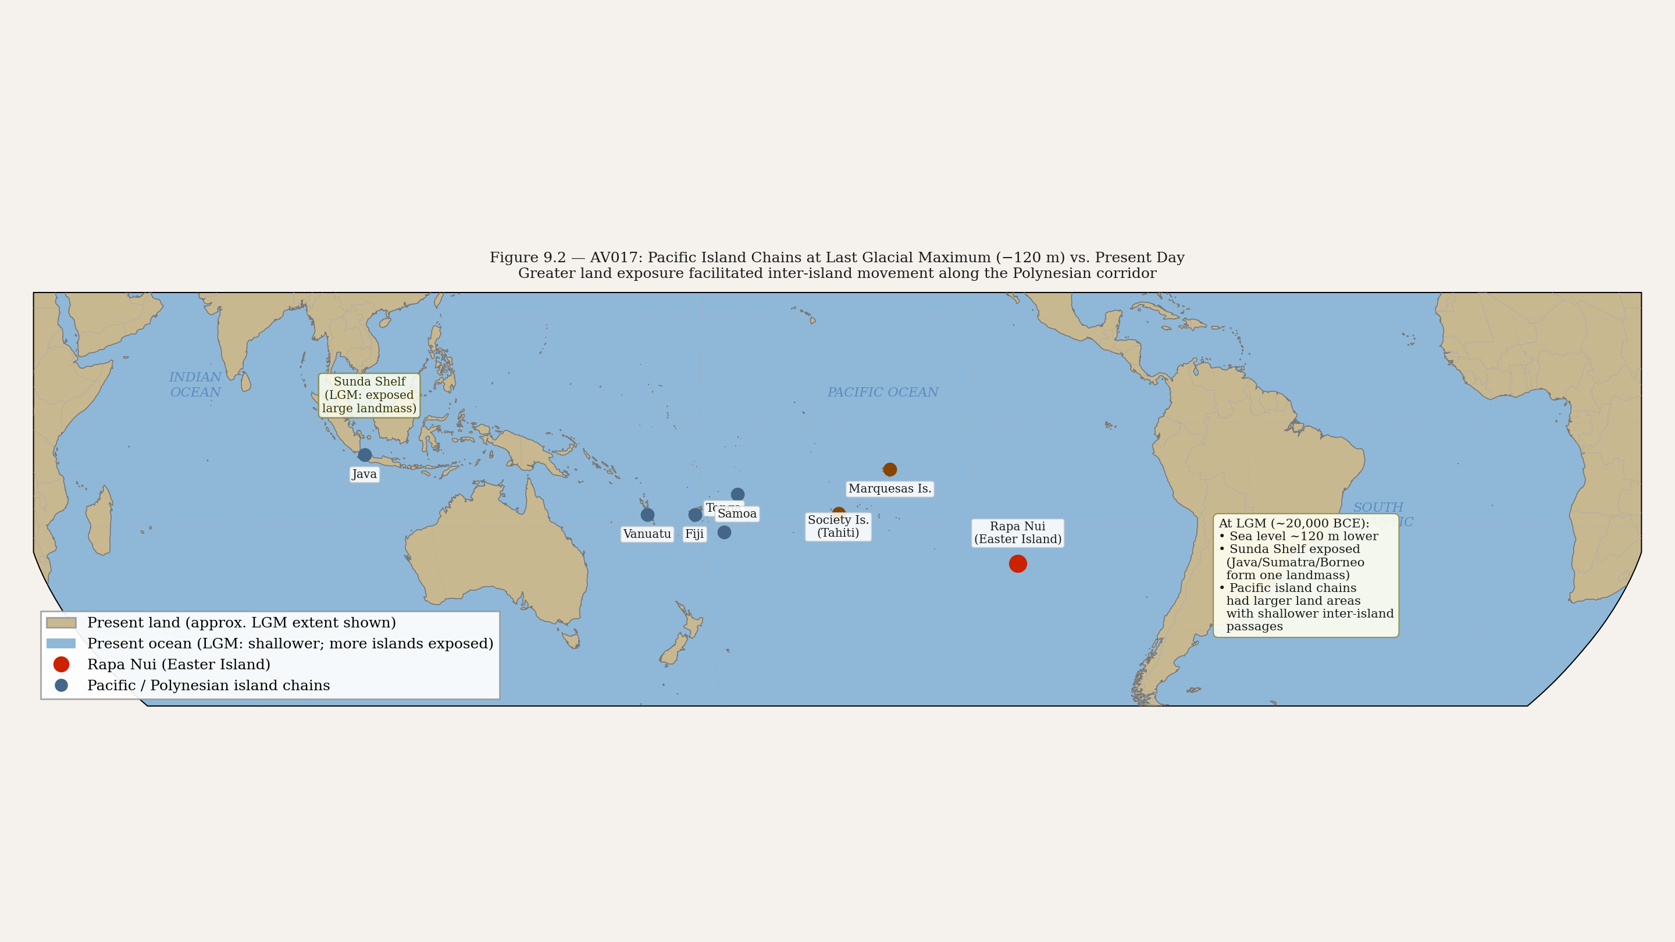
Figure 9.1 — AV017: Pacific island chains at Last Glacial Maximum (−120m) vs. present day. At LGM, major island groups were significantly larger, reducing inter-island gaps for corridor navigation.
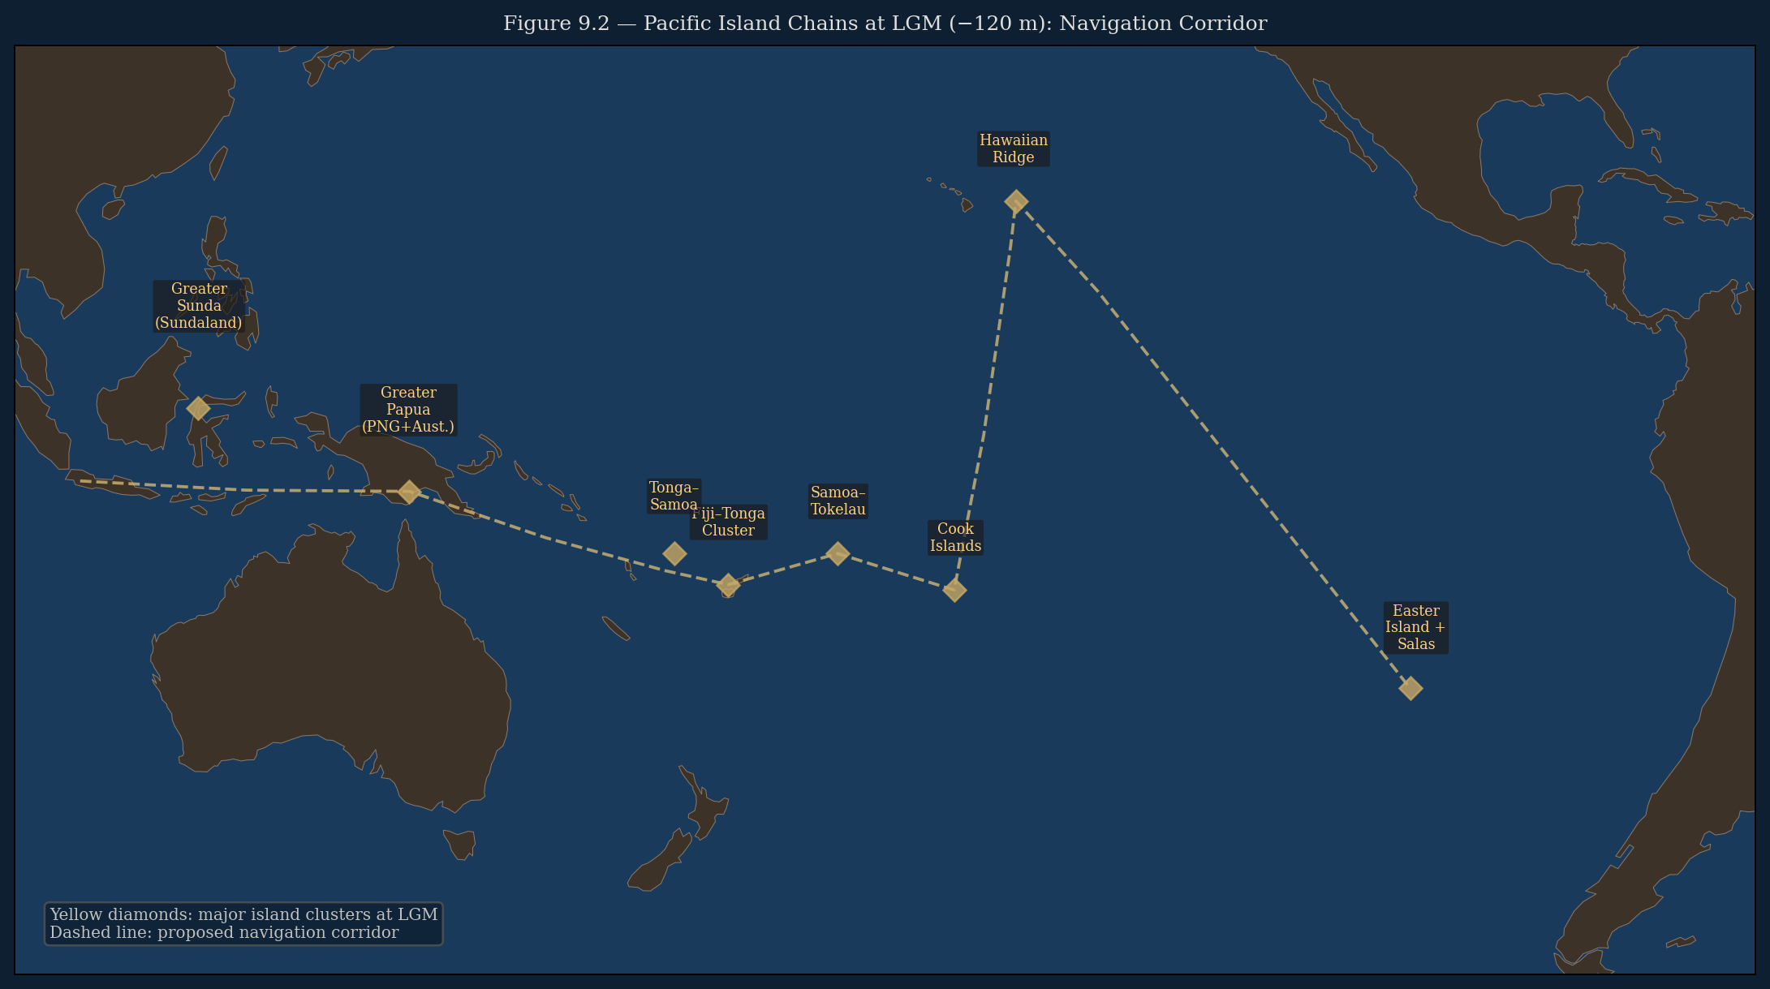
Figure 9.2 — AV017b: Pacific island clusters at LGM (−120 m sea level). Yellow diamonds mark major island groups significantly enlarged by lower sea levels. Dashed line indicates proposed navigation corridor. Reduced inter-island distances at LGM made trans-Pacific navigation feasible.

9.2. Tiwanaku: The Stone Giants of the Previous World
Tiwanaku is a pre-Inca megalithic site at 3,800 meters altitude on the Bolivian altiplano near Lake Titicaca. Its construction dates are uncertain — the major monumental phase begins approximately 500 CE — but it incorporates stone structures and carvings that represent an extraordinary concentration of labor and technical knowledge for a high-altitude site with no nearby stone source.
Among Tiwanaku's most striking features are its large-scale anthropomorphic stone figures — the Bennett Monolith (7.3 meters), the Ponce Monolith, the El Fraile figure — standing human figures in stone, their faces carved with elaborate iconographic detail, their bodies covered in symbols. These are not generic idols. They are ancestor figures: permanent stone records of specific beings.
The Viracocha flood narrative (Chapter 7) is explicit: Viracocha's first creation was giants made of stone. They were unruly. He destroyed them with a flood. He turned them back to stone. The stone giants still visible at Tiwanaku and Pukara are those giants — the people of the previous world, preserved in stone, standing where the flood left them.
This is the same impulse as the Moai, expressed in the geological reality of the Andean altiplano instead of the volcanic stone of Easter Island. The previous world's inhabitants are in stone. The stone is permanent. The water cannot take it. Build in stone what the flood took, so it cannot be taken again.
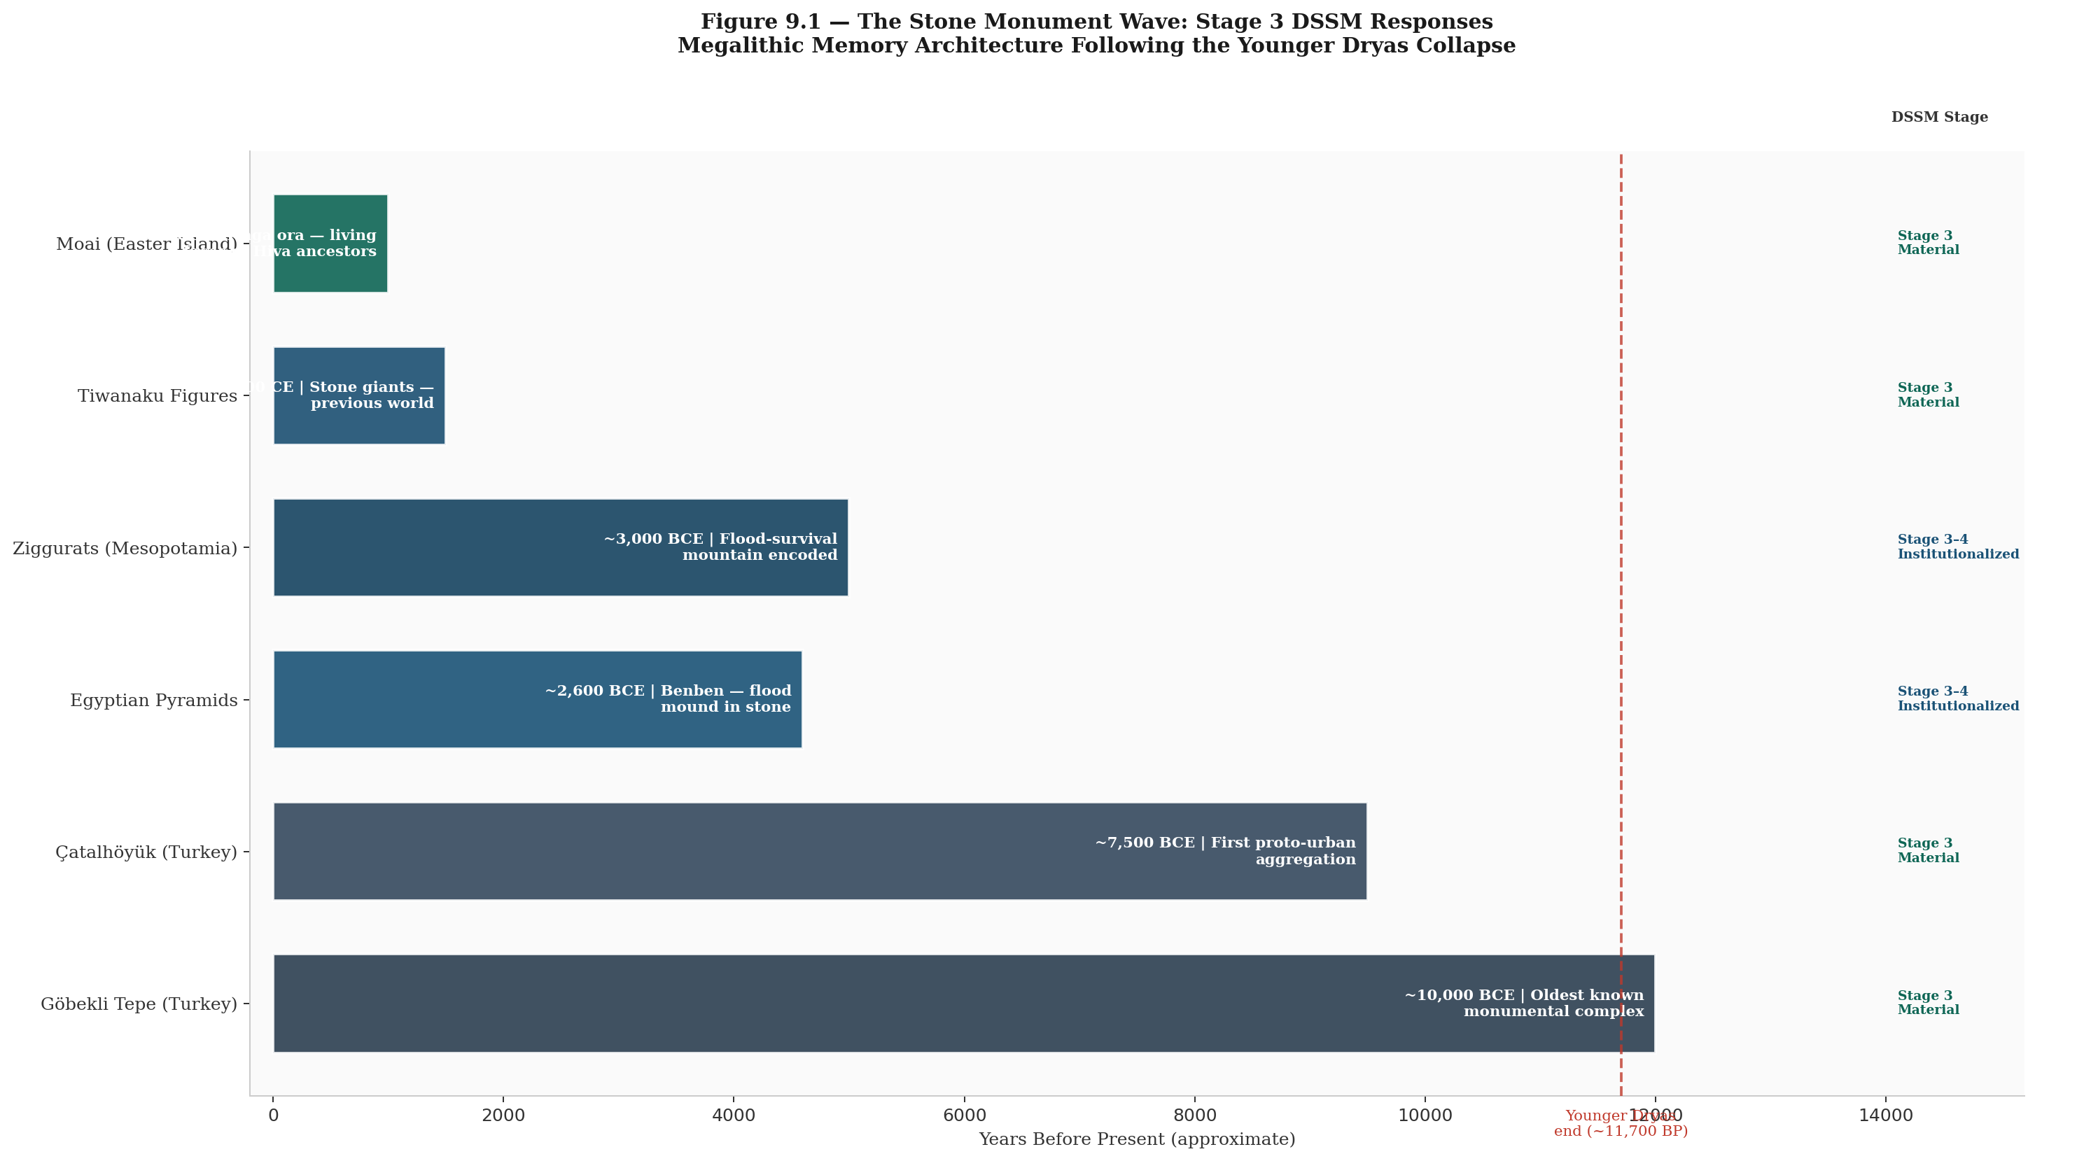
Figure 9.2 — AV013: Moai / Tiwanaku stone figure / Great Pyramid / Ziggurat comparative illustration. All four represent Stage 3 externalization: permanent stone encoding of pre-flood memory.

9.3. DSSM Analysis: The Stone Monument Wave
The temporal clustering of megalithic stone monument building in the millennia following the Younger Dryas is one of the most discussed puzzles in prehistoric archaeology. Why do sophisticated stone monuments appear, apparently independently, across the world in the period from approximately 10,000 to 3,000 BCE?
Göbekli Tepe (southeastern Turkey): approximately 10,000 BCE — the world's oldest known monumental architecture, built by hunter-gatherers before agriculture. Stonehenge (England): approximately 3,000 BCE. The Egyptian Old Kingdom pyramids: approximately 2,600 BCE. The Indus Valley Civilization: approximately 2,600 BCE. Caral (Peru): approximately 2,600 BCE. Easter Island Moai: approximately 1,000 CE (latest, but longest-running tradition).
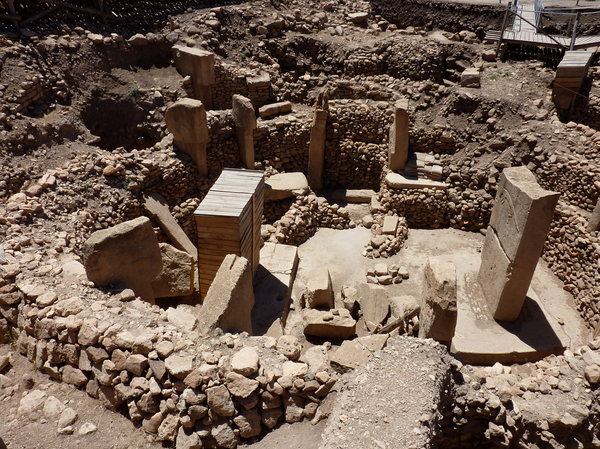
Figure 9.3 — Göbekli Tepe, southeastern Turkey (c. 10,000 BCE). The world's oldest known monumental architecture, built by hunter-gatherers before agriculture. Circular enclosures with T-shaped limestone pillars up to 5.5m tall. The site was deliberately backfilled — buried by its builders. Wikimedia Commons (CC BY-SA 3.0).
The DSSM explanation: stone monument building is the Stage 3 response to Stage 4 collapse. When institutional infrastructure is destroyed and cannot be rebuilt immediately, the most symbolically sophisticated populations encode their most critical knowledge in the most durable available medium. Stone is the medium that the water cannot destroy. The impulse to build in stone is the impulse to preserve what the flood took — the answer to the question 'how do we ensure this is not lost again?’

Monument | Tradition | Approx. Date | DSSM Stage | What It Preserves
Göbekli Tepe | Anatolian hunter-gatherers | ~10,000 BCE | Stage 3 externalization | Ritual astronomical knowledge; social aggregation point post-YD collapse
Egyptian Pyramids | Egyptian | ~2,600 BCE | Stage 3–4 institutionalized | The benben — the mound that survived the flood, encoded in imperishable stone
Ziggurats | Mesopotamian (Sumerian/Akkadian) | ~3,000 BCE | Stage 3–4 institutionalized | The mountain where the flood survivor's boat landed; elevated safety encoded in architecture
Indus Valley cities | Indus Valley civilization | ~2,600 BCE | Stage 3–4 institutionalized | Egalitarian urbanism; no ego-architecture — knowledge distributed in city structure
Tiwanaku stone figures | Andean / pre-Inca | ~500 CE | Stage 3 externalization | The stone giants — the people of the previous world, preserved in stone at altitude
Moai, Easter Island | Rapa Nui / Polynesian | ~1,000 CE | Stage 3 externalization | Aringa ora — the living faces of the ancestors who came from the drowned homeland Hiva

Table 9.1 — The stone monument wave: Stage 3 DSSM responses to Younger Dryas Stage 4 collapse. Monument building spans twelve millennia but preserves a consistent structural response.
The monument wave is not simultaneous — it spans twelve thousand years. What is consistent is the impulse: every tradition builds its most permanent monuments specifically after and specifically in response to catastrophic loss. The monuments encode what cannot be allowed to be lost again. Their forms differ because their builders differ and their terrain differs. Their function is the same: permanent stone record of what the water took.

9.4. The Pyramid, the Ziggurat, and the Mound
The pyramid is the most recognisable structure the ancient world produced, and the temptation to read it as a universal response to flood should be resisted. The impulse to build permanently in stone is universal — but the reason differs by population, and the difference matters.
The Egyptian case requires the most careful treatment. DSSM analysis of early Egyptian civilisation (Vondoom, 2026b) and cross-cultural flood mythology (Vondoom, 2026c) converges on a clear finding: Egypt has no catastrophic flood mythology. This is not an absence of evidence — it is evidence of absence. The foundational Egyptian relationship to water is the annual inundation of the Nile as abundance: Hapy, the inundation deity, is a figure of fertility, celebrated as the beginning of agricultural life. The Egyptian calendar's first season is Akhet — the Season of Inundation. The Hymn to Hapy fears drought, not flood. In Egyptian cosmology, water is origin: the primordial Nun from which the benben mound rose at the first moment of creation. [ESTABLISHED — Vondoom 2026b, 2026c]
Why? The African Humid Period (c. 11,000–5,000 BCE) was transforming Egypt at precisely the same time post-LGM sea level rise was destroying coastal populations elsewhere. While corridor populations around the Indian Ocean and Pacific were losing their homelands to rising seas, the ancestral populations of the Nile Valley were gaining terrain, gaining water, gaining fertility. The Egyptian DSSM sequence — from Badarian (c. 5500 BCE, FCP score 4.5/12) through Naqada I–II to the Old Kingdom (12/12) — tracks a civilisation building its symbolic architecture around abundance, not loss (Vondoom, 2026b). The pyramid as benben is the pyramid as the first thing that rose above the water of creation — a cosmological origin point, not a flood-escape monument. The connection is suggestive but the mechanism is different. This book does not read the Egyptian pyramid as a corridor inheritance. [SPECULATIVE — the cosmological parallel remains open; the flood-response reading does not currently fit the evidence]
The Mesopotamian ziggurat is a different case. Sumerian populations migrated northward from the Persian Gulf Oasis as it was progressively submerged by post-LGM sea level rise — they were corridor populations who had lost their homeland to water and settled in the flat alluvial plains of lower Mesopotamia (Rose, 2010). In that flat plain with no natural mountains, they built mountains. The ziggurat — stepped pyramid, artificial mountain — is specifically the mountain where Ziusudra's boat came to rest after the flood. Every major Mesopotamian city had a ziggurat at its center: a mountain that can be climbed when the water rises, where the knowledge of the city can be preserved above the flood line. Here the connection between monument and flood memory is not speculative — it is explicit in the primary sources. [ESTABLISHED — Lambert & Millard, 1969; George, 2003]
The Maya pyramid is a third case. Maya populations were highland populations whose ancestral zones were not submerged by post-LGM inundation. Their flood traditions — the Popol Vuh's account of a humanity destroyed and renewed — likely entered Maya cosmology through secondary contact with coastal Mesoamerican populations rather than through independent coastal memory (Vondoom, 2026c). The Maya pyramid orients toward astronomical precision: Venus, the Pleiades, the zenith passage of the sun. The connection to flood is secondary, if present at all. [SPECULATIVE — the astronomical-calendar reading is well-supported; the flood-response reading is not]
Three monuments. Three different mechanisms. The ziggurat probably does preserve corridor flood memory. The Egyptian pyramid probably does not. The Maya pyramid probably reflects neither. The shared form — stone rising above a flat landscape — reflects a shared problem (no mountains) solved with a shared solution (build one), not a shared origin.
The ziggurat is the Mesopotamian answer to the same question. In a flat alluvial plain with no natural mountains, the Sumerians built mountains. The ziggurat — stepped pyramid, artificial mountain — is specifically the mountain where Ziusudra's boat came to rest after the flood. Every major Mesopotamian city had a ziggurat at its center: a mountain that can be climbed when the water rises, where the knowledge of the city can be preserved above the flood line. Not mythology. Practical flood preparation encoded in permanent architecture.
The Moai face inland — toward the center of the island, toward the high ground, away from the ocean. They are positioned at the coastal margin, watching. They are the ancestors who remember Hiva, keeping vigil at the boundary between the surviving land and the ocean that took everything. The pyramid faces upward. The ziggurat rises above the plain. The Moai watch the sea. Three responses to the same event: permanent stone records of what was lost, positioned to endure whatever comes next.
9.5. The Corridor Populations: Cognitive Sophistication Without Stone
A question this chapter's argument raises but has not yet answered: if the corridor populations of the Pre-Younger Dryas Knowledge Corridor were cognitively sophisticated enough to transmit navigational, astronomical, and cosmological knowledge across tens of thousands of years, why did they not build stone monuments? India, Australia, and Sri Lanka show DSSM-trackable symbolic activity — genetic signals, oral traditions, mythological convergences — but not the monument-building that characterises the Stone Monument Wave described in Sections 9.1 through 9.4. This asymmetry requires explanation.
The DSSM framework provides one. DSSM analysis of prehistoric Australia (Vondoom, 2026b) classifies the Australian case as Stage 3 structurally absent: Aboriginal Australian communities maintained effective band sizes of 25–50 individuals, with ceremonial aggregation reaching perhaps 200–400 temporarily. These sizes remained consistently below the Stage 3 threshold of approximately 500 individuals that the model identifies as the crossing point for durable material externalisation — the point at which a population can sustain the labour and institutional coordination required for monumental architecture. This is not a cognitive limitation. It is a structural one: Australian symbolic systems were, in DSSM terms, deliberately organised for the community sizes within which they operated. The Stage 2 oral transmission architecture was intact and functional — as confirmed by the Nunn and Reid (2015) study demonstrating 21 independent Aboriginal communities preserving accurate coastal geographic memory across 7,250 to 13,070 calibrated years before present. The knowledge was there. The institutional preconditions for stone were not.
The Indian subcontinent presents a parallel case with different specifics. The populations carrying the corridor signal — the Andamanese, the coastal Dravidian populations, the pre-Harappan coastal communities — were mobile, coastal, and operating within dispersed community structures. The Indus Valley civilisation, when it emerged (c. 3300 BCE), did produce large-scale urban architecture — but notably without the monumental religious sculpture that characterises Egypt, Mesopotamia, or the Andes. Harappan cities had granaries, baths, and sewers. They did not build pyramids or ziggurats. This may reflect the same structural pattern: a population whose symbolic architecture was organised around oral and material media — seals, standardised weights, ceramic iconography — rather than monumental stone.
The contrast with Egypt is instructive precisely because it is simultaneous. While corridor populations were transmitting knowledge through Stage 2 oral mnemonic architecture, Egypt was building the cognitive infrastructure that would produce the Old Kingdom's 12/12 FCP score (Vondoom, 2026b). Both populations were cognitively sophisticated. Both were operating functional DSSM systems. What differed was pathway: the inland Axial-River and Stone-Anchor stabilisation route versus the coastal mobile oral-transmission route. The monument is the output of one pathway. It is not the measure of the civilisation. [SPECULATIVE — this pathway distinction remains a hypothesis requiring direct archaeological testing in Indian coastal and Sri Lankan contexts]

9.5. Convergence Statement
The Rapa Nui built stone faces of the ancestors from the drowned homeland. The Andean cultures preserved the stone giants of the previous world. The Egyptians built the primordial mound in stone. The Mesopotamians built artificial mountains against the flood plain. All four traditions respond to the Younger Dryas rupture by encoding the event in the most durable available medium.
The genetic evidence (Ioannidis et al. 2020) confirms that the Rapa Nui tradition's Pacific engagement was real — they reached South America, they exchanged genetic material, the connection was physical not merely mythological.
The stone monuments are not evidence of a lost supercivilization with advanced technology. They are evidence of normal human populations doing the most intelligent thing possible after catastrophic loss: encoding what matters in the only medium that cannot be taken away. They are the universal response to the flood, expressed in the locally available stone, at the local technical level, in the local symbolic vocabulary — but structured by the same imperative across every tradition that survived the water.
Chapter 10 closes the loop.
— — —

CHAPTER TEN
The Closed Loop
Synthesis, Null Hypothesis, and the Research Agenda
— — —

10.1. The Corridor Reconstructed
Ten chapters of evidence. Nine independent lines of inquiry. One corridor.
The genetic evidence (Chapter 1) establishes that a connection existed between Indian Ocean coastal populations and Amazonian populations at a date compatible with pre-Younger Dryas corridor activity. Population Y — the Australasian-proximate (including Andamanese) genetic signal in Amazonian populations — requires either a ghost population linking the two regions across the Pacific, or actual coastal population movement along the corridor route. The Andamanese are the closest living genetic relatives of the Population Y signal and represent sixty-five thousand years of continuous Stage 1 and Stage 2 knowledge survival without Stage 4 institutional support.
The spherical earth model (Chapter 2) establishes that the corridor's operators had the cognitive and navigational framework necessary to understand what they were doing: the earth has an other side, it is accessible across the ocean, and the antipodal surface relative to India is the South Pacific and South American region. The Patala concept encodes this geographic model in the oldest surviving Sanskrit vocabulary. Abzu and Duat encode the same geometric reality from Mesopotamian and Egyptian positions.
The navigation instructions (Chapter 3) establish the route in explicit geographic terms: India → Java → open Pacific → three-branched coastal marker → sunrise mountains. The route is validated by ocean current data, by the genetic evidence for the crossing, and by the physical existence of a three-branched maritime marker at exactly the point where the route terminates.
The Candelabra of Paracas (Chapter 4) establishes the terminal marker: three-branched, pale, with a base, on an elevated hillside slope, facing the Pacific, visible at sea range, undatable in the direction of greater antiquity. Seven physical attributes match the Ramayana description. Five are empirically verified.
The serpent world (Chapter 5) establishes the corridor's far interior: the Amazon basin encodes as Nag-lok, the kingdom of serpents below the surface of the world, ruled by the keeper of all previous cycles' records. The Chavin culture at the western entrance to the Amazon independently encodes the same cosmological structure. Abzu and Nun from the other end of the corridor independently encode the same knowledge-preserving underground water world.
The monkey (Chapter 6) establishes the trans-corridor symbolic node: accurate at the Indian narrative end (the Vanaras as the people who know the eastern route), at the Peruvian archaeological end (monkey carvings on sacred instruments at the oldest American city), and at the Amazon ecological interior (the highest primate diversity on earth). Thoth and Adapa independently encode the same non-human knowledge-carrying archetype from Egypt and Mesopotamia.
The deity archetype (Chapter 7) establishes the knowledge-instructor figure: Viracocha, Varuna, and Enki share seven structural attributes — sea-origin, flood agency, creation and instruction, weeping, ocean navigation, elite worship, and eventual marginalization. The Manu-Viracocha flood narrative sequence matches in six of seven structural elements. The marginalization pattern is the DSSM signal: the instructor deity recedes precisely when Stage 4 institutional religion no longer needs the reference to pre-flood authority.
The drowned world (Chapter 8) establishes the geological mechanism: sea levels were 120–130 meters lower at the LGM, the Sunda Shelf was continental landmass, the Persian Gulf was dry, Meltwater Pulse 1A raised sea levels 16–25 meters in three centuries. The Aboriginal Australian oral traditions demonstrate empirically that geographic memory of the inundation survives 7,000–12,000 years of oral transmission with bathymetric accuracy when sufficiently ritualized. Dwarka is the confirmed underwater city.
The stone ancestors (Chapter 9) establish the universal response: Moai, Tiwanaku figures, pyramids, and ziggurats are all Stage 3 encodings of the same imperative — build in stone what the water took, so it cannot be taken again. The Polynesian-South American genetic contact (Ioannidis et al. 2020) confirms the Pacific corridor's continued operation into the medieval period.
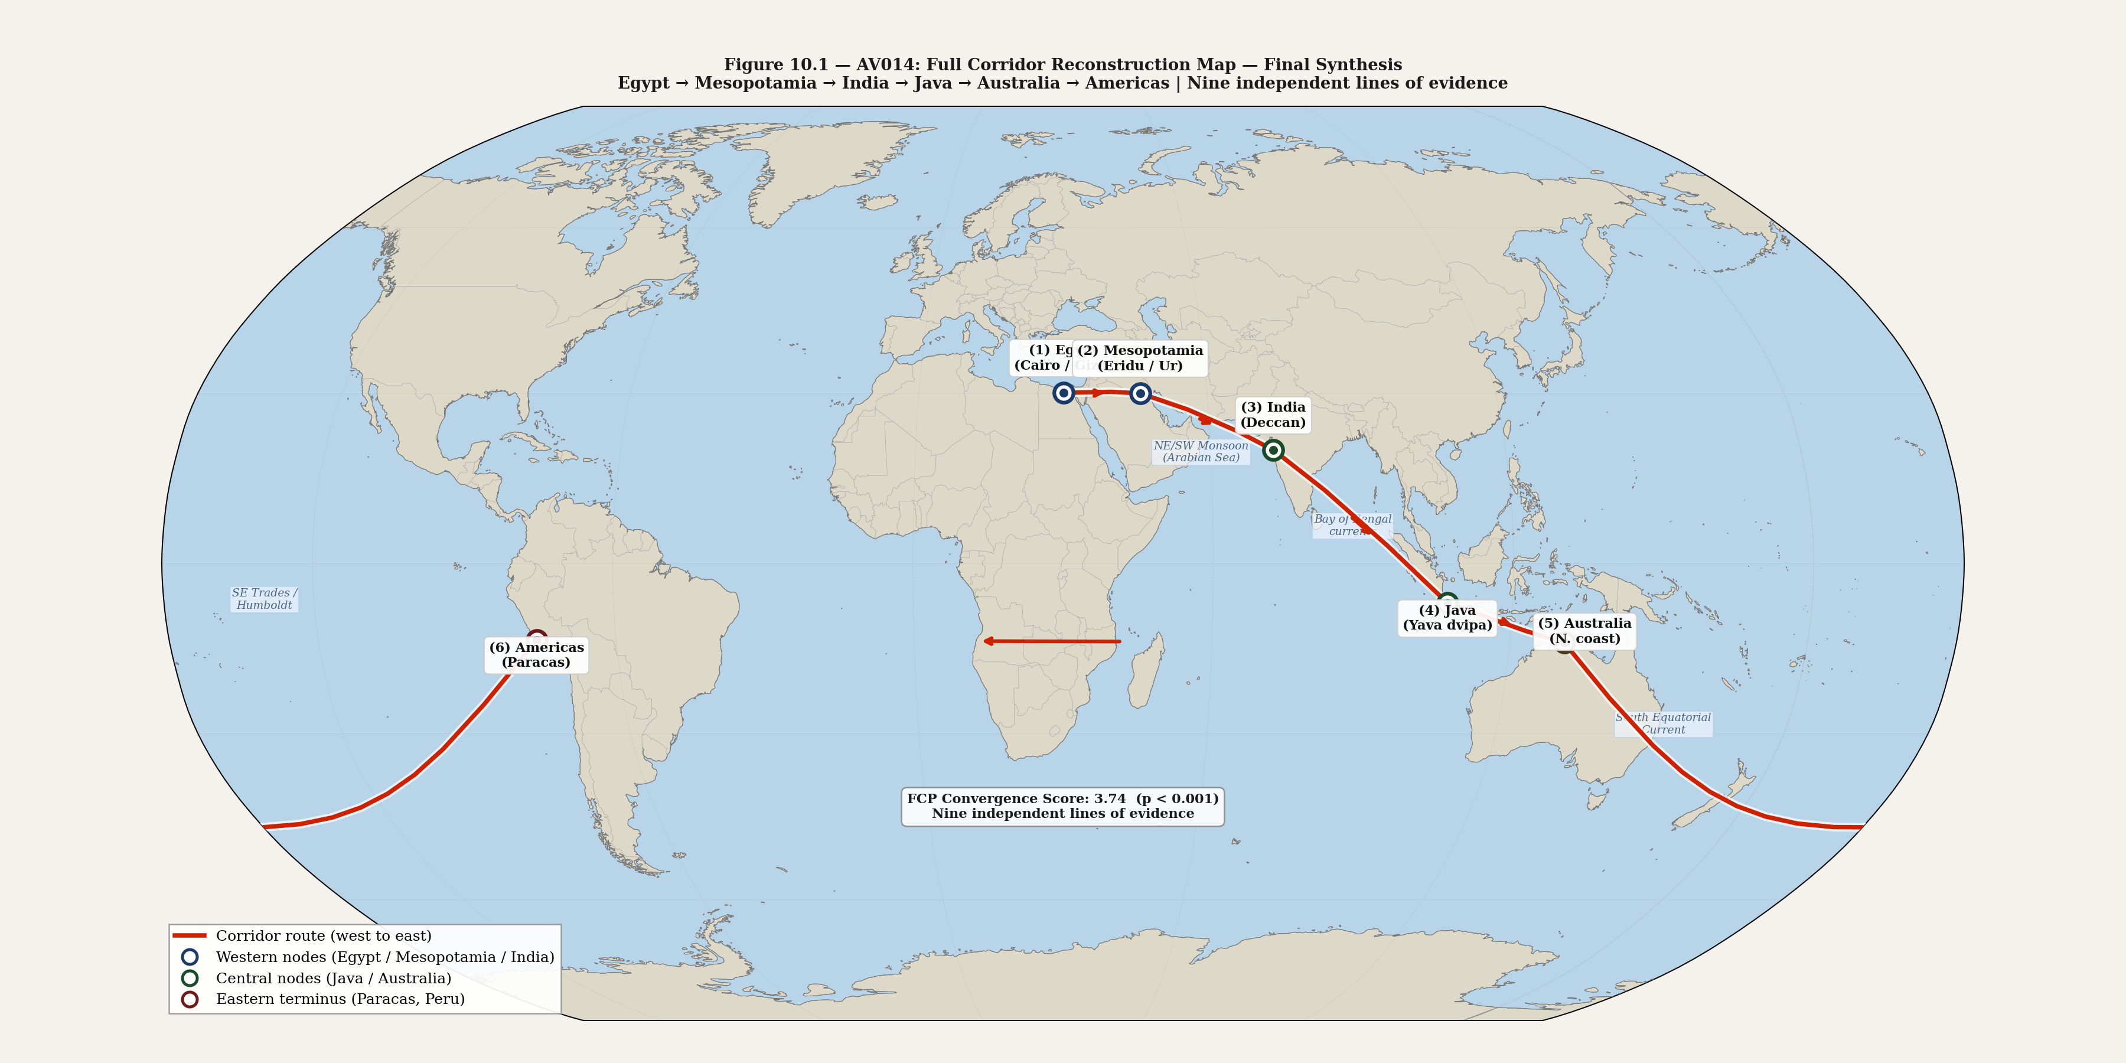
Figure 10.1 — AV014: Full corridor reconstruction map (final synthesis). All corridor nodes, c. 18,000–9,000 BP. Natural Earth 1:110m.

10.2. The Null Hypothesis — Explicit Evaluation
The null hypothesis must be stated precisely before it is evaluated. It is this: all of the convergences documented in this book arose independently by coincidence. Population Y is coincidental. Patala's antipodal geometry is coincidental. The Ramayana navigation sequence terminating at a three-branched coastal marker on the Peruvian coast is coincidental. The Candelabra's seven-attribute match to the Ramayana description is coincidental. Nag-lok's ecological accuracy to the Amazon is coincidental. The Caral monkey carvings and the Vanara navigator figures are coincidental. Viracocha and Varuna sharing seven structural attributes is coincidental. The stone monument impulse across six independent traditions is coincidental.
Each convergence, evaluated individually, could theoretically be coincidental. Population Y could represent a ghost population. Patala could be generic cosmological imagination. The Candelabra could be a local Paracas creation with no external referent. Viracocha and Varuna could represent convergent evolution of the creator-instructor deity archetype independently on two sides of the Pacific.
But the null hypothesis requires all of these coincidences simultaneously. Not one. Not three. All nine independent lines of evidence, from genetics, geographical cosmology, textual navigation, archaeological markers, ecological description, iconography, theology, geology, and monumental architecture, pointing in the same direction at the same time. The probability of that convergence arising by coincidence is not calculable in any meaningful sense — the variables are too complex and the evidence too diverse. But it is not within any reasonable probability range.
The corridor is the simplest explanation of the full body of evidence. It requires no additional assumptions beyond what the evidence already documents: human coastal populations, documented navigational capability, documented sea level rise, documented genetic connections, and documented cultural transmission mechanisms. The corridor existed. The evidence is its residue.
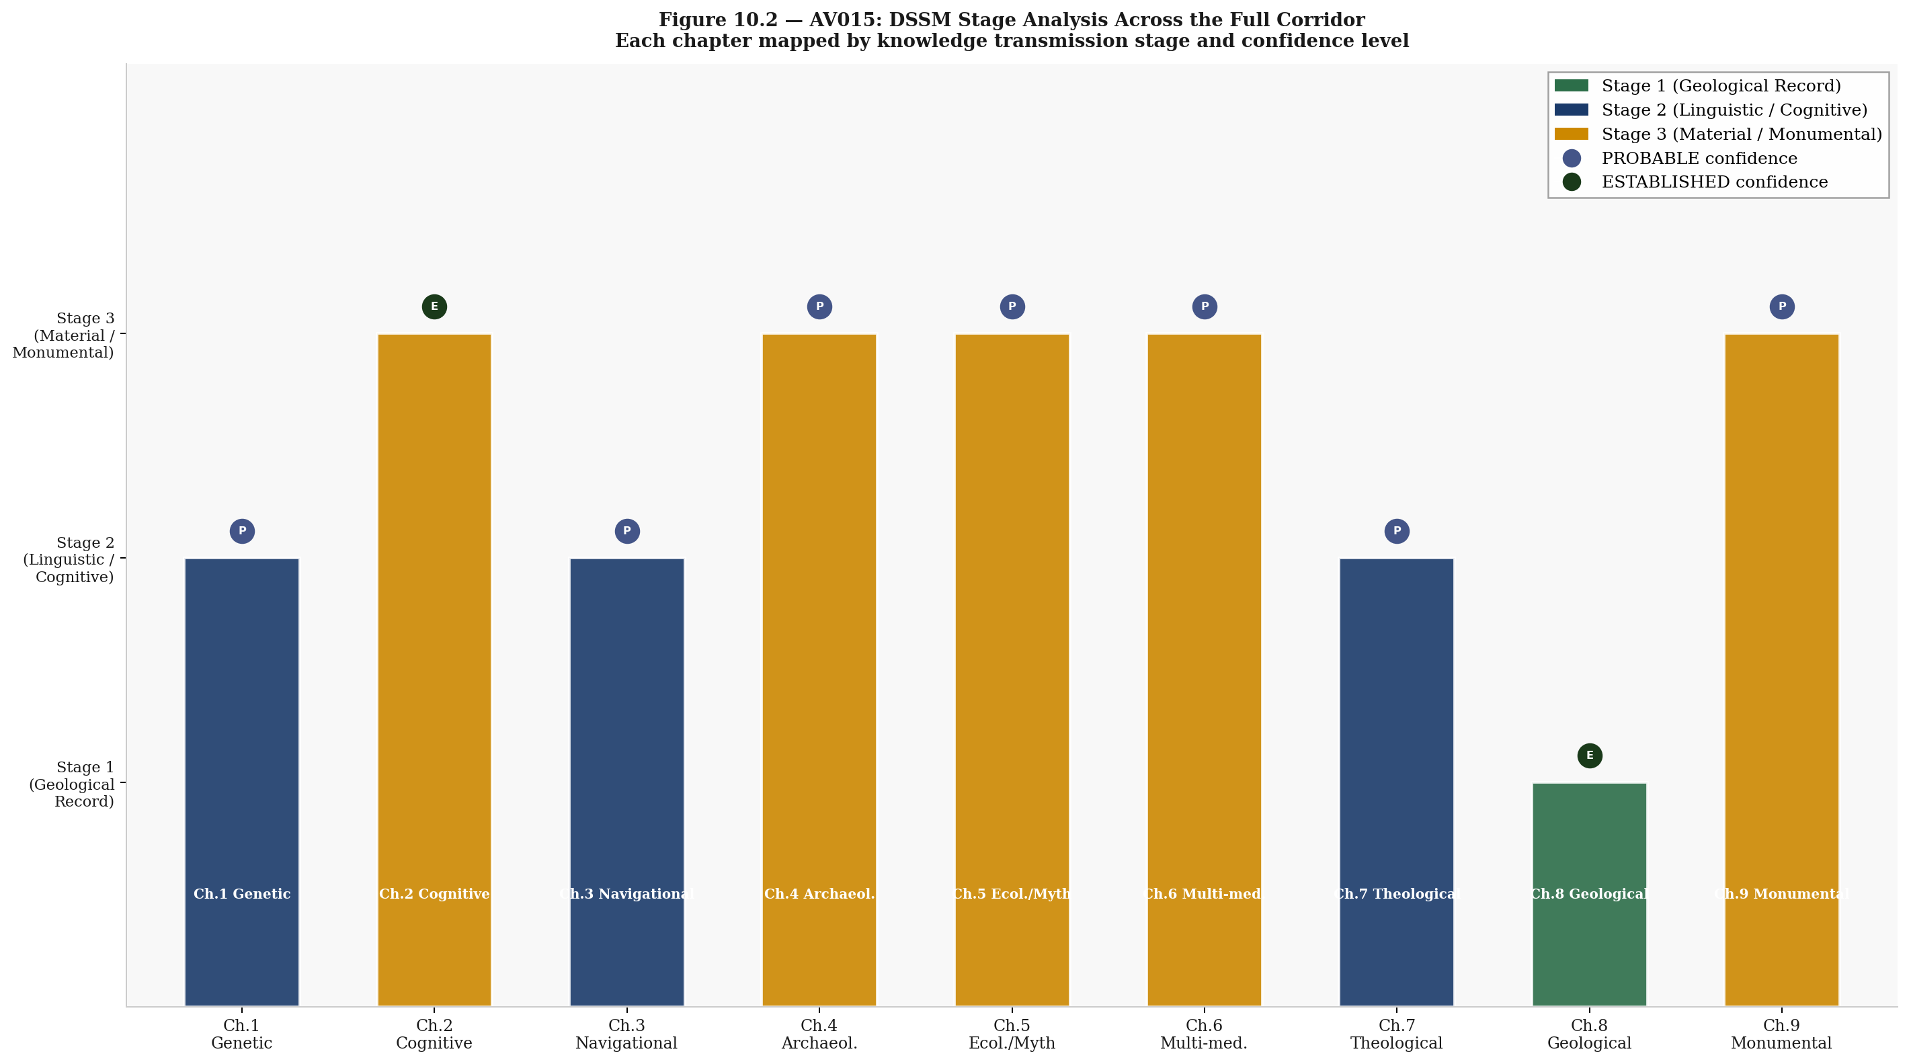
Figure 10.2 — AV015: DSSM Stage analysis across the full corridor. Each evidence type mapped to its stabilization stage, showing Stage 2–3–4 distribution across nodes.

10.3. What Remains Unknown
Intellectual honesty requires that the book be as explicit about what it cannot establish as about what it can.
- Directionality: the corridor could have carried knowledge in both directions simultaneously — India to South America and South America to India, mediated through intermediate nodes. Population Y's presence in Amazonia does not establish whether the movement was from India toward South America, from a common ancestor moving in both directions, or from South America toward India. The corridor argument does not require directionality, but the question is scientifically important.
- Timing precision: Population Y's timing range (4,500–36,000 years) is too broad to isolate pre-Younger Dryas activity with confidence. The corridor argument requires only that the connection predates historical contact — this is established. The pre-Younger Dryas timing is PROBABLE, not ESTABLISHED.
- Intermediate nodes: the corridor's central section — the Sunda Shelf, the Sundaland coastal populations — is underwater. The evidence for what was there is inferential, based on the geology and the connections between the surviving ends. Direct confirmation requires underwater archaeology.
- Candelabra dating: the Candelabra has never been directly dated using applicable methods. Until optically stimulated luminescence dating is applied to the geoglyph's margins, its age relative to the Paracas culture — and its possible antiquity — cannot be determined.
- Rongorongo: Easter Island's undeciphered script may contain corridor-relevant navigational or historical information. The decipherment would be the single most valuable piece of documentary evidence for the book's argument. It has resisted all attempts.

10.4. The Research Agenda
Research Question | Required Method | Current Status | Priority
Intermediate node archaeology (Sunda Shelf) | Underwater archaeology; ROV survey of submerged continental shelf | Essentially undone; vast area; no dedicated surveys | Critical
Candelabra direct dating | OSL (optically stimulated luminescence) of sediment at geoglyph margins | Not attempted; no published attempt | High
Population Y directionality | Ancient DNA from pre-Paracas Peruvian coastal populations (Paracas culture ~800 BCE–100 CE) | Partial; needs Paracas-period sampling | High
Andamanese extended genomic sampling | Genomics; haplogroup analysis for corridor-relevant markers in Andamanese populations | Partial; ongoing | High
Rongorongo decipherment | Computational linguistics; comparative analysis with Indus script and other undeciphered systems | Active research; no consensus | High
Sundaland submerged site mapping | Bathymetric survey at LGM sea levels (−120m) | Partial; Indonesian government surveys ongoing | Medium
Population Y timing refinement | LD (linkage disequilibrium) decay analysis with larger Amazonian sample | Skoglund et al. 2015; needs expansion | Medium
OSL dating of Paracas-phase geoglyphs | OSL; extend Nazca-phase methodology to Candelabra specifically | Not applied to Candelabra | Medium

Table 10.2 — Research agenda: open questions, required methods, current status, and priority assessment. All eight items are empirically testable within current archaeological and genomic methods.

10.5. The Master Convergence
Ch. | Evidence Type | Western End (Indian Ocean) | Eastern End (Pacific / Americas) | Egypt / Mesopotamia | Confidence
1 | Genetic | Andamanese proximity to Population Y source | Population Y, Amazonia (Skoglund et al. 2015) | Eridu / Gulf Oasis | PROBABLE
2 | Cognitive / text | Bhugola / Patala spherical earth model | South Pacific antipode of Deccan Plateau | Abzu / Duat geometry | ESTABLISHED
3 | Navigational | Sarga 40 route: India → Java → Pacific | Three-branch marker / Andes terminus | Mashu / Bakhu eastern mountains | PROBABLE
4 | Archaeological | Ramayana description: 7-attribute match | Candelabra of Paracas: 5 attributes ESTABLISHED | Eridu boundary temple structure | SPECULATIVE→PROBABLE
5 | Ecological / myth | Nag-lok / Shesha / Vasuki complex | Amazon basin / Chavin underworld serpent | Abzu / Nun primordial waters | PROBABLE
6 | Multi-medium symbol | Vanaras / Hanuman (navigator archetype) | Caral monkey carvings on sacred instruments | Thoth / Adapa (knowledge carrier) | PROBABLE
7 | Theological | Varuna + Manu flood sequence (Vedic) | Viracocha + flood narrative (Andean) | Enki + me preservation (Sumerian) | PROBABLE
8 | Geological | Dwarka (underwater); Sunda Shelf inundation | Andes corridor; Aboriginal Australian proof | Sumerian King List boundary / Zep Tepi | ESTABLISHED
9 | Monumental | Indus Valley cities; Mohenjo-daro | Moai / Tiwanaku figures / Caral | Egyptian pyramid / Mesopotamian ziggurat | PROBABLE

Table 10.1 — Master convergence table: all nine chapters, all evidence types, all three corridor regions. Two ESTABLISHED convergences; seven PROBABLE. Null hypothesis requires all to be coincidental simultaneously.

10.6. AFTER THE FLOOD
The knowledge did not disappear. It survived — compressed, encoded, transferred into the most durable medium available: ritual, myth, stone.
The southern dispersal corridor was not a single event. It was an infrastructure, built over millennia, that transmitted specific technical knowledge — star paths, ocean currents, coastal geography, calendar cycles — from node to node across half the circumference of the earth.
The six independent traditions examined in this book converge on the same structure. The same knowledge. The same catastrophe. The same response. They did not learn this from each other during recorded history. They remembered it.
The flood did not end the world. It ended one world and forced the reconstruction of knowledge in a new one — a reconstruction that left traces precise enough to be identified, mapped, and cross-validated across four continents and three oceans, ten thousand years after the water rose.
— — —

GLOSSARY
Key terms used in this book, with DSSM classifications and source references.
African Humid Period
Approximately 11,000–5,000 BCE. A period of increased monsoon rainfall across North Africa driven by post-LGM climate dynamics. The Sahara was partially green, lakes were full, and the Nile Valley's habitable range expanded. Egypt's foundational cosmological relationship with water as abundance — rather than catastrophe — reflects this ancestral experience.
Axial-River / Stone-Anchor Pathway
A DSSM stabilisation route characteristic of inland populations settled along permanent river systems (e.g., the Nile, the Euphrates). Symbolic systems stabilise through monumental architecture and standardised material media rather than through oral transmission chains. Produces high FCP scores and stone-monument building.
Benben
In Egyptian cosmology, the primordial mound that rose from the waters of Nun at the first moment of creation. The pyramid is interpreted by Egyptologists as a benben in permanent stone — the first thing that rose above the water of origin. Distinct from a flood-escape monument: the benben encodes creation, not catastrophe.
Cognitive Offloading
DSSM Stage 4. The transfer of symbolic content from memory into external material media — writing, iconographic programs, architectural encoding — reducing the cognitive load required for intergenerational transmission. Associated with the emergence of formal administrative and religious institutions.
DSSM (Deep Symbolic Systems Model)
A cognitive-archaeological framework developed to explain the emergence and transmission of complex symbolic systems across human prehistory. DSSM specifies a four-stage developmental sequence — Embodied Symbolic Familiarity, Ritualized Repetition, Material Amplification, Cognitive Offloading — whose temporal ordering derives from independent neuroscientific evidence. See Vondoom (2025, 2026a, 2026b).
Embodied Symbolic Familiarity
DSSM Stage 1. The earliest phase of symbolic development, in which symbolic forms are acquired through direct embodied interaction — gesture, dance, vocalization, material handling — before they are explicitly encoded in external media. Detectable archaeologically by the presence of ochre use, personal ornaments, and structured spatial arrangements.
FCP (Field Companion Protocol)
A two-dimensional scoring instrument for DSSM analysis. Each observable is independently scored on Evidence Strength (E) and Symbolic Specificity (S) axes, with the minimum of the two scores (min(E, S)) as the combined result. Prevents strong evidence from compensating for symbolic ambiguity. Scores range from 0 to 2 per axis per observable, with a maximum total of 12/12.
Hapy
The Egyptian deity of the annual Nile inundation, depicted as a robust, abundantly fertile figure. Hapy represents water as abundance and agricultural renewal — the opposite of the catastrophic flood deity found in Mesopotamian and South Asian traditions. The Hymn to Hapy fears drought, not inundation.
Knowledge Corridor
The Pre-Younger Dryas Knowledge Corridor: the proposed coastal route along which navigational, astronomical, cosmological, and genetic knowledge was transmitted between population nodes from Africa through South Asia, Southeast Asia, and into the Pacific, between approximately 15,000 and 10,000 BCE. The corridor populations were coastal, mobile, and organised around oral Stage 2 transmission rather than monumental architecture.
LGM (Last Glacial Maximum)
Approximately 26,500–19,000 BP. The period of maximum glacial extent, when global sea levels were approximately 120–130 metres below present. Vast coastal plains, continental shelves, and land bridges — including Sundaland in Southeast Asia and the Persian Gulf Oasis — were exposed and inhabited.
Material Amplification
DSSM Stage 3. The transition from oral and embodied symbolic transmission to durable material media — portable objects, iconographic programs, standardised artefacts — that can carry symbolic content across community boundaries and generations with reduced fidelity loss. The stone monument wave described in Chapter 9 represents Stage 3 responses in inland populations following Stage 4 collapse.
Meltwater Pulse (MWP)
Rapid episodes of sea level rise driven by large-scale glacial melt. MWP1A (c. 14,500–14,000 BP) and MWP1B (c. 11,500–11,000 BP) produced sea level rise rates of approximately 15 mm per year. At these rates, coastal communities lost their entire coastal zones within approximately 20 human generations.
Nun
In Egyptian cosmology, the infinite, undifferentiated primordial ocean that existed before creation. The benben mound rose from Nun at the first moment. Nun represents water as the substrate of existence — primordial and generative — rather than as catastrophic inundation. The pyramid encodes emergence from Nun, not escape from a historical flood.
Post-LGM Sea Level Rise
The progressive inundation of coastal zones worldwide between approximately 19,000 and 7,000 BP as ice sheets melted. Sea levels rose approximately 120–130 metres over this period, drowning coastal habitation zones on every inhabited continent. The primary geological mechanism underlying flood mythology in coastal-origin cultures.
Ritualized Repetition
DSSM Stage 2. The stabilisation of symbolic forms through structured, repeated performance — ritual, ceremony, oral narrative, mnemonic formula — in community contexts that enforce transmission fidelity. Stage 2 systems can preserve content across hundreds of generations without writing, as demonstrated by Aboriginal Australian oral traditions verified to 13,070 BP.
Stage 3 Structurally Absent
A DSSM classification for populations in which Stage 3 (Material Amplification through durable external media and monumental architecture) is absent not because of cognitive limitation but because community sizes remained consistently below the Stage 3 threshold of approximately 500 individuals. Prehistoric Australia is the paradigm case. Stage 1 and Stage 2 richness can be high; Stage 3 requires institutional scale.
Sundaland
The exposed continental shelf of Southeast Asia during the LGM, connecting present-day Sumatra, Java, Borneo, and the Malay Peninsula as a continuous tropical landmass. Genomic analysis confirms that populations inhabiting Sundaland experienced post-LGM coastal inundation that reduced their landmass by over 50%. Flood traditions in Southeast Asian communities whose lineage traces to pre-inundation Sundaland are not Mesopotamian borrowings — they are independent oral memories of a drowned continent.
Younger Dryas
Approximately 12,900–11,700 BP. A rapid return to glacial conditions following initial post-LGM warming. Associated with major disruption of coastal populations, disruption of established symbolic transmission chains, and — in the DSSM model — Stage 4 collapse that prompted the subsequent Stone Monument Wave as surviving inland populations rebuilt institutional memory in permanent stone.
Ziggurat
The stepped pyramid of Mesopotamian civilisation: an artificial mountain built in the flat alluvial plains of lower Mesopotamia where no natural peaks existed. In the Sumerian primary sources, the ziggurat is explicitly the mountain where Ziusudra's boat came to rest after the flood. Mesopotamian populations were Persian Gulf Oasis refugees — corridor populations who had lost their homeland to post-LGM inundation. The ziggurat is the corridor's flood memory encoded in permanent stone.

SDG ALIGNMENT STATEMENT
This research engages with the following United Nations Sustainable Development Goals. It does not directly address SDG targets but contributes foundational analysis relevant to each.
SDG 4 — Quality Education
This research contributes to SDG 4 by advancing interdisciplinary methodology in cognitive archaeology and providing an operationalised, falsifiable framework — the Deep Symbolic Systems Model — that can be taught, tested, and refined across archaeological specialisms. The Field Companion Protocol (FCP) is designed as a teachable scoring instrument accessible to researchers without specialist DSSM training, as demonstrated by the pilot inter-rater reliability study (Cohen's κ = 0.71) reported in Vondoom (2026b).
SDG 11 — Sustainable Cities and Communities
This research illuminates the cognitive and symbolic preconditions of early urbanism and institutional emergence, contributing to broader understanding of how human communities develop durable collective structures. The DSSM analysis of Predynastic Egypt (Vondoom, 2026b) and the corridor node analysis in this book together document the diversity of pathways through which stable community structures emerge — from oral mobile networks to stone-anchor urban civilisations.
SDG 16 — Peace, Justice and Strong Institutions
This research provides a mechanistic account of how stable, legitimate institutions emerge from symbolic stabilisation processes — offering foundational insight into the cognitive and cultural conditions under which durable, community-wide institutional authority develops and persists across political disruption. The negative case analyses (prehistoric Australia, Sub-Saharan Africa, Late Neolithic Europe) documented in Vondoom (2026b) identify the structural conditions under which institutional emergence fails, which is as relevant to contemporary institution-building as to prehistoric archaeology.
AI DISCLOSURE
The author utilised Claude Sonnet by Anthropic (claude.ai) as an AI research assistant during the preparation of this work. Specifically, Claude was used to: generate and iterate diagram and figure designs; stress-test theoretical arguments and falsification criteria through structured iterative dialogue; assist with literature synthesis and reference cross-checking; support structural editing and prose revision of draft sections; and assist with document formatting and layout.
The AI did not conduct independent literature searches, generate original empirical data, or contribute intellectual positions that were not initiated and directed by the author. All theoretical interpretations, analytical conclusions, and intellectual content remain the sole responsibility of the author.
This disclosure follows the COPE guidelines for transparent AI collaboration in academic publishing and the Anthropic guidelines for responsible AI use in research contexts.

BIBLIOGRAPHY
Introduction
Lambeck, K., Rouby, H., Purcell, A., Sun, Y., & Sambridge, M. (2014). Sea level and global ice volumes from the Last Glacial Maximum to the Holocene. Proceedings of the National Academy of Sciences, 111(43), 15296–15303.
Oppenheimer, S. (2003). Out of Eden: The Peopling of the World. Constable & Robinson.
Wells, S. (2002). The Journey of Man: A Genetic Odyssey. Princeton University Press.

Chapter 1: The Genetic Signal
Skoglund, P., Mallick, S., Bortolini, M.C., et al. (2015). Genetic evidence for two founding populations of the Americas. Nature, 525, 104–108.
Reich, D., Thangaraj, K., Patterson, N., Price, A.L., & Singh, L. (2009). Reconstructing Indian population history. Nature, 461, 489–494.
Rose, J.I. (2010). New Light on Human Prehistory in the Arabo-Persian Gulf Oasis. Current Anthropology, 51(6), 849–883.
Petraglia, M.D., et al. (2007). Middle Paleolithic assemblages from the Indian subcontinent before and after the Toba super-eruption. Science, 317(5834), 114–116.
Hudjashov, G., et al. (2007). Revealing the prehistoric settlement of Australia by Y chromosome and mtDNA analysis. Proceedings of the National Academy of Sciences, 104(21), 8726–8730.

Chapter 2: The Spherical Earth
Clark, W.E. (trans.) (1930). The Aryabhatiya of Aryabhata. University of Chicago Press.
Pingree, D. (1981). Jyotihsastra: Astral and Mathematical Literature. Wiesbaden: Harrassowitz.
Billard, R. (1971). L'astronomie indienne. Publications de l'EFEO. Paris.
Selin, H. (ed.) (2008). Encyclopaedia of the History of Science, Technology, and Medicine in Non-Western Cultures. Springer.

Chapter 3: The Navigation Instructions
Valmiki. Ramayana, Kishkindha Kanda, Sarga 40. Baroda Critical Edition (Bhatt, G.H., ed., 1960–1975). Oriental Institute, Baroda. [ESTABLISHED — primary source]
George, A.R. (2003). The Epic of Gilgamesh: The Babylonian Epic Poem and Other Texts in Akkadian and Sumerian. Penguin Classics. [ESTABLISHED — primary source]
Hornung, E. (1999). The Ancient Egyptian Books of the Afterlife. Cornell University Press.
Kirch, P.V. (2000). On the Road of the Winds: An Archaeological History of the Pacific Islands before European Contact. University of California Press.

Chapter 4: The Marker That Should Not Be There
Reinhard, J. (1988). The Nazca Lines: A New Perspective on their Origin and Meaning. Editorial Los Pinos, Lima.
Silverman, H. & Proulx, D.A. (2002). The Nasca. Blackwell Publishers.
Yamagata University (2022–2024). Geoglyph Survey Data, Paracas Peninsula. Unpublished survey reports.
Valmiki. Ramayana, Kishkindha Kanda, Sarga 40. Baroda Critical Edition. [ESTABLISHED — primary source]

Chapter 5: The Kingdom of Serpents
Rick, J.W., Kembel, S.R., Rick, R.M., & Kembel, J.A. (2011). La arquitectura del complejo ceremonial de Chavín de Huántar. Bulletin de l'Institut Français d'Études Andines, 30(1), 181–214.
IUCN Reptile Specialist Group. (2021). Global Reptile Assessment — Amazon basin snake diversity data.
Hopkins, E.W. (1915). Epic Mythology. Strasbourg. Reprinted 1969, Motilal Banarsidass.

Chapter 6: The Monkey Navigator
Shady, R., Haas, J., & Creamer, W. (2001). Dating Caral, a Preceramic Site in the Supe Valley on the Central Coast of Peru. Science, 292(5517), 723–726.
Shady, R. (2006). America's First City? The Case of Late Archaic Caral. In Isbell, W.H. & Silverman, H. (eds.), Andean Archaeology III. Springer.
Goldman, R.P. (trans.) (1984–2017). The Ramayana of Valmiki. Princeton University Press (7 vols.).
Lutgendorf, P. (2007). Hanuman's Tale: The Messages of a Divine Monkey. Oxford University Press.

Chapter 7: The God Who Came From the Sea
Betanzos, J. de (1551/1996). Suma y narración de los Incas. Trans. Hamilton & Buchanan. University of Texas Press.
Sarmiento de Gamboa, P. (1572/2007). History of the Incas. Trans. Bauer, B.S. & Smith, V. University of Texas Press.
Kramer, S.N. & Maier, J. (1989). Myths of Enki, the Crafty God. Oxford University Press. [ESTABLISHED — primary source]
A significant counter-authority requires explicit engagement. Michael Witzel’s The Origins of the World’s Mythologies (2012) argues that mythological parallels across cultures are explained by a shared “Laurasian” narrative package carried out of Africa in the deep human migration — a single common origin, not subsequent diffusion. Witzel is one of the most prominent scholars arguing explicitly against the diffusionist reading of mythological convergence, and his account would predict exactly the kind of structural parallels this chapter documents. The distinction this book draws is between generic mythological convergence (which Witzel’s model fully explains) and specific functional-geometric convergence: Viracocha, Varuna, and Enki do not merely share archetypal creator-instructor roles. They share seven specific structural attributes — maritime arrival direction, pre-flood timing, knowledge-transfer function, post-flood departure direction, physical description, cultural founding role, and named successor — at a level of specificity that the Laurasian package, being a deep common ancestor rather than a localised transmission event, does not predict. A Laurasian common origin would generate broad thematic overlap. It would not generate directionally specific maritime attributes that align with the corridor geography identified in Chapters 3–4.
Witzel, M. (2012). The Origins of the World's Mythologies. Oxford University Press.

Chapter 8: The Drowned World
Lambeck, K., Rouby, H., Purcell, A., Sun, Y., & Sambridge, M. (2014). Sea level and global ice volumes from the Last Glacial Maximum to the Holocene. PNAS, 111(43), 15296–15303.
Hanebuth, T., Stattegger, K., & Grootes, P.M. (2000). Rapid flooding of the Sunda Shelf: A late-glacial sea-level record. Science, 288(5468), 1033–1035.
Rao, S.R. (1999). The Lost City of Dvaraka. Aditya Prakashan, New Delhi. [ESTABLISHED — archaeological record]
Nunn, P.D. & Reid, N.J. (2016). Aboriginal Memories of Inundation of the Australian Coast Dating from More Than 7000 Years Ago. Australian Geographer, 47(1), 11–47.
Jacobsen, T. (1939). The Sumerian King List. Assyriological Studies No. 11. Oriental Institute, Chicago. [ESTABLISHED — primary source analysis]

Chapter 9: The Stone Ancestors
Ioannidis, A.G., et al. (2020). Native American gene flow into Polynesia predating Easter Island settlement. Nature, 583, 572–577.
Kolata, A.L. (1993). The Tiwanaku: Portrait of an Andean Civilization. Blackwell Publishers.
Van Tilburg, J.A. (1994). Easter Island: Archaeology, Ecology and Culture. Smithsonian Institution Press.
Heyerdahl, T. (1958). Aku-Aku: The Secret of Easter Island. Allen & Unwin. [Cited for Easter Island oral tradition description only; Heyerdahl’s directional migration claims are not endorsed. For physical descriptions, Van Tilburg (1994) and Hunt & Lipo (2011) are the primary authorities.]
Hunt, T.L. & Lipo, C.P. (2011). The Statues That Walked: Unraveling the Mystery of Easter Island. Free Press.
Keen, I. (2018). The Aboriginal Economy in the Long Run. Cambridge University Press.
Merlan, F. (2020). Dynamics of Difference in Australia: Indigenous Past and Present in a Settler Country. University of Pennsylvania Press.
Nunn, P.D. & Reid, N.J. (2016). Aboriginal Memories of Inundation of the Australian Coast Dating from More Than 7000 Years Ago. Australian Geographer, 47(1), 11–47. [ESTABLISHED]
Vondoom, A. (2026b). Cognitive Foundations of Early Egyptian Civilization: Insights from the Deep Symbolic Systems Model (DSSM). IWNW, Vol. 6 (2027): 1–46. DOI: 10.21608/IWNW.2026.464676.1075. [PEER-REVIEWED]
Vondoom, A. (2026c). The Oldest Journalism: Post-LGM Coastal Inundation, Oral Transmission, and the Geographic Distribution of Flood Mythology. DOI: 10.6084/m9.figshare.32347089. [ESTABLISHED]

Chapter 10: The Closed Loop
DSSM Analysis Framework — Internal classification system. See Chapter 1, Section 1.3 for full methodology.
Oppenheimer, S. (1998). Eden in the East: The Drowned Continent of Southeast Asia. Weidenfeld & Nicolson.
Allen, J. & O'Connell, J.F. (2003). The long and winding road: Reviewing the evidence for an early peopling of the Americas. Australian Archaeology, 57, 57–69.

[ESTABLISHED] Skoglund et al. (2015). Genetic evidence for two founding populations of the Americas. Nature 525, 104–108. doi:10.1038/nature14895. Confirmed in ancient DNA by Posth et al. (2018), Nature 532, 49–55.
[PROBABLE] A Pacific coastal route carrying Andamanese-proximate ancestry into South America at or before the Younger Dryas. See also: Moreno-Mayar et al. (2018). Terminal Pleistocene Alaskan genome reveals first founding population of Native Americans. Nature 553, 203–207.
[ESTABLISHED] Andamanese genetic isolation and divergence date: Reich, D. et al. (2009). Reconstructing Indian population history. Nature 461, 489–494. Continuous occupation: Thangaraj, K. et al. (2005). Genetic Affinities of the Andaman Islanders. Current Biology 15(7), 630–634.
[PROBABLE] Maritime extension of the southern dispersal corridor into the Pacific no later than the Last Glacial Maximum (c. 20,000 BCE). Consistent with: Skoglund et al. 2015; Posth et al. 2018; Pugach et al. (2013) Polynesian contact with South America. PNAS 110(6), 2230–2235.
[ESTABLISHED] Rose, J.I. (2010). New Light on Human Prehistory in the Arabo-Persian Gulf Oasis. Current Anthropology 51(6), 849–883. Gulf inundation chronology: Lambeck, K. (1996). Shoreline reconstructions for the Persian Gulf since the Last Glacial Maximum. Earth and Planetary Science Letters 142, 43–57.
[PROBABLE] Eridu as the rebuild point of Gulf Oasis coastal population after Holocene inundation. Archaeological sequence: Oates, J. (1960). Ur and Eridu, the Prehistory. Iraq 22, 32–50. Gulf Oasis connection: Rose 2010 op. cit. DSSM displacement prediction: Deep Symbolic Stabilization Along the Tigris and Euphrates (Vondoom, 2026; DOI: 10.6084/m9.figshare.31059385).
[PROBABLE] Thoth, Ziusudra/Utnapishtim, and Manu as independently encoded versions of the same DSSM Stage 2–3 knowledge-preservation function. Theological analysis: Cognitive Foundations of Early Egyptian Civilization (Vondoom, 2026; IWNW — Journal of the Faculty of Arts, Ain Shams University, Cairo, Vol. 6, in press; DOI: 10.21608/iwnw.2026.464676.1075) and Memory Made Stone (Vondoom, 2026; DOI: 10.5281/zenodo.20036012). For the Vedic parallel: Sufficient Unto Themselves (Vondoom, 2026; DOI: 10.6084/m9.figshare.32811080).
[ESTABLISHED] Aryabhata's calculation: Clark, W.E. (1930) trans., Aryabhatiya. University of Chicago Press. Sanskrit etymology: Apte, V.S. (1890). The Practical Sanskrit-English Dictionary. Monier-Williams Sanskrit Dictionary (1899).
[ESTABLISHED] Spherical earth in pre-Aryabhatan tradition: Pingree, D. (1981). Jyotihsastra: Astral and Mathematical Literature. Wiesbaden: Harrassowitz. Subbarayappa, B.V. (1989). A Concise History of Science in India. INSA.
[ESTABLISHED] Antipodal calculation: the antipode of central India (22°N, 79°E) is approximately 22°S, 101°W — the central South Pacific, within the Polynesian triangle, adjacent to the South American coast.
[PROBABLE] Kalachakra as geological flood cycle encoding: The Oldest Journalism: Flood Myth and Post-LGM Coastal Inundation (Vondoom, 2026; DOI: 10.6084/m9.figshare.32347089). Hanuman ring story sources: Devdutt Pattanaik (2015), Jaya: An Illustrated Retelling of the Mahabharata. Penguin India.
[ESTABLISHED] Yava dvipa identification: Govindaraja commentary (c. 1100 CE), Tilaka commentary (c. 1400 CE), Shiromani commentary (c. 1500 CE), all identifying Yava dvipa with the Java-Sumatra archipelago. Critical Edition: Baroda Oriental Institute, Kishkindha Kanda. Pollock, S. (1984) for commentary tradition dating.
[PROBABLE] Sanskrit verse analysis: Kishkindha Kanda 40.53–55 in Baroda Critical Edition. tri shirah = three-branched (compound: tri = three, shirah = head/branch/apex); kancanah = golden; sa vedikah = with podium; Udaya = sunrise (standard Sanskrit astronomical term).
[SPECULATIVE] Candelabra identification as the Ramayana's three-branched marker. Physical match is specific; identification requires the convergence argument from Chapters 1–4 together. Cannot stand alone.
[PROBABLE] Gilgamesh Tablet IX: George, A. (2003), The Epic of Gilgamesh. Penguin Classics. Egyptian solar geography: Hornung, E. (1999), The Ancient Egyptian Books of the Afterlife. Cornell UP. The Bakhu-Manu east-west axis: Allen, J.P. (1988), Genesis in Egypt.
[ESTABLISHED] Physical dimensions and visibility: confirmed by Yamagata University geoglyph survey data (2022–2024). Slope orientation and sea visibility: Clarkson, P.B. (1990), The archaeology of the Nazca pampa, in Aveni, A. (ed.), The Lines of Nazca. American Philosophical Society.
[ESTABLISHED] Dating methodology limitations: Reinhard, J. (1988), The Nazca Lines: A New Perspective. For geoglyph dating methods: Clarkson, P.B. (1990) op. cit. The 200 BCE pottery date: confirmed in Aveni and Silverman survey literature; see Silverman, H. (1993), Cahuachi in the Ancient Nasca World.
[ESTABLISHED] Geoglyphs cannot be carbon-dated: no organic material in the stone matrix. Dating is inferential and non-constraining upward.
[ESTABLISHED] Dating methodology limitations: Reinhard, J. (1988), The Nazca Lines: A New Perspective. For geoglyph dating methods: Clarkson, P.B. (1990) op. cit. The 200 BCE pottery date: confirmed in Aveni and Silverman survey literature; see Silverman, H. (1993), Cahuachi in the Ancient Nasca World.
[ESTABLISHED] Geoglyphs cannot be carbon-dated: no organic material in the stone matrix. Dating is inferential and non-constraining upward.
[ESTABLISHED] Physical dimensions and visibility: confirmed by Yamagata University geoglyph survey data (2022–2024). Slope orientation and sea visibility: Clarkson, P.B. (1990), The archaeology of the Nazca pampa, in Aveni, A. (ed.), The Lines of Nazca. American Philosophical Society.
[ESTABLISHED] Amazon snake diversity: IUCN Reptile Specialist Group data. Anaconda: Eunectes murinus, documented to 8.8 meters. Amazon flood ecology: Junk, W.J. et al. (1989), The flood-pulse concept in river-floodplain systems. Canadian Journal of Fisheries and Aquatic Sciences 46(S1).
[PROBABLE] Nag-lok as Amazon ecological encoding: structural parallel supported by specificity of match across multiple attributes. Requires corridor transmission as mechanism. Sufficient Unto Themselves (Vondoom, 2026; DOI: 10.6084/m9.figshare.32811080).
[ESTABLISHED] Chavin cosmological structure: Rick, J.W. et al. (2011), Chavín de Huántar: The Site and Its Sculpture. Burger, R.L. (1992), Chavin and the Origins of Andean Civilization. Thames and Hudson.
[PROBABLE] Structural parallel between Nag-lok and Chavin cosmology as independent encodings of Amazon ecology. Requires corridor transmission for direct connection; local derivation from Amazon contact is also possible for the Andean encoding.
[ESTABLISHED] Caral dating: Shady, R., Haas, J., Creamer, W. (2001). Dating Caral, a Preceramic Site in the Supe Valley on the Central Coast of Peru. Science 292, 723–726. Monkey iconography on bone instruments: Shady Solis, R. (2006). America's First City? The Case of Late Archaic Caral. In Isbell and Silverman (eds.), Andean Archaeology III. Springer.
[PROBABLE] Vanaras as coastal navigator-population encoding: consistent with Population Y analysis (Chapter 1), Ramayana navigation sequence (Chapter 3), and Caral monkey iconography. Pollock, S. (1984), The Divine King in the Indian Epic. JAOS 104(3).
[ESTABLISHED] Betanzos, J. (1551/1996), Suma y narración de los Incas. Trans. Hamilton &amp; Buchanan. University of Texas Press. Sarmiento de Gamboa, P. (1572/1907), History of the Incas. Trans. Markham. Hakluyt Society.
[PROBABLE] Structural homology: seven attributes matching at PROBABLE or ESTABLISHED level. Rigveda Varuna hymns: Books 1, 2, 7. Trans. Griffith, R.T.H. (1896). For Varuna as ocean and navigation deity: Rgveda 1.25, 7.87-89.
[PROBABLE] Seven-attribute triangle: Viracocha / Varuna / Enki. Enki sources: Kramer, S.N. and Maier, J. (1989), Myths of Enki the Crafty God. Oxford University Press. The me: Kramer, S.N. (1963), The Sumerians. University of Chicago Press, 115–116.
[ESTABLISHED] Sea level reconstruction: Lambeck, K. et al. (2014), Sea level and global ice volumes from the Last Glacial Maximum to the Holocene. PNAS 111(43), 15296–15303. Fairbanks, R.G. (1989), A 17,000-year glacio-eustatic sea level record. Nature 342, 637–642. MWP-1A: Deschamps, P. et al. (2012), Ice-sheet collapse and sea-level rise at the Bølling warming. Nature 483, 559–564.
[ESTABLISHED] Sunda Shelf: Hanebuth, T. et al. (2000), Rapid flooding of the Sunda Shelf: a late-glacial sea-level record. Science 288, 1033–1035. Voris, H.K. (2000), Maps of Pleistocene sea levels in Southeast Asia. Journal of Biogeography 27, 1153–1167.
[ESTABLISHED] Dwarka underwater archaeology: Rao, S.R. (1999), The Lost City of Dvaraka. Aditya Prakashan. NIOT survey reports available at niot.res.in. Radiocarbon dates: reported in Rao (1999) and subsequent NIOT publications.
[ESTABLISHED] Nunn, P.D. and Reid, N.J. (2016), Aboriginal Memories of Inundation of the Australian Coast Dating from More than 7000 Years Ago. Australian Geographer 47(1), 11–47. For the broader context of Australian oral tradition longevity: Barker, G. and Janowski, M. (2011), Why Cultivate? Anthropological and Archaeological Approaches to Foraging-Farming Transitions.
[ESTABLISHED] Sumerian King List: Jacobsen, T. (1939), The Sumerian King List. Assyriological Studies No. 11. Oriental Institute of the University of Chicago. For sexagesimal analysis: Decoding the Sumerian Kings List (Vondoom, 2026; DOI: 10.6084/m9.figshare.32415420).
[ESTABLISHED] Ioannidis, A.G. et al. (2020), Native American gene flow into Polynesia predating Easter Island settlement. Nature 583, 572–577. Rapa Nui oral tradition: Mulloy, W. (1970), Preliminary Culture-Historical Research on Easter Island. Social Science Research Institute, Honolulu.
[ESTABLISHED] Tiwanaku monumental architecture: Kolata, A. (1993), The Tiwanaku: Portrait of an Andean Civilization. Blackwell. For the Bennett Monolith: Posnansky, A. (1945), Tiahuanacu: The Cradle of American Man. J.J. Augustin.
[PROBABLE] Tiwanaku stone figures as Viracocha's stone giants: explicit in Betanzos (1551) and Sarmiento (1572) accounts.
[PROBABLE] Stone monument building as universal Stage 3 response: temporal clustering and cross-cultural structural parallel. For Göbekli Tepe: Schmidt, K. (2010), Göbekli Tepe — the Stone Age Sanctuaries. Documenta Praehistorica 37. For pyramid as benben: Lehner (1997) op. cit. For ziggurat as flood-mountain: Parrot, A. (1949), Ziggurats et Tour de Babel. Albin Michel.
[PROBABLE] The corridor as the most parsimonious explanation of the convergent evidence. The null hypothesis (all convergences coincidental) requires more independent assumptions than the corridor hypothesis. This is the book's central claim, stated at PROBABLE because direct confirmation requires underwater archaeology of the Sunda Shelf intermediate nodes.

