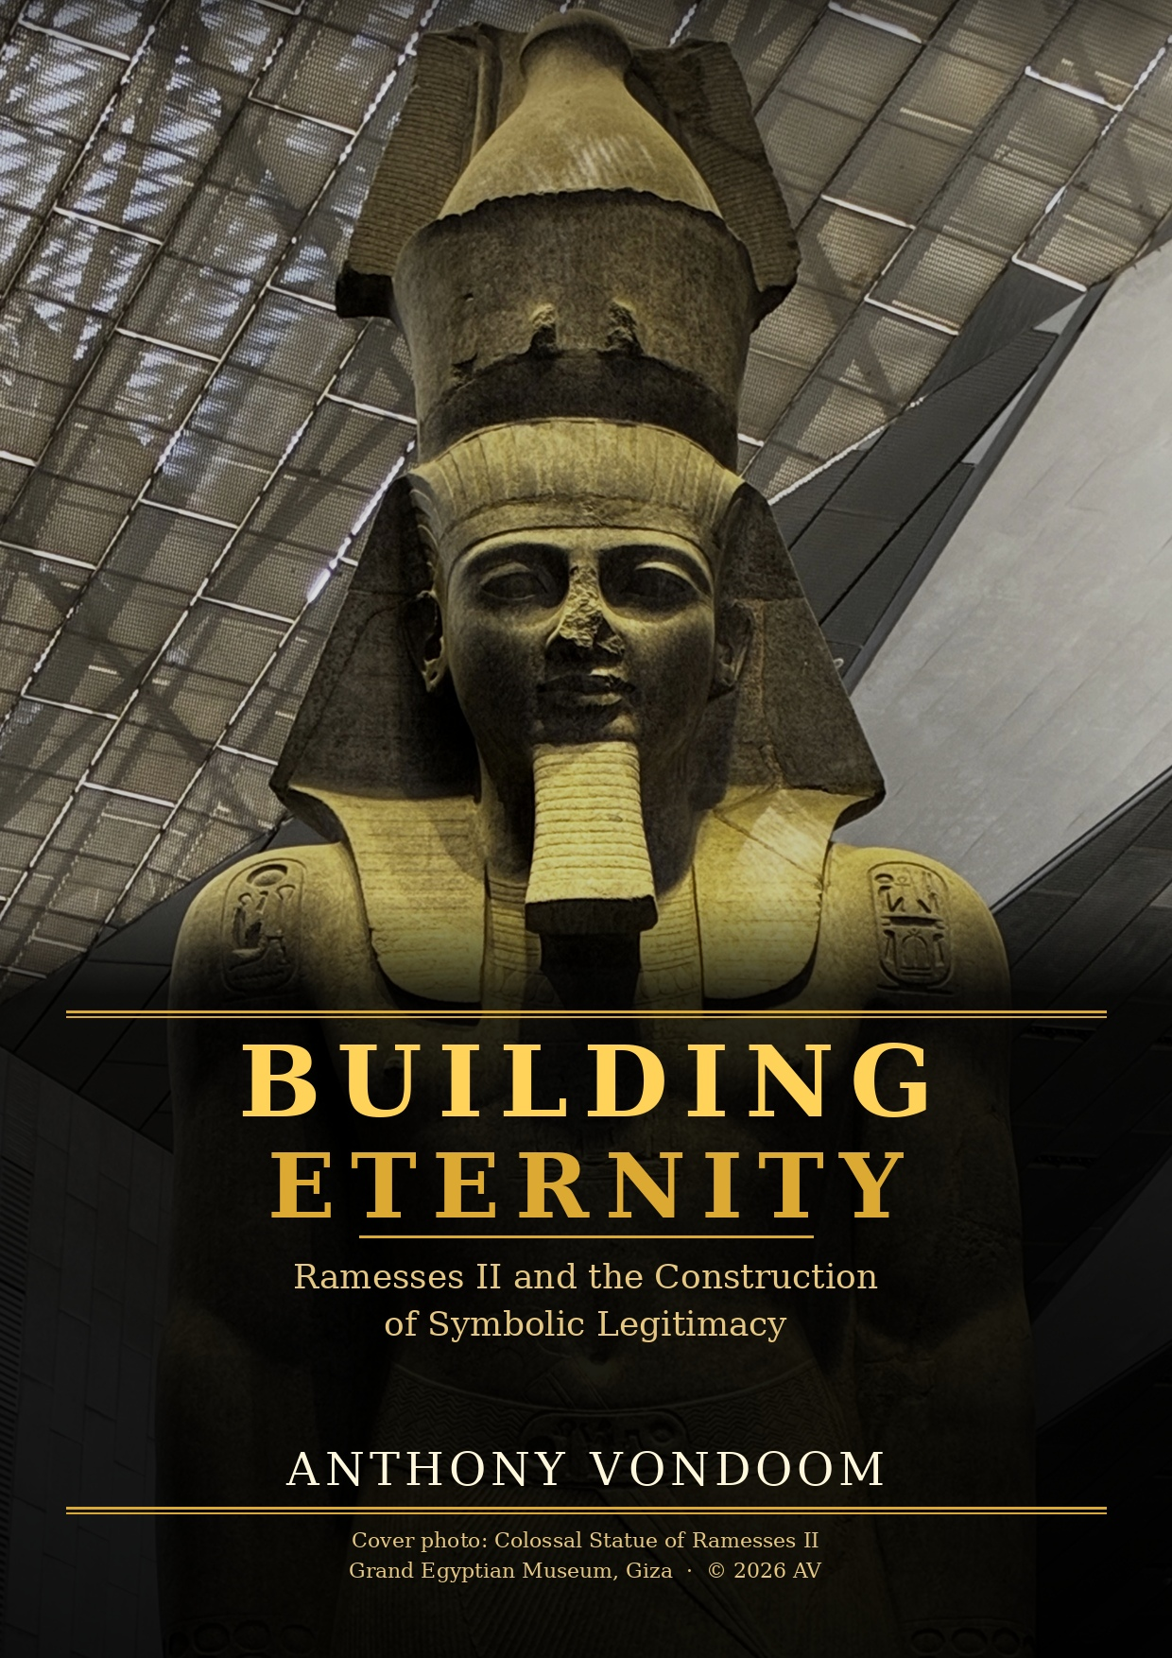

BUILDING ETERNITY:
Ramesses II and the Construction of Symbolic Legitimacy

A 2026 Figshare Publication
https://doi.org/10.6084/m9.figshare.32228970

Anthony Vondoom
Independent Researcher | Cognitive Archaeology
Sirmione, Italy
ORCID: 0009-0003-4953-1427 | anthony.vondoom@outlook.com

AI Assistance Disclosure: This paper was developed with editorial and structural support from Claude Sonnet (Anthropic). The theoretical framework, arguments, and conclusions are solely those of the author.

Acknowledgements
The photographs that form the primary material evidence of this paper were taken by me during visits to Karnak Temple, Luxor Temple, the Grand Egyptian Museum (GEM) at Giza, and the National Museum of Egyptian Civilization (NMEC) in Cairo. I am grateful to have had direct, sustained access to these sites and to the objects they house.
I want to acknowledge the archaeologists and scholars who have worked at these sites — excavating, documenting, restoring, and interpreting the material record of Ramesses II's reign across two centuries of systematic work. Their published scholarship is the substrate without which this paper could not exist. I want equally to acknowledge the excavation workers, the Egyptians whose physical labour at these sites made the objects accessible to scholarship, and whose contribution is rarely named in academic papers. They are part of this record.
The Grand Egyptian Museum is a remarkable institution. I am grateful to the Egyptian government and the Ministry of Tourism and Antiquities for building it, for the preservation policy it represents, and for the decision to make primary engagement with these objects possible for independent researchers. The museum's organization of the Ramesside collection — the colossal at the atrium's centre — is itself a statement about what these objects are and what they deserve.
More broadly, I want to acknowledge everyone who has ever contributed to the continuity of Egyptian civilization: the priests who encoded its theology, the scribes who preserved its texts, the builders who raised its monuments, the scholars who have translated and interpreted them, and the curators who guard them now. Their collective labour is the reason this record exists.
Anthony Vondoom.
Sharm El Sheik,
09.05.2026

Abstract
Ramesses II (r. 1279–1213 BCE) stands as one of history’s most extraordinary rulers: a king who, rather than relying on accumulated hereditary prestige, proved his right to the throne through demonstrated mastery across every domain of pharaonic authority. The Nineteenth Dynasty was young, but Ramesses did not wait for dynastic depth to accumulate — he generated it himself, through a sovereign and deliberate strategy of multi-domain competence saturation across astronomy, military command, religious governance, and monumental architecture — and then offloaded that achieved authority into stone at a scale and geographic density sufficient to sustain it across three millennia without institutional continuity. This paper applies the Deep Symbolic Systems Model (DSSM) to analyse this strategy as a theoretically significant pathway to symbolic stabilization: competence-based legitimacy as a sovereign achievement in its own right, earned rather than inherited.
Four primary arguments are developed, followed by two comparative cases that test the DSSM framework from different directions: Akhenaten as a documented case of symbolic system collapse under deliberate revolutionary destabilization, and Cleopatra VII as a late-period case of competence-based legitimacy construction within a fully saturated but dynastically alien substrate. The paper deploys original field photographs as primary material evidence and scores key artifact categories against the DSSM Field Companion Protocol (FCP).
Keywords: Ramesses II, Akhenaten, Cleopatra VII, DSSM, symbolic legitimacy, cognitive offloading, cross-media redundancy, New Kingdom Egypt, Amarna, competence-based legitimacy

1. Introduction
When Ramesses II ascended to the throne of Egypt in 1279 BCE, he faced a historical moment that would have diminished a lesser king — and transformed it into one of the most remarkable reigns in recorded history. The Nineteenth Dynasty was one generation old. Its founder, Ramesses I, had been a military commander elevated by Horemheb — himself a non-royal general — after the Amarna disruption left the Eighteenth Dynasty without viable heirs. The symbolic capital that Egyptian kingship normally accumulated across generations of ritual performance, hereditary divine embodiment, and dynastic monument-building was, for the Nineteenth Dynasty, still being established. Seti I had made a powerful beginning in one reign — the Hypostyle Hall at Karnak, the Abydos king list, campaigns in the Levant — but one generation is not a dynasty, and the work of deep symbolic settlement fell to his son.
The conventional Egyptological account of Ramesses II treats his reign primarily as one of exceptional longevity, military activity, and monumental construction. This paper argues for a more precise analytical framing: Ramesses II demonstrated, through sovereign personal achievement, that a king of true greatness does not require the scaffolding of inherited dynastic capital. He earned his authority through a documented, coherent, and empirically traceable strategy of competence-based legitimacy, followed by an unprecedented program of symbolic offloading designed to make that authority self-sustaining across millennia.
The Deep Symbolic Systems Model (DSSM) provides the analytical framework. DSSM defines symbolic stabilization through four criteria: intergenerational repetition, spatial constraint, cross-media redundancy, and persistence under stress. It maps symbolic systems through four developmental stages — embodied symbolic familiarity, ritualized repetition, material amplification and externalization, and cognitive offloading and institutional emergence — and operationalizes each stage through the Field Companion Protocol (FCP): a six-observable scoring instrument assessing evidence strength (E) and symbolic specificity (S) independently on a 0–2 scale with a minimum-rule final score (Vondoom, 2025; 2026c). The DSSM framework and its full application to the Egyptian Predynastic record are elaborated in the companion paper (Vondoom, 2026d).
The Ramesside case is analytically significant because it represents Stage 4 stabilization achieved through acceleration rather than accumulation — a competence-based pathway that differs structurally from the gradualist Predynastic trajectory. Two comparative cases that bracket the Ramesside argument are analysed: Akhenaten's deliberate attempt to dismantle the existing saturated substrate and replace it with a monolatrous counter-system, which failed catastrophically and rapidly; and Cleopatra VII's sophisticated attempt to legitimize Ptolemaic authority by re-engaging the native symbolic substrate after two and a half centuries of Greek dynastic rule, which succeeded in the short term but could not overcome the structural incompatibility between Hellenistic institutional frameworks and Egyptian symbolic saturation. All field photographs are original and uncropped; copyright resides with the author.

2. Dynastic Context and the Legitimacy Deficit

2.1 The Nineteenth Dynasty and the Opportunity for Sovereign Achievement
Egyptian kingship was constituted through three interlocking domains of accumulated symbolic authority: divine genealogy (the pharaoh as biological descendant of Horus, heir of Ra, embodiment of the living god); ritual precedent (the accumulated record of correct performance across prior reigns); and monumental testimony (the physical record of divine favor, military victory, and cosmological competence inscribed in stone). The Eighteenth Dynasty had operated within this system for approximately two centuries. When Horemheb died without an heir and elevated his vizier Paramessu — Ramesses I — to the throne, he transferred political power alongside a symbolic inheritance that would require a ruler of exceptional force to complete. Ramesses I reigned for perhaps two years before his death, leaving that task to his descendants.
Seti I’s reign (c. 1290–1279 BCE) represents the first great building of the Nineteenth Dynasty’s symbolic foundation. The Abydos king list — inscribing Seti and his son as the rightful successors of a legitimizing sequence of pharaohs while deliberately omitting Akhenaten, Smenkhkare, Neferneferuaten, Tutankhamun, Ay, and Horemheb — was a deliberate act of symbolic genealogy construction (Redford, 1986; Kitchen, 1982). The Hypostyle Hall at Karnak, begun under Seti and completed under Ramesses II, was an act of architectural legitimation: associating the new dynasty with the primary cult center of Amun. The foundation Seti laid was powerful; what Ramesses built upon it was extraordinary.

2.2 Competence as Symbolic Capital
DSSM’s stage architecture provides a precise vocabulary for the opportunity that Ramesses II seized. Dynastic symbolic authority normally functions as accumulated Stage 2 and Stage 3 stabilization: the ritualized repetition of correct royal performance across multiple reigns, and the material amplification of that performance in monuments that carry legitimating meaning independently of any living actor. Ramesses II recognized that this accumulation could be achieved not through passive inheritance but through sovereign action — compressed, deliberate, and total.
The analytical question the Ramesside case poses for DSSM is: what does it look like when a ruler of exceptional ability chooses to earn Stage 4 symbolic saturation through personal achievement rather than wait for dynastic accumulation? The evidence of the reign answers this with exceptional clarity — competence demonstration across all constitutive domains of pharaonic authority simultaneously — and the following four sections trace the primary mechanisms through which that extraordinary achievement was executed and offloaded into the symbolic substrate.

3. Abu Simbel and the Hypostyle Hall: Astronomical Knowledge as Proof

3.1 Abu Simbel: The Solar Alignment as Political Statement
The Great Temple at Abu Simbel (c. 1264 BCE) is conventionally described as a monument to Ramesses II's military victories, with particular reference to Kadesh. This description is accurate but incomplete. The temple's defining structural feature — the twice-annual solar alignment in which sunlight penetrates approximately sixty-five meters of bedrock to illuminate the sanctuary's four seated statues on or near the dates of Ramesses II's birthday and coronation — is a demonstration of astronomical knowledge requiring multi-year observational record, geometric calculation, and coordinated engineering across the entire construction program (Arnold, 1991). The alignment must have been designed in advance: the geological cut cannot be adjusted after completion.
Within the DSSM framework, this alignment functions as externalized cognition of the highest symbolic specificity. A temple whose architecture enacts solar precision on dates of personal significance to Ramesses II is not claiming a relationship with the divine solar order; it is demonstrating it in stone. The demonstration works without a witness — it has worked every year for over three thousand years. This is Stage 4 cognitive offloading: the authority claim encoded so thoroughly in the physical structure that the structure itself performs the legitimation independent of any institutional continuation (Vondoom, 2025; Clark, 2008).

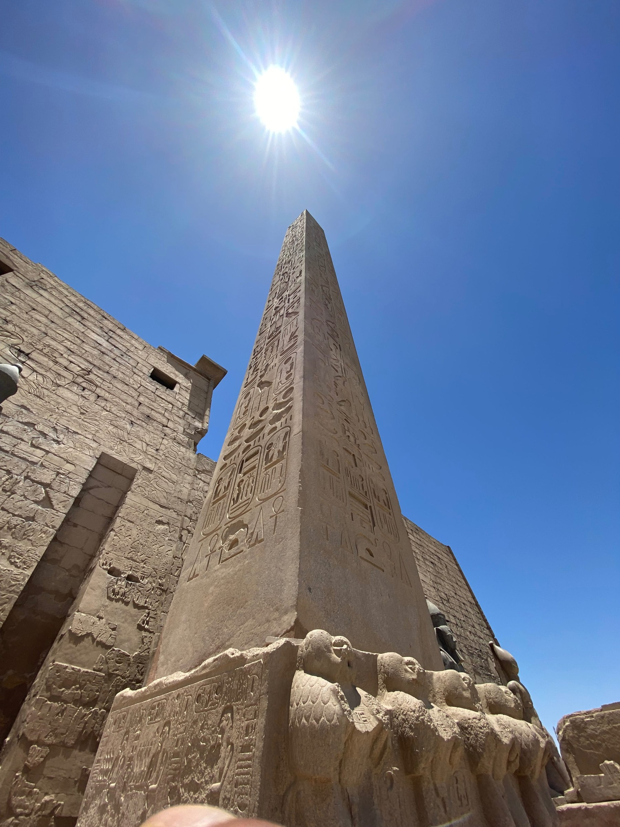
Fig. 1. Obelisk of Ramesses II at the first pylon of Luxor Temple, inscribed on all four faces with royal epithets and cartouches from base to pyramidion. Its twin was removed to the Place de la Concorde, Paris, in 1836.
Luxor Temple

3.2 The Hypostyle Hall, the Obelisk, and the Logic of Redundancy
The Hypostyle Hall at Karnak — 134 columns covering approximately 5,000 square meters, completed under Ramesses II — operates through a structurally related logic. The relief program does not tell a single narrative: it repeats, across 134 surfaces, the same legitimating formula of pharaoh before deity, pharaoh receiving divine sanction, pharaoh performing correct ritual. The repetition is the mechanism. Figs. 2 and 3 document this program at the level of individual column faces — hieroglyphic registers and pharaoh in adoration posture — illustrating how the symbolic vocabulary functions as a system of redundant claims rather than individual statements.

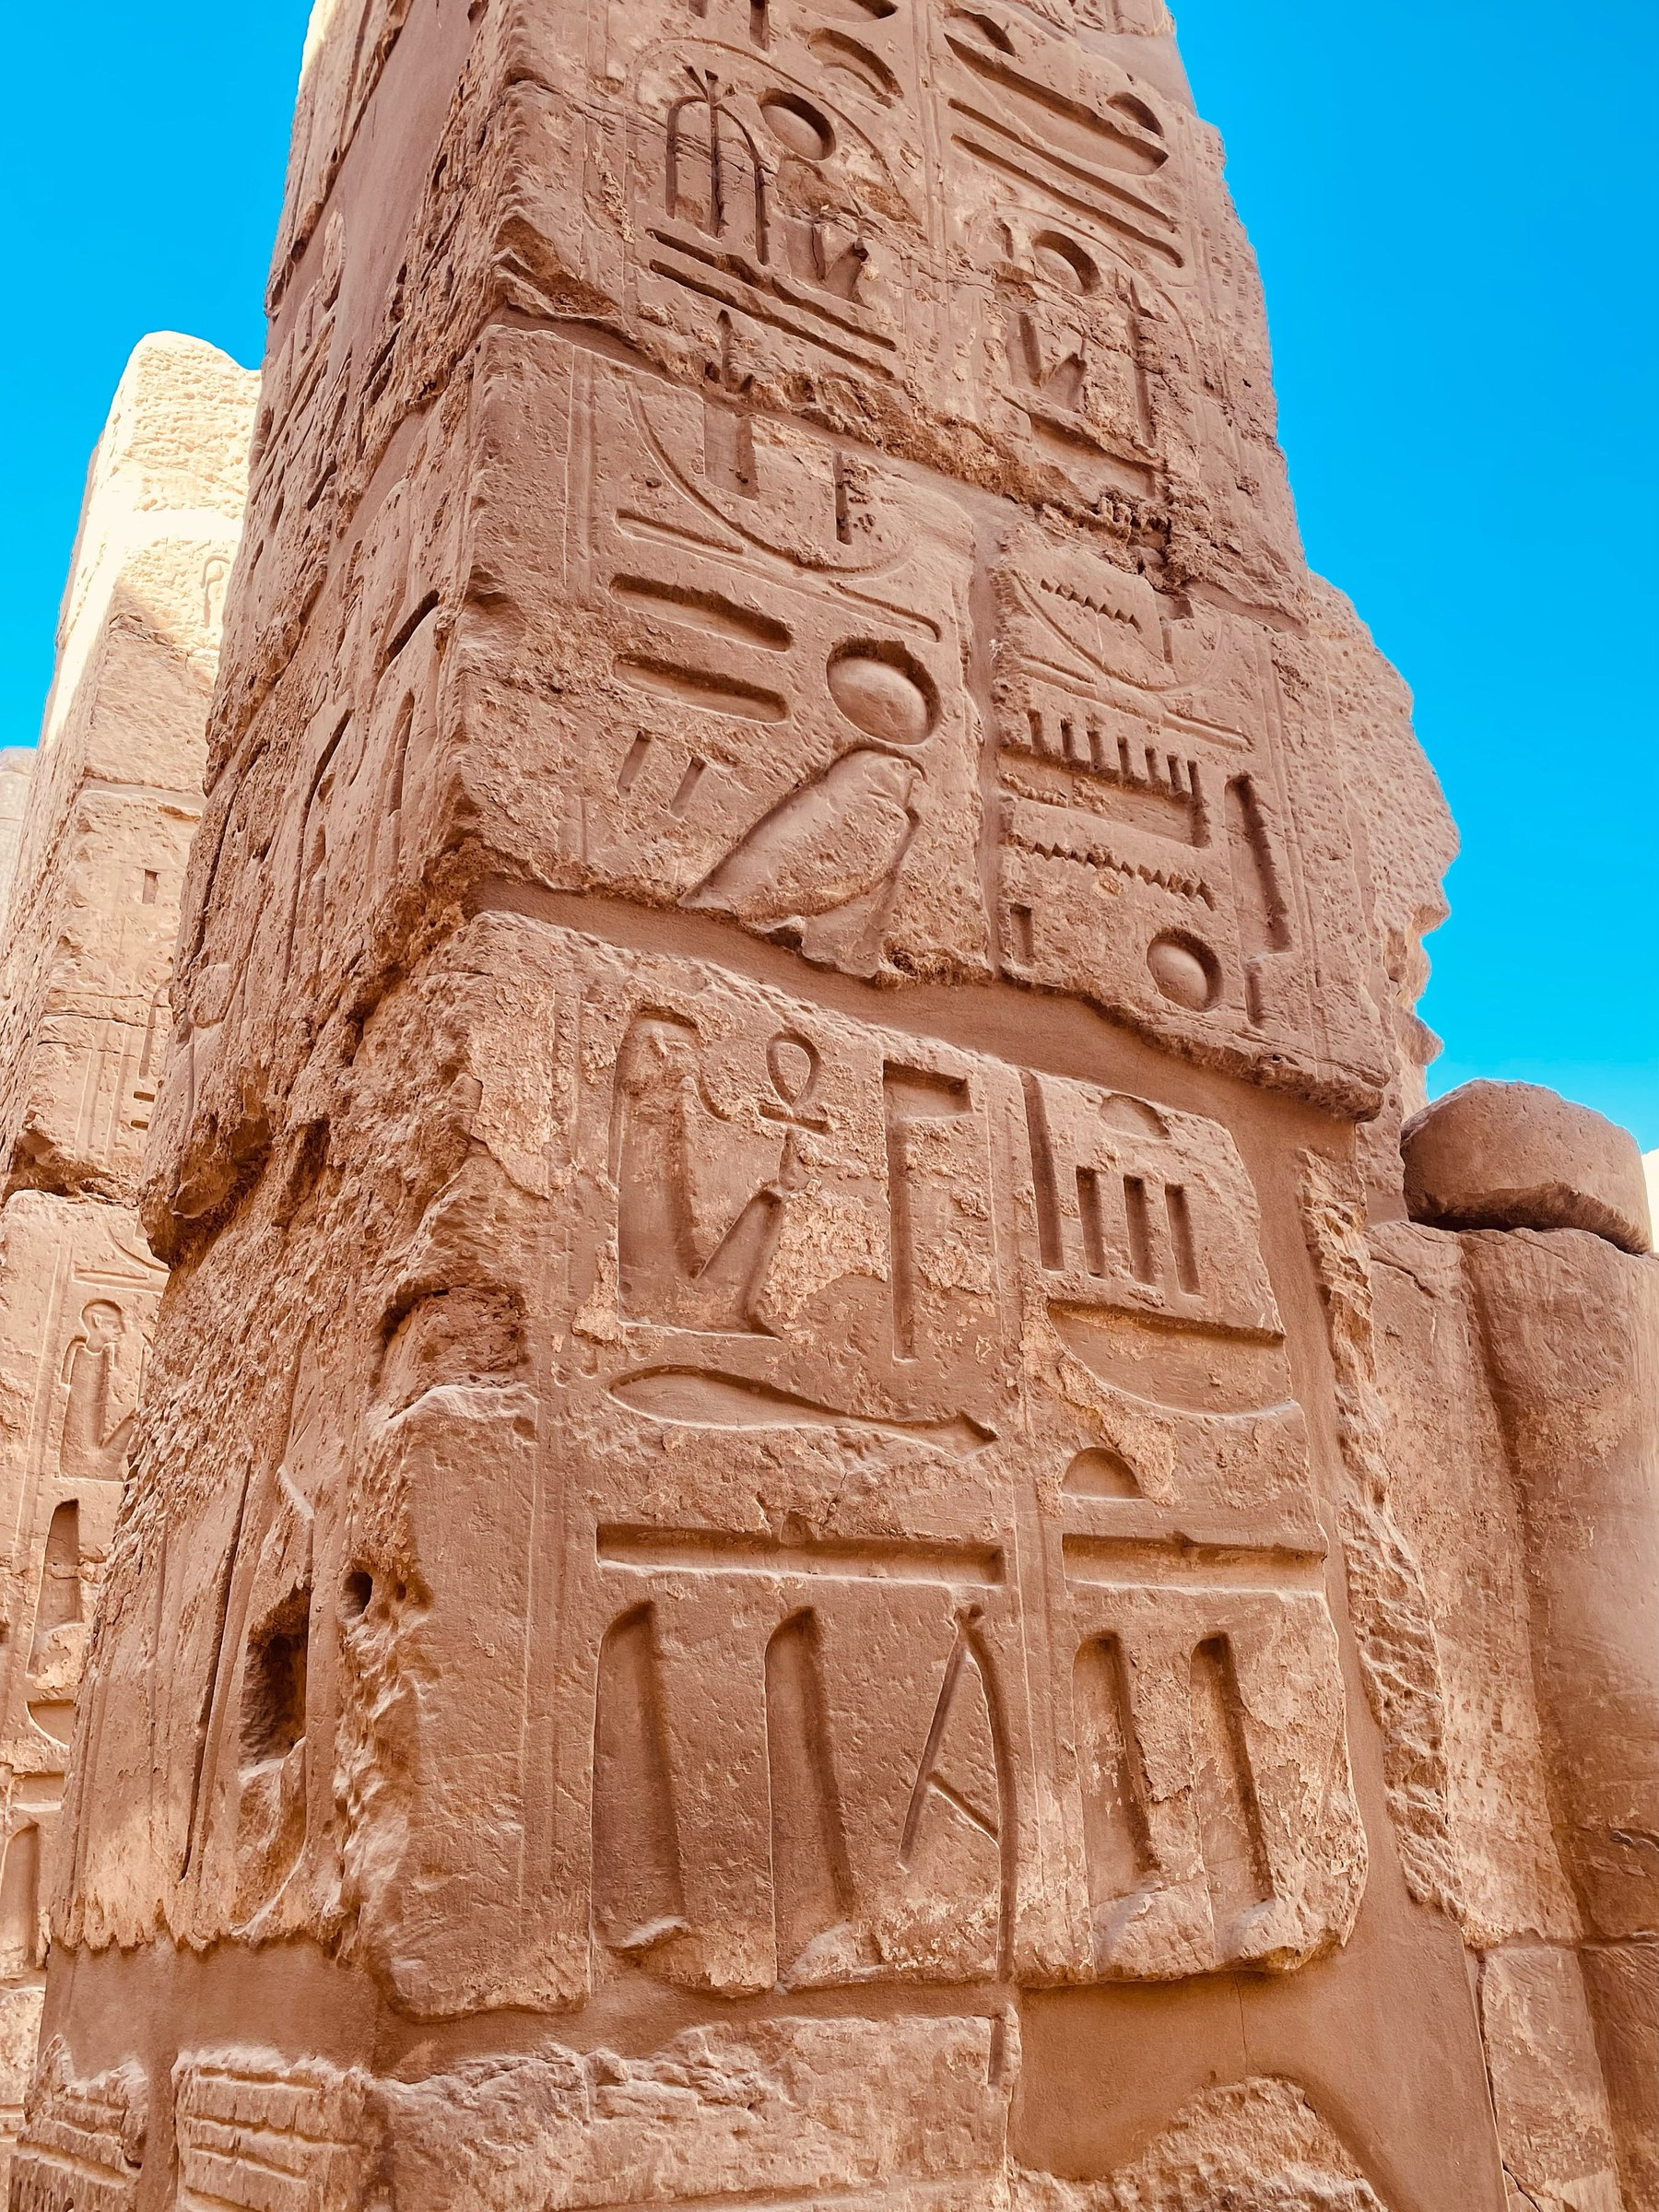
Fig. 2. Monumental pillar face, Karnak Temple — large hieroglyphic panel registers including cartouches and a kneeling figure with solar disk.
Karnak Temple, Luxor

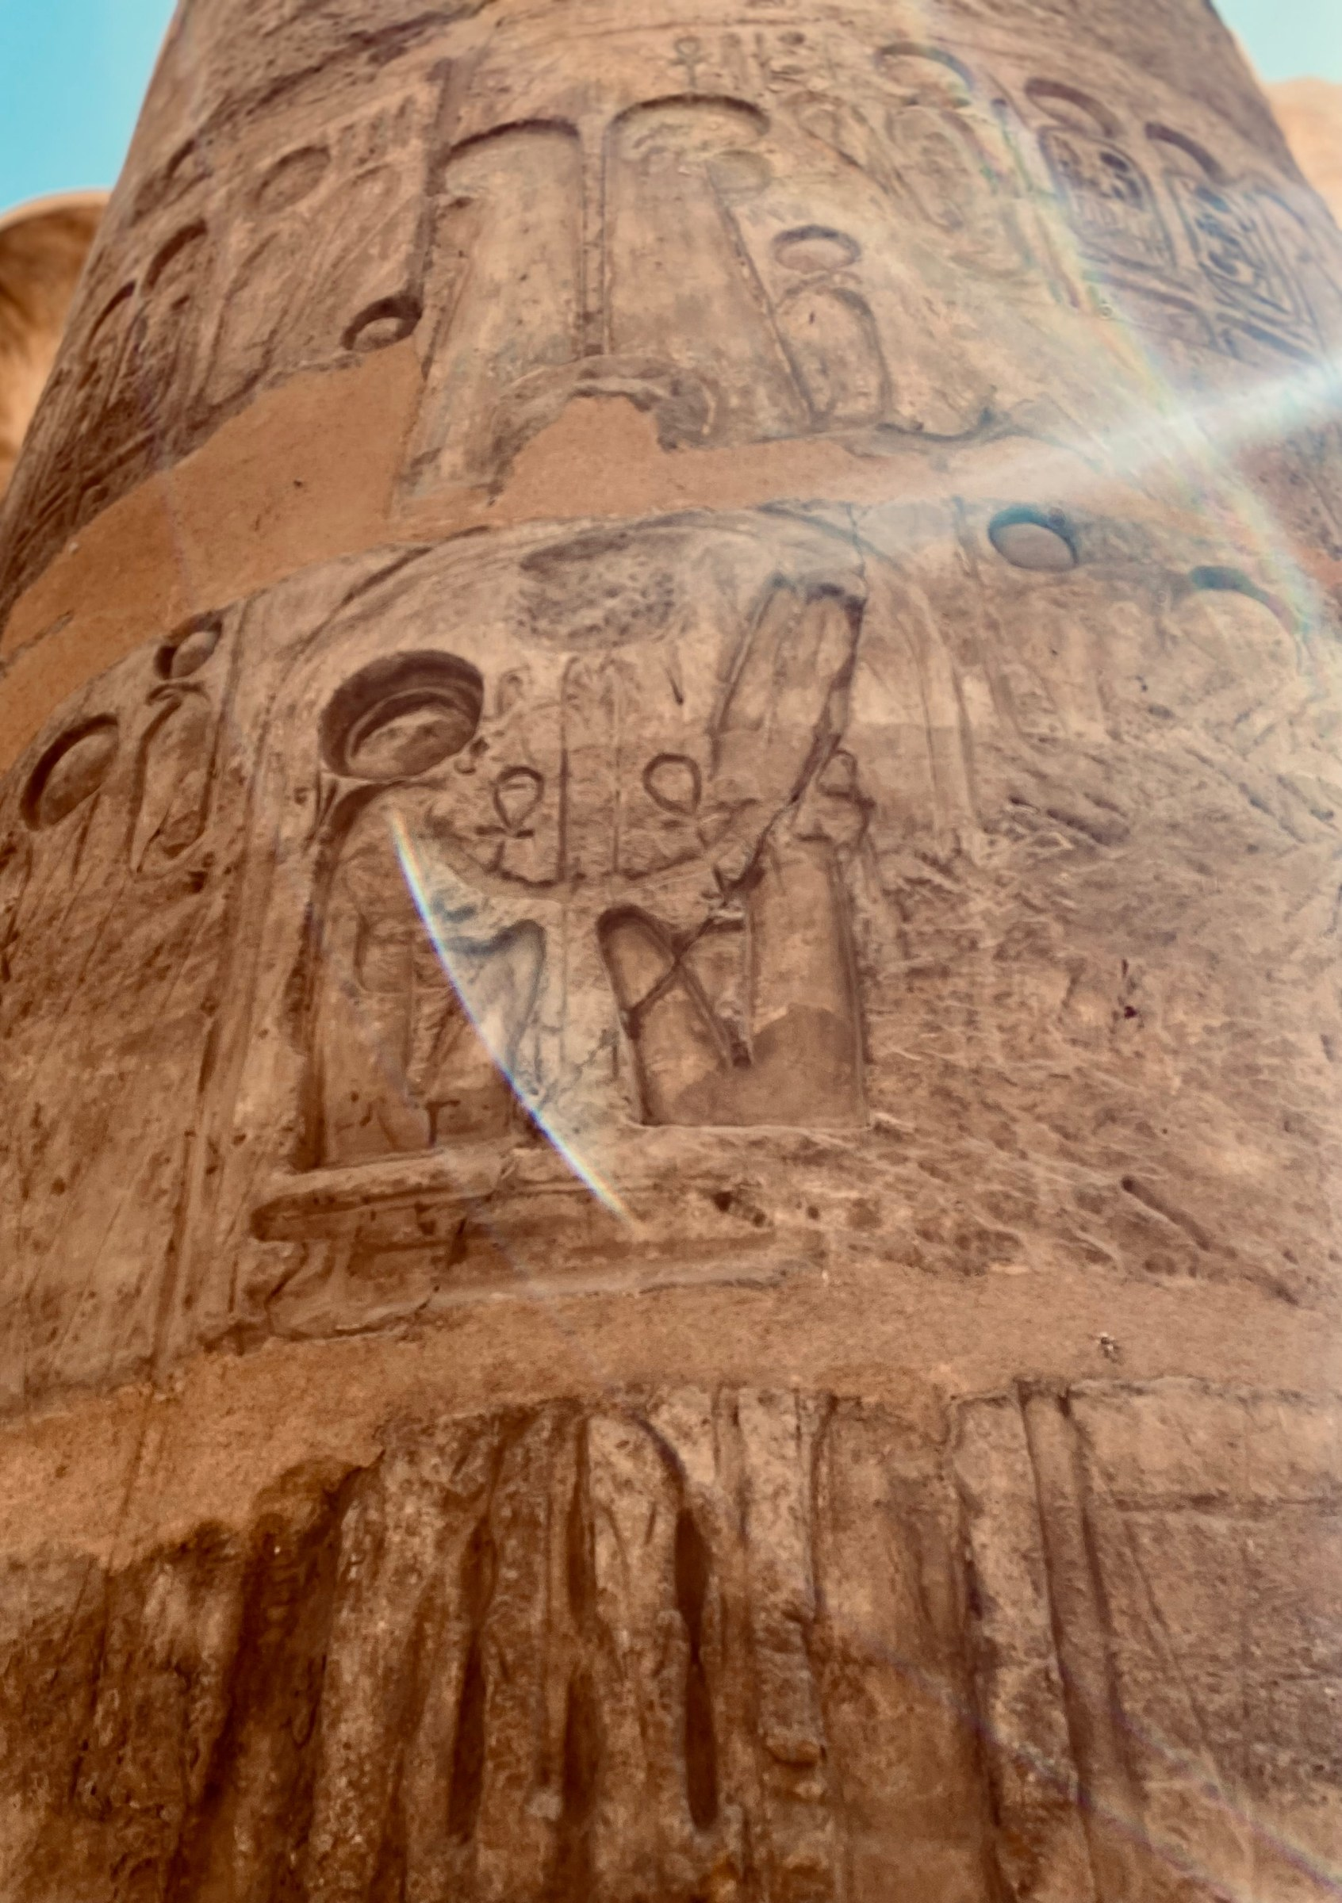
Fig. 3. Column face, Karnak Temple — pharaoh in adoration posture before a deity; ankh and was-scepter motifs. Part of the Hypostyle Hall's repeat offering-scene program across 134 column surfaces.
Karnak Temple, Luxor
The obelisk at Luxor Temple (Fig. 1) carried in its original gilded form the first light of dawn broadcast across the temple precinct: an instrument converting solar light into dynastic authority at every sunrise. Fig. 4 documents the sema-tawy panel at its base — two kneeling figures binding the plant emblems of Upper and Lower Egypt around a central pillar, with cartouche registers above — presenting the cosmological meaning of that solar mediation at the human scale.

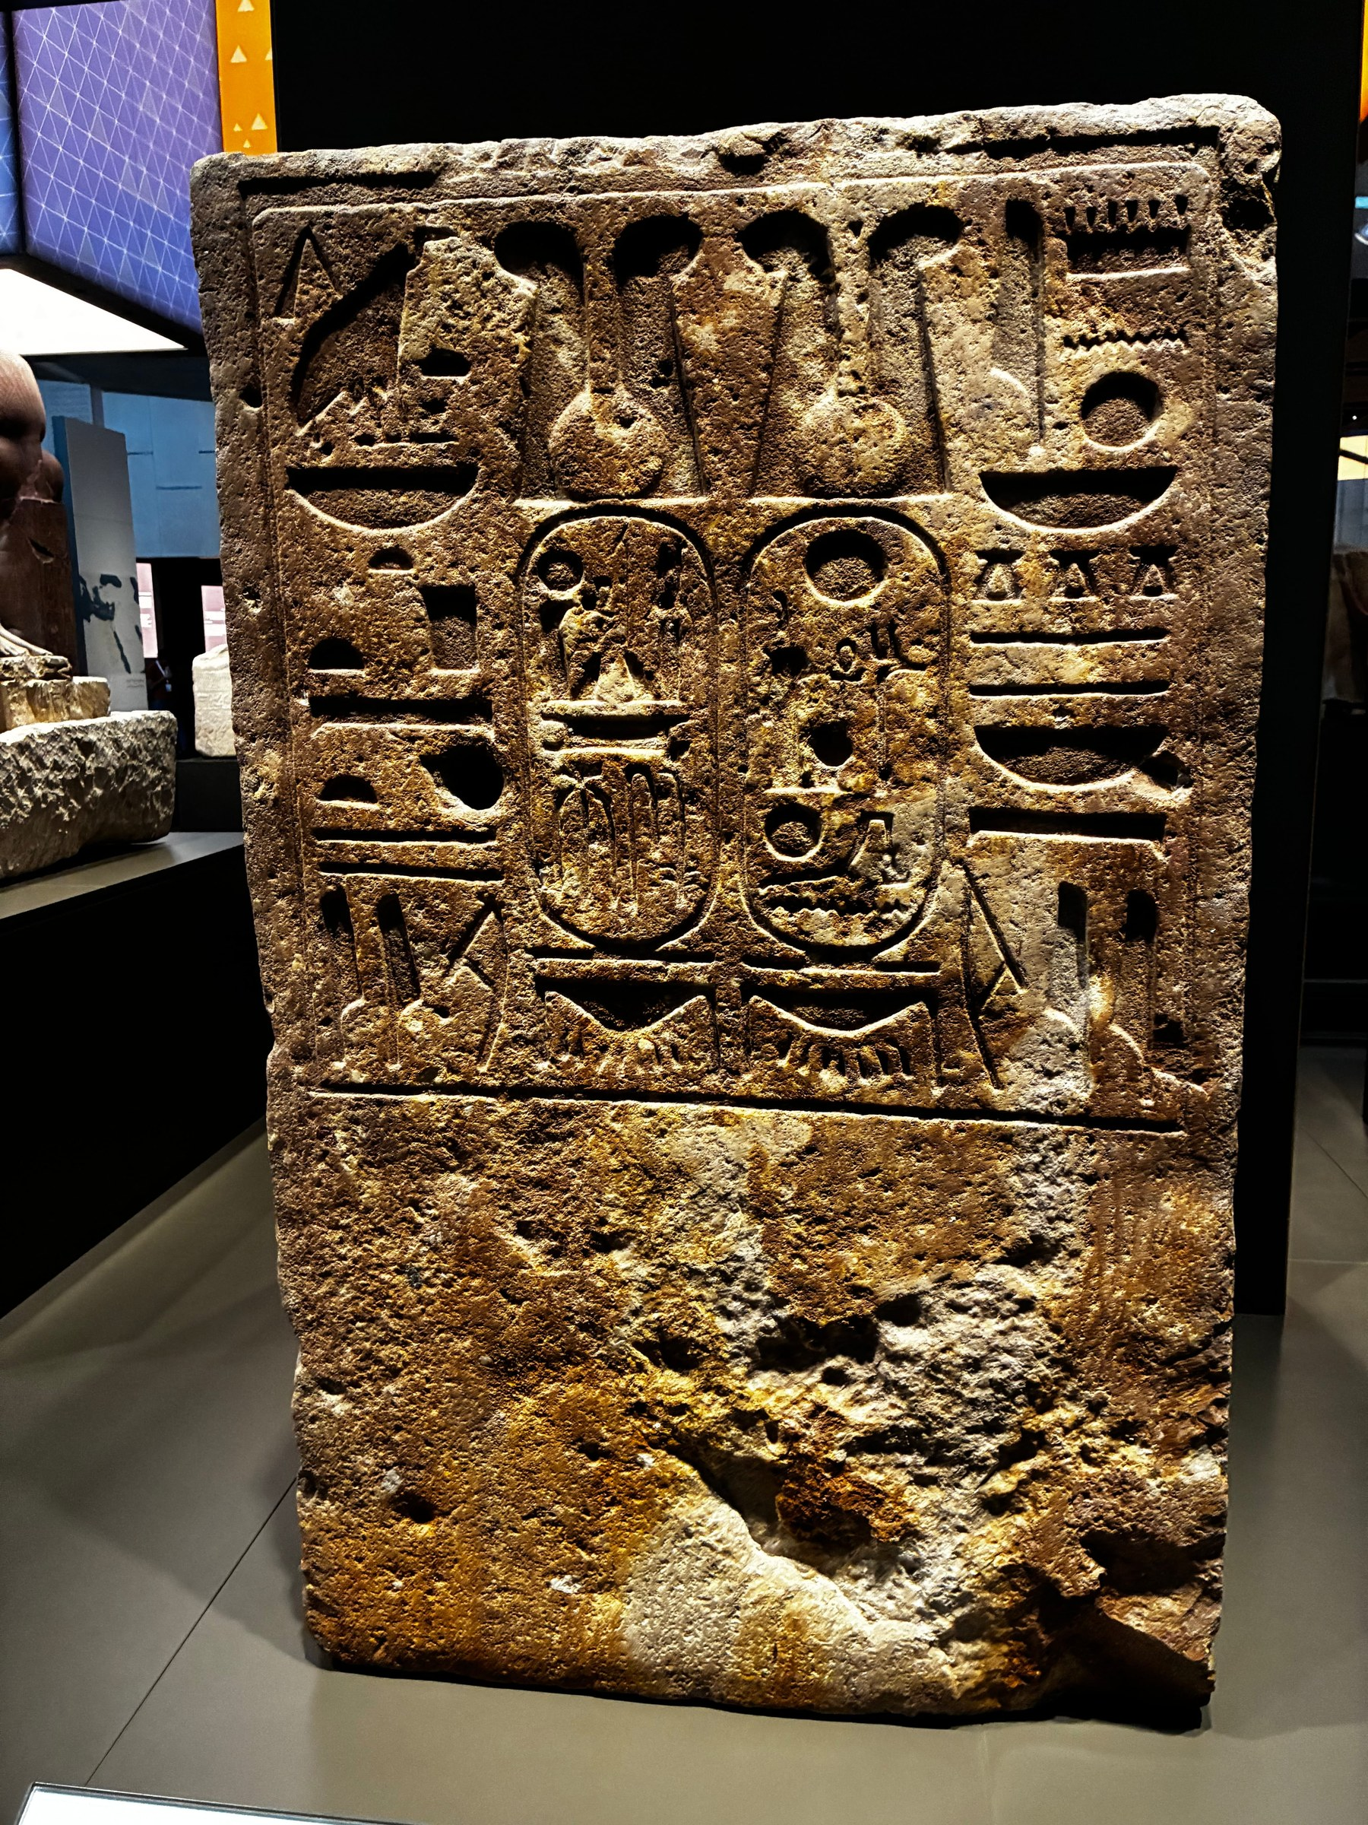
Fig. 4. Obelisk base panel, Luxor Temple. Sema-tawy (Two Lands unification) relief: two kneeling figures binding the papyrus and lotus emblems below Ramesside cartouche registers.
Grand Egyptian Meuseum , Giza

4. Kadesh: Cognitive Offloading Applied to Military-Diplomatic Legitimacy

4.1 The Battle and Its Symbolic Problem
The Battle of Kadesh (c. 1274 BCE) was, by any military assessment, a strategic draw. Ramesses II advanced into a Hittite ambush at Kadesh on the Orontes, was nearly captured, fought his way out with a personal charge celebrated in both the Bulletin and the Poem, and retreated without taking the city. Neither side achieved a decisive military outcome. Sixteen years later, the two powers signed the Treaty of Kadesh (c. 1259 BCE) under Hattusili III, establishing the Orontes River as the boundary between their spheres and including a mutual extradition clause (Langdon and Gardiner, 1920; Murnane, 1990). This is the military and diplomatic reality.
The symbolic reality Ramesses II constructed around Kadesh is analytically more significant. The Bulletin (a prose account) and the Poem (an extended literary narrative in which Ramesses is portrayed as a lone warrior saved by divine intervention when his army failed him) were composed in the immediate aftermath and inscribed across every major temple in Egypt — Abu Simbel, Abydos, Karnak, Luxor, the Ramesseum, Aksha, Derr, and Gerf Hussein — as well as preserved in multiple papyrus copies, including Papyrus Sallier III and Papyrus Raifet (Gardiner, 1960; Lichtheim, 1976, II:57–72). The Treaty itself was inscribed at Karnak and the Ramesseum in both hieroglyphic and Akkadian cuneiform. This distribution is symbolic pre-emption: the meaning of Kadesh was fixed before the political outcome was fully resolved, inscribed in a medium that could not be revised.

4.2 The Treaty as Symbolic Stabilization Event
The Treaty of Kadesh is the oldest surviving international peace treaty for which both copies are partially preserved — the Egyptian hieroglyphic version on temple walls and the Akkadian cuneiform version on tablets recovered from Hattusa (Beckman, 1996). Within DSSM, it functions as a cognitive offloading artifact: a bilateral political agreement converted into a publicly inscribed symbolic object that simultaneously represented the agreement's content, authenticated it through divine witness (both Egyptian and Hittite gods are invoked as guarantors), and made it materially persistent independent of the negotiating parties' continued existence (Hutchins, 1995; Vondoom, 2025).
The FCP scores this artifact at maximum on four observables: Externalized Cognition (E=2, S=2 — canonical symbolic forms including divine witness invocations and full royal titularies); Distributed Symbolic Authority (E=2, S=2 — legitimacy anchored in both pantheons simultaneously); Mnemonic Architecture (E=2, S=2 — temple wall inscription as the most durable medium available); and Symbolic Stabilization (E=2, S=2 — the boundary defined was referenced in subsequent administrative and military records). The Treaty is a Stage 4 cognitive offloading event: political authority outsourced to inscribed stone. The Poem, composed in the earliest known Egyptian literary epic register, functions as a Portable Symbolic Anchor that carries the divine-relationship claim across time and space without requiring witness or institutional continuity (Lichtheim, 1976; Assmann, 2002). Fig. 5 documents the standard distribution medium for such claims across the kingdom.

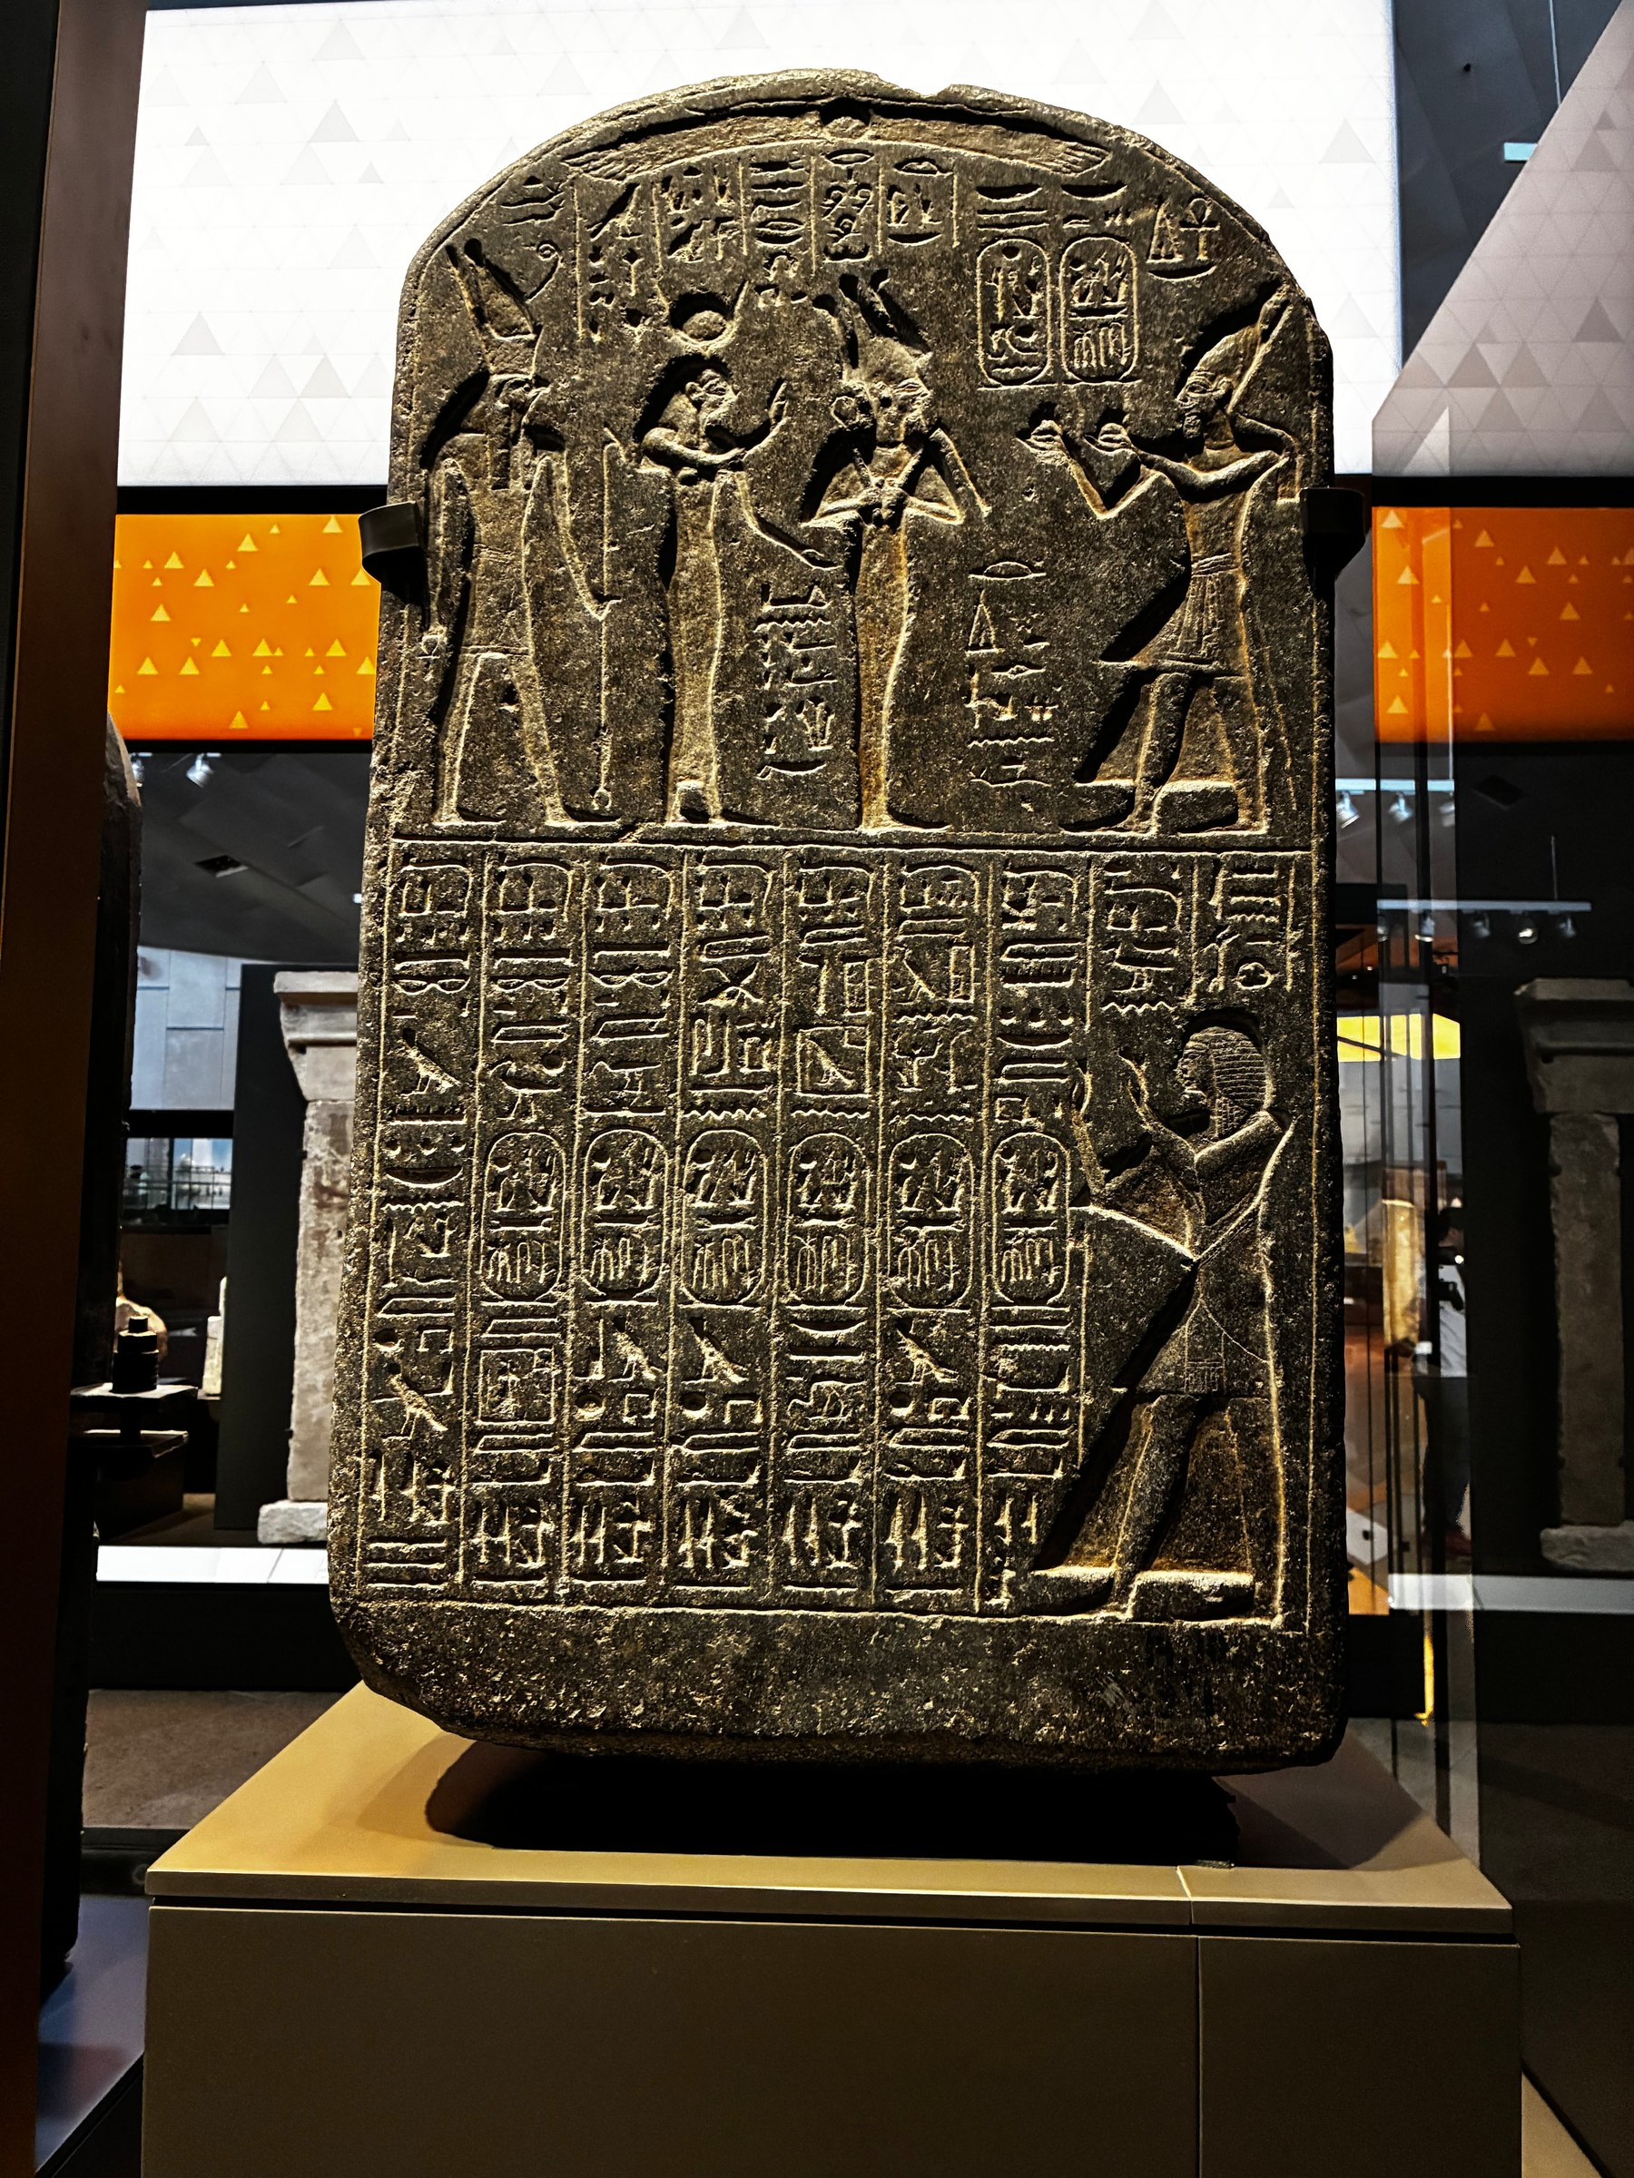
Fig. 5. Round-topped dedicatory stele, black granite. Lunette scene: Ramesses before deities. Below: hieroglyphic text columns. Portable Symbolic Anchor type — distributed across boundary zones and cult sites throughout the kingdom.
National Museum of Egyptian Civilization (NMEC), Cairo

5. Living Horus Embodiment as Governance Philosophy

5.1 The Horus Theology and Its Political Function
Egyptian pharaonic theology constituted the living king as the embodiment of Horus — the falcon-headed son of Osiris, legitimate heir of the divine order — while simultaneously constituting the dead king as Osiris, whose resurrection sustained the cosmic cycle. This dual embodiment was not a metaphor available for political invocation: it was the ontological foundation of pharaonic governance (Hornung, 1982; Quirke, 1992). For Ramesses II, the Horus embodiment theology carried a profound truth: divine kingship is not a matter of bloodline alone, but of demonstrated divine performance. The pharaoh who is fully constituted as Horus on the day of coronation must then prove that identification through action — through the competences that divine embodiment demands. Ramesses II did not merely claim the Horus identity; he inhabited it with a totality that no successor would match. What the coronation required was that the embodied Horus perform consistently with the divine identity — that the pharaoh demonstrate, through ongoing action, the competences that divine embodiment claimed. Ramesses II answered that demand across every domain simultaneously.

5.2 Ramesses as Hapi: The Rarest Iconographic Claim
Fig. 6 (NMEC) — Ramesses depicted as Hapi, the Nile inundation deity, in the nw-pot offering posture, flanked by kneeling figures — is one of the rarest surviving examples of a pharaoh shown embodying the fertility function that was cosmologically central but iconographically almost never associated with a named ruler. The statue places Ramesses within the category of divine natural process: not merely performing ritual before Hapi, but constituted as Hapi himself. This is a Symbolic Regulation artifact of the highest DSSM specificity: it regulates the symbolic meaning of the pharaoh's person by categorically identifying it with a cosmological function, foreclosing any interpretation of pharaonic authority as merely political or administrative (Vondoom, 2025; Hornung, 1982).

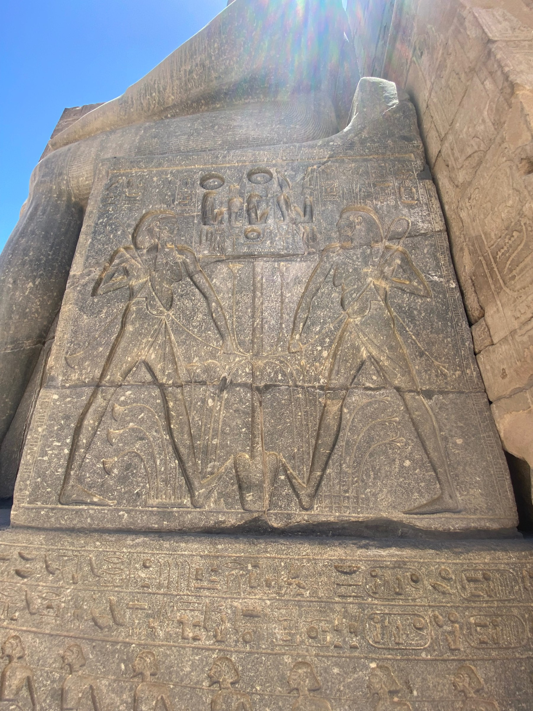
Fig. 6. Ramesses II depicted as Hapi, the Nile inundation deity, in the nw-pot offering posture.
Luxor Temple

5.3 The GEM Colossus, the Kneeling Figure, and the Ontology of Scale
The eleven-meter granite colossus of Ramesses II at the Grand Egyptian Museum (Fig. 7) — originally from Mit Rahina (Memphis), now the centerpiece of the GEM atrium — instantiates the Horus embodiment theology at a scale that makes the identification visceral rather than textual. At this scale, the statue does not represent divine presence; it instantiates it. The GEM's architectural decision to organize the atrium around this colossus reproduces the same symbolic logic as the original temple design: the building organized around the cult image as Egyptian temple space was organized around the divine (Quirke, 1992).

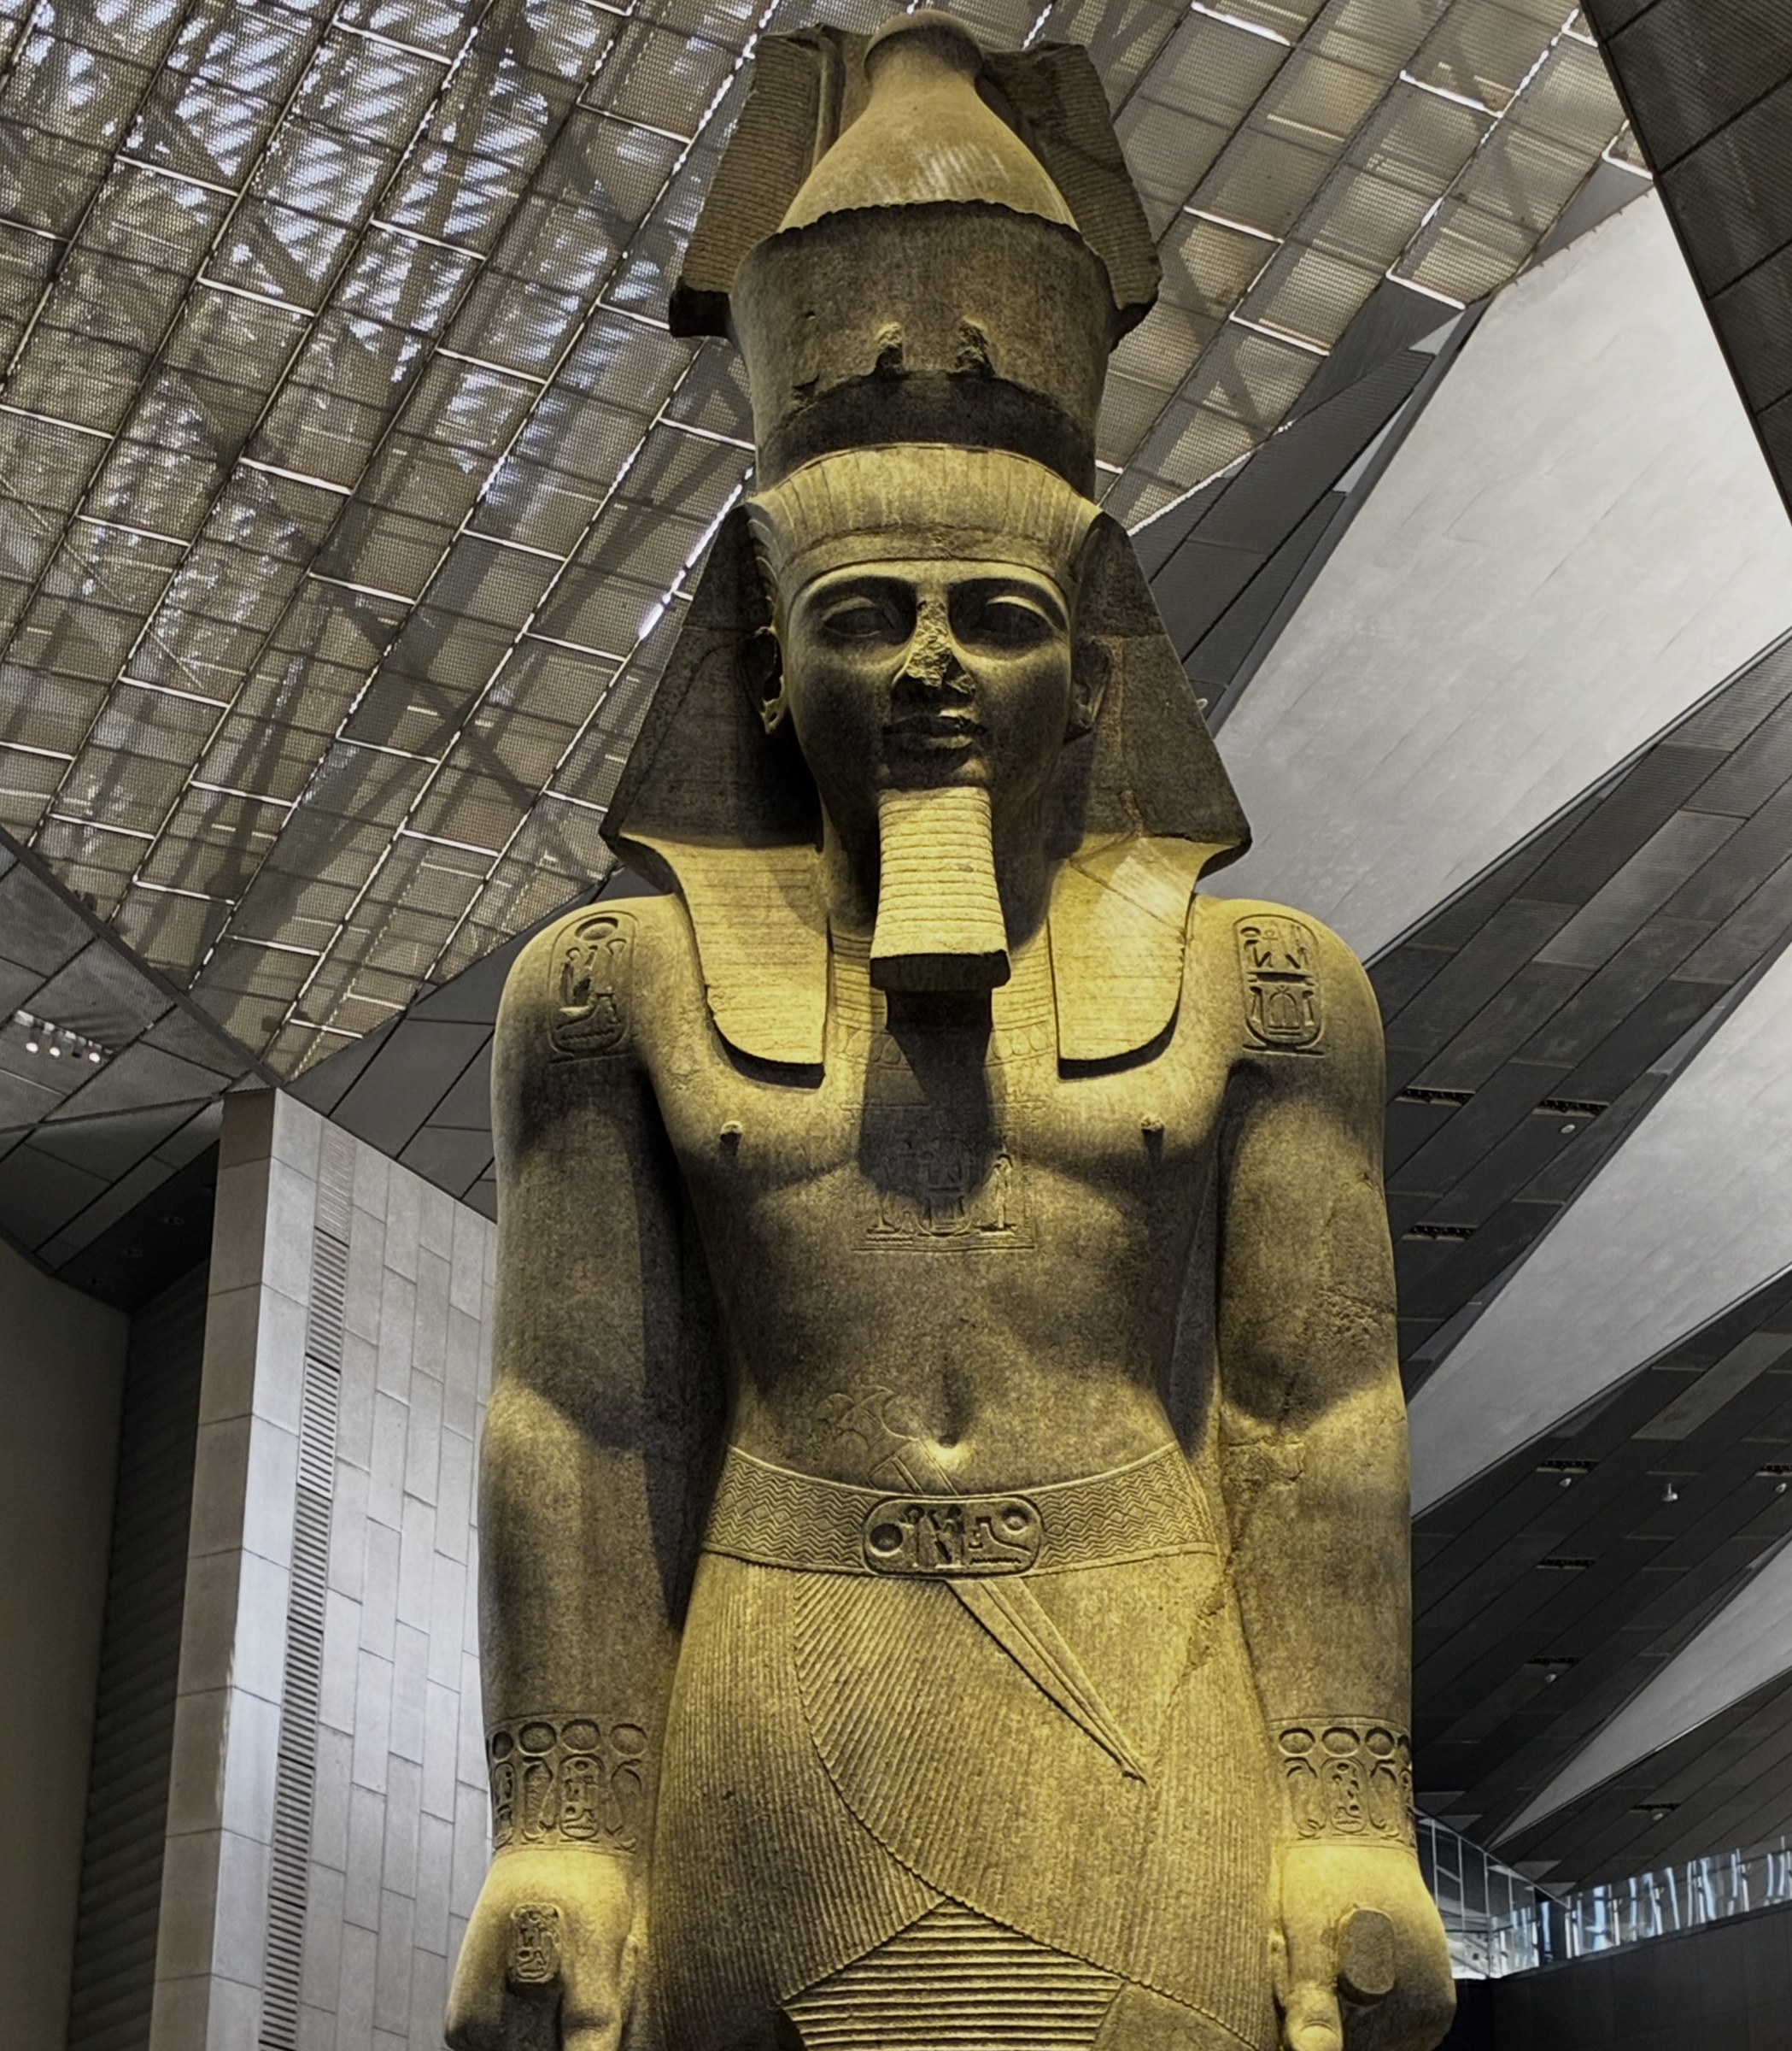
Fig. 7. Standing colossal statue of Ramesses II, granite (11 m), originally from Mit Rahina (Memphis). Nemes headdress and double crown; cartouches on shoulders and belt.
Grand Egyptian Museum (GEM), Giza

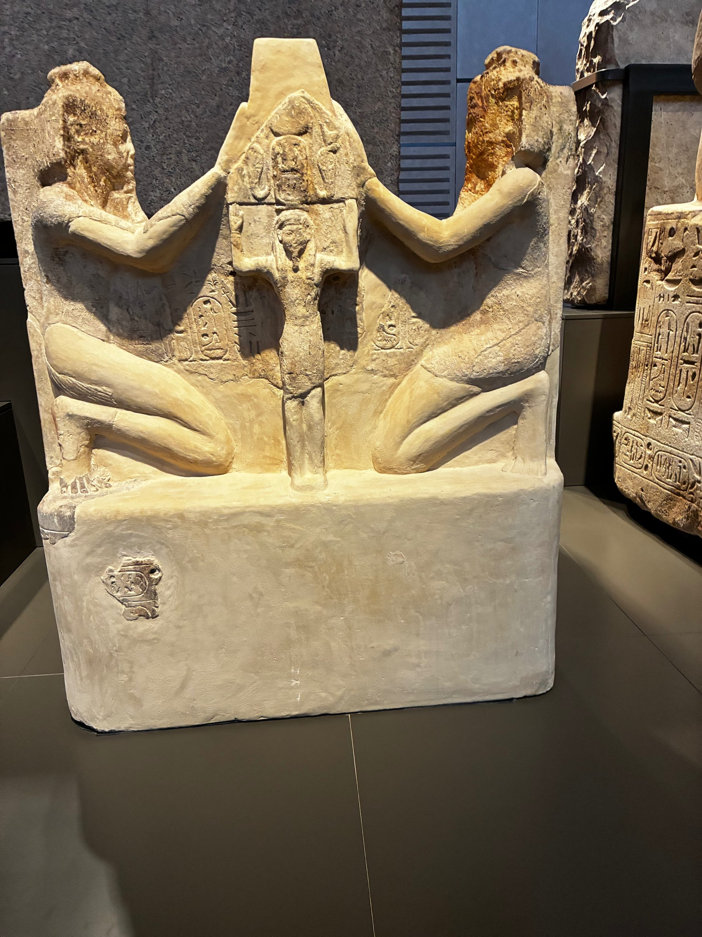
Fig. 8. Ramesses II in kneeling offering posture, presenting the nw-vessel. Granite. The posture enacts the pharaoh as active ritual agent before the divine — the same claim as the colossus, rendered at human scale.
Grand Egyptian Museum (GEM), Giza
The seated dyads (Figs. 9 and 10) — Ramesses II paired with a deity on a shared throne — document the formal equation of royal and divine persons at the level of composition. Shared throne and equivalent seated posture constitute an identity claim rather than an association: the pharaoh is beside the god, in the same postural register. This is the Horus theology rendered in granite: not subordination, not supplication, but ontological equivalence (Aldred, 1980; Hornung, 1982).

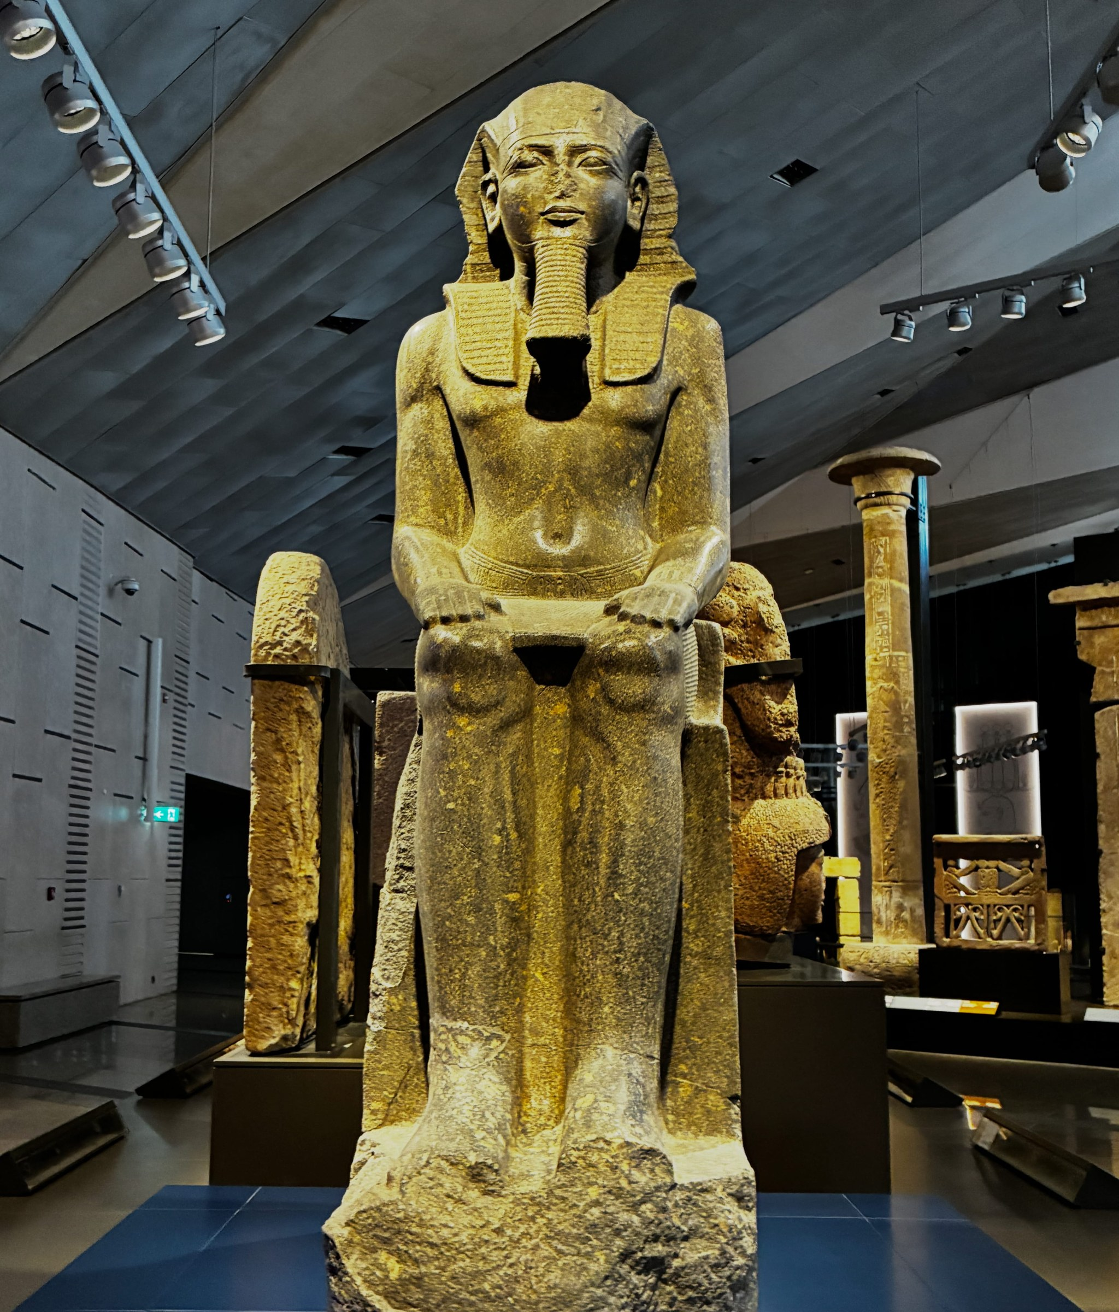
Fig. 9. Sitting Statue of Ramesses II. Granite.
Grand Egyptian Museum (GEM), Giza

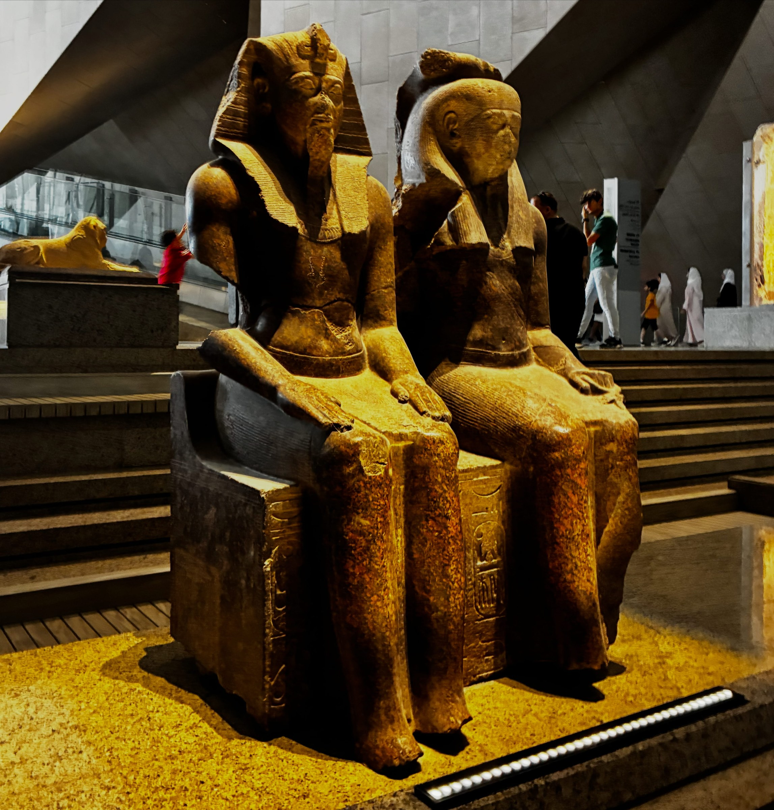
Fig. 10. Two seated colossal figures of Ramesses II and a deity on a shared throne. Granite..
National Museum of Egyptian Civilization (NMEC), Cairo

6. Cross-Media Redundancy as the Defining Ramesside Mechanism

6.1 Geographic Density and the Simultaneity of Inscription
The defining structural feature of Ramesside symbolic output, from a DSSM perspective, is not the number of monuments or the quality of the art — both are exceptional — but the geographic simultaneity and cross-media density of the symbolic program. Earlier pharaohs built and inscribed extensively, but typically through sequential accumulation. Ramesses II's program operated differently: the Kadesh Bulletin-Poem was inscribed at eight temple sites in apparent coordination; the cartouche program extended from the Nile Delta to Nubia in a pattern suggesting systematic deployment; the modification and re-inscription of existing monuments — including the controversial practice of replacing predecessors' cartouches with his own — achieved a density of symbolic presence across the existing substrate that would have taken subsequent dynasties generations to approach (Kitchen, 1975–1990; Brand, 2000).
The field photographs document the material signature of this density across multiple surface categories. Fig. 11 shows the Karnak outer wall relief program — dense hieroglyphic registers with processional figures and a large central erasure zone consistent with damnatio memoriae subsequently re-inscribed within the Ramesside program. This illustrates the comprehensive coverage of the program: not only building new surfaces but overwriting and absorbing existing ones. Fig. 12 shows a cartouche inscribed on the knee of a sphinx — a surface accessible only at close range — evidence that the program operated independently of processional visibility.

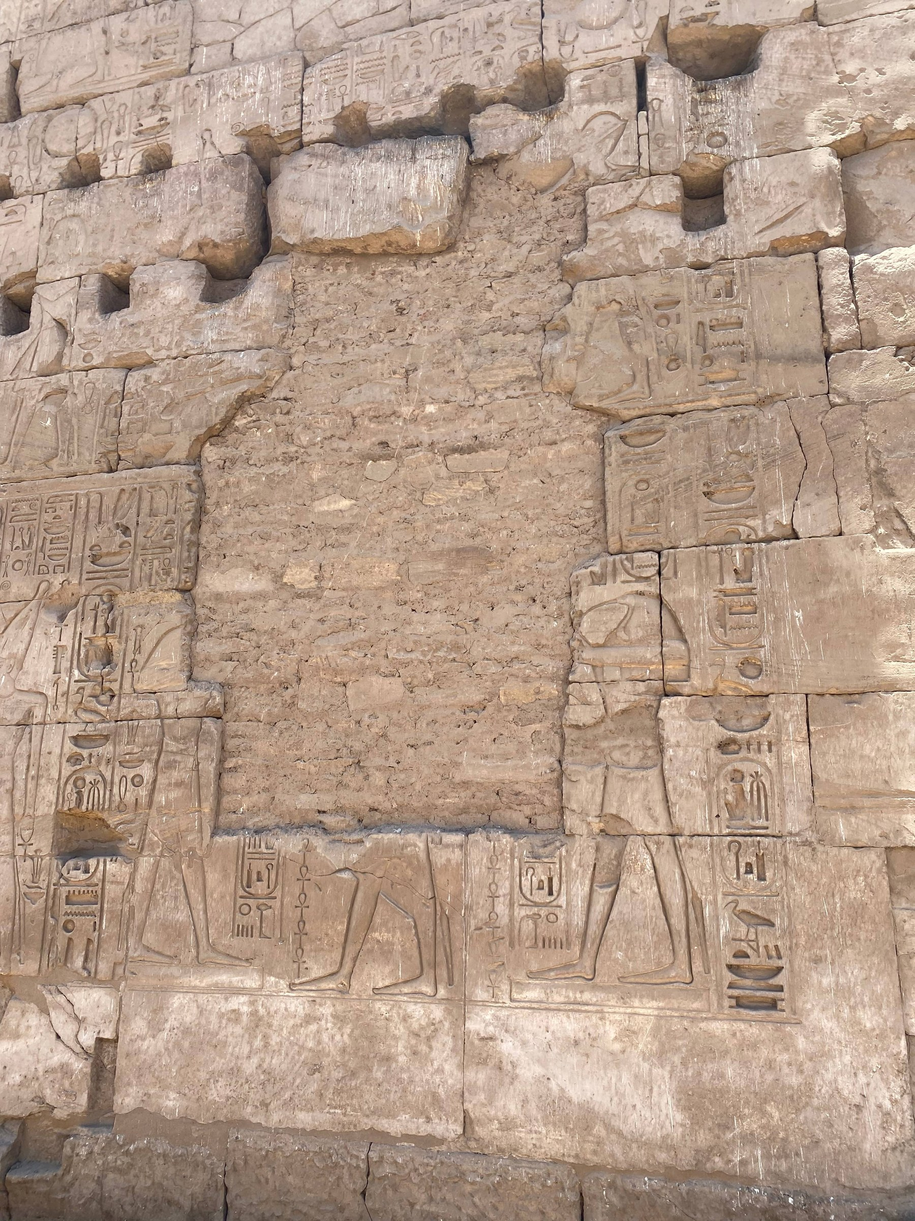
Fig. 11. Outer wall relief panel, Karnak Temple. Dense hieroglyphic registers with processional figures. The large central erasure zone is consistent with damnatio memoriae subsequently re-inscribed within the Ramesside program.
Karnak Temple, Luxor

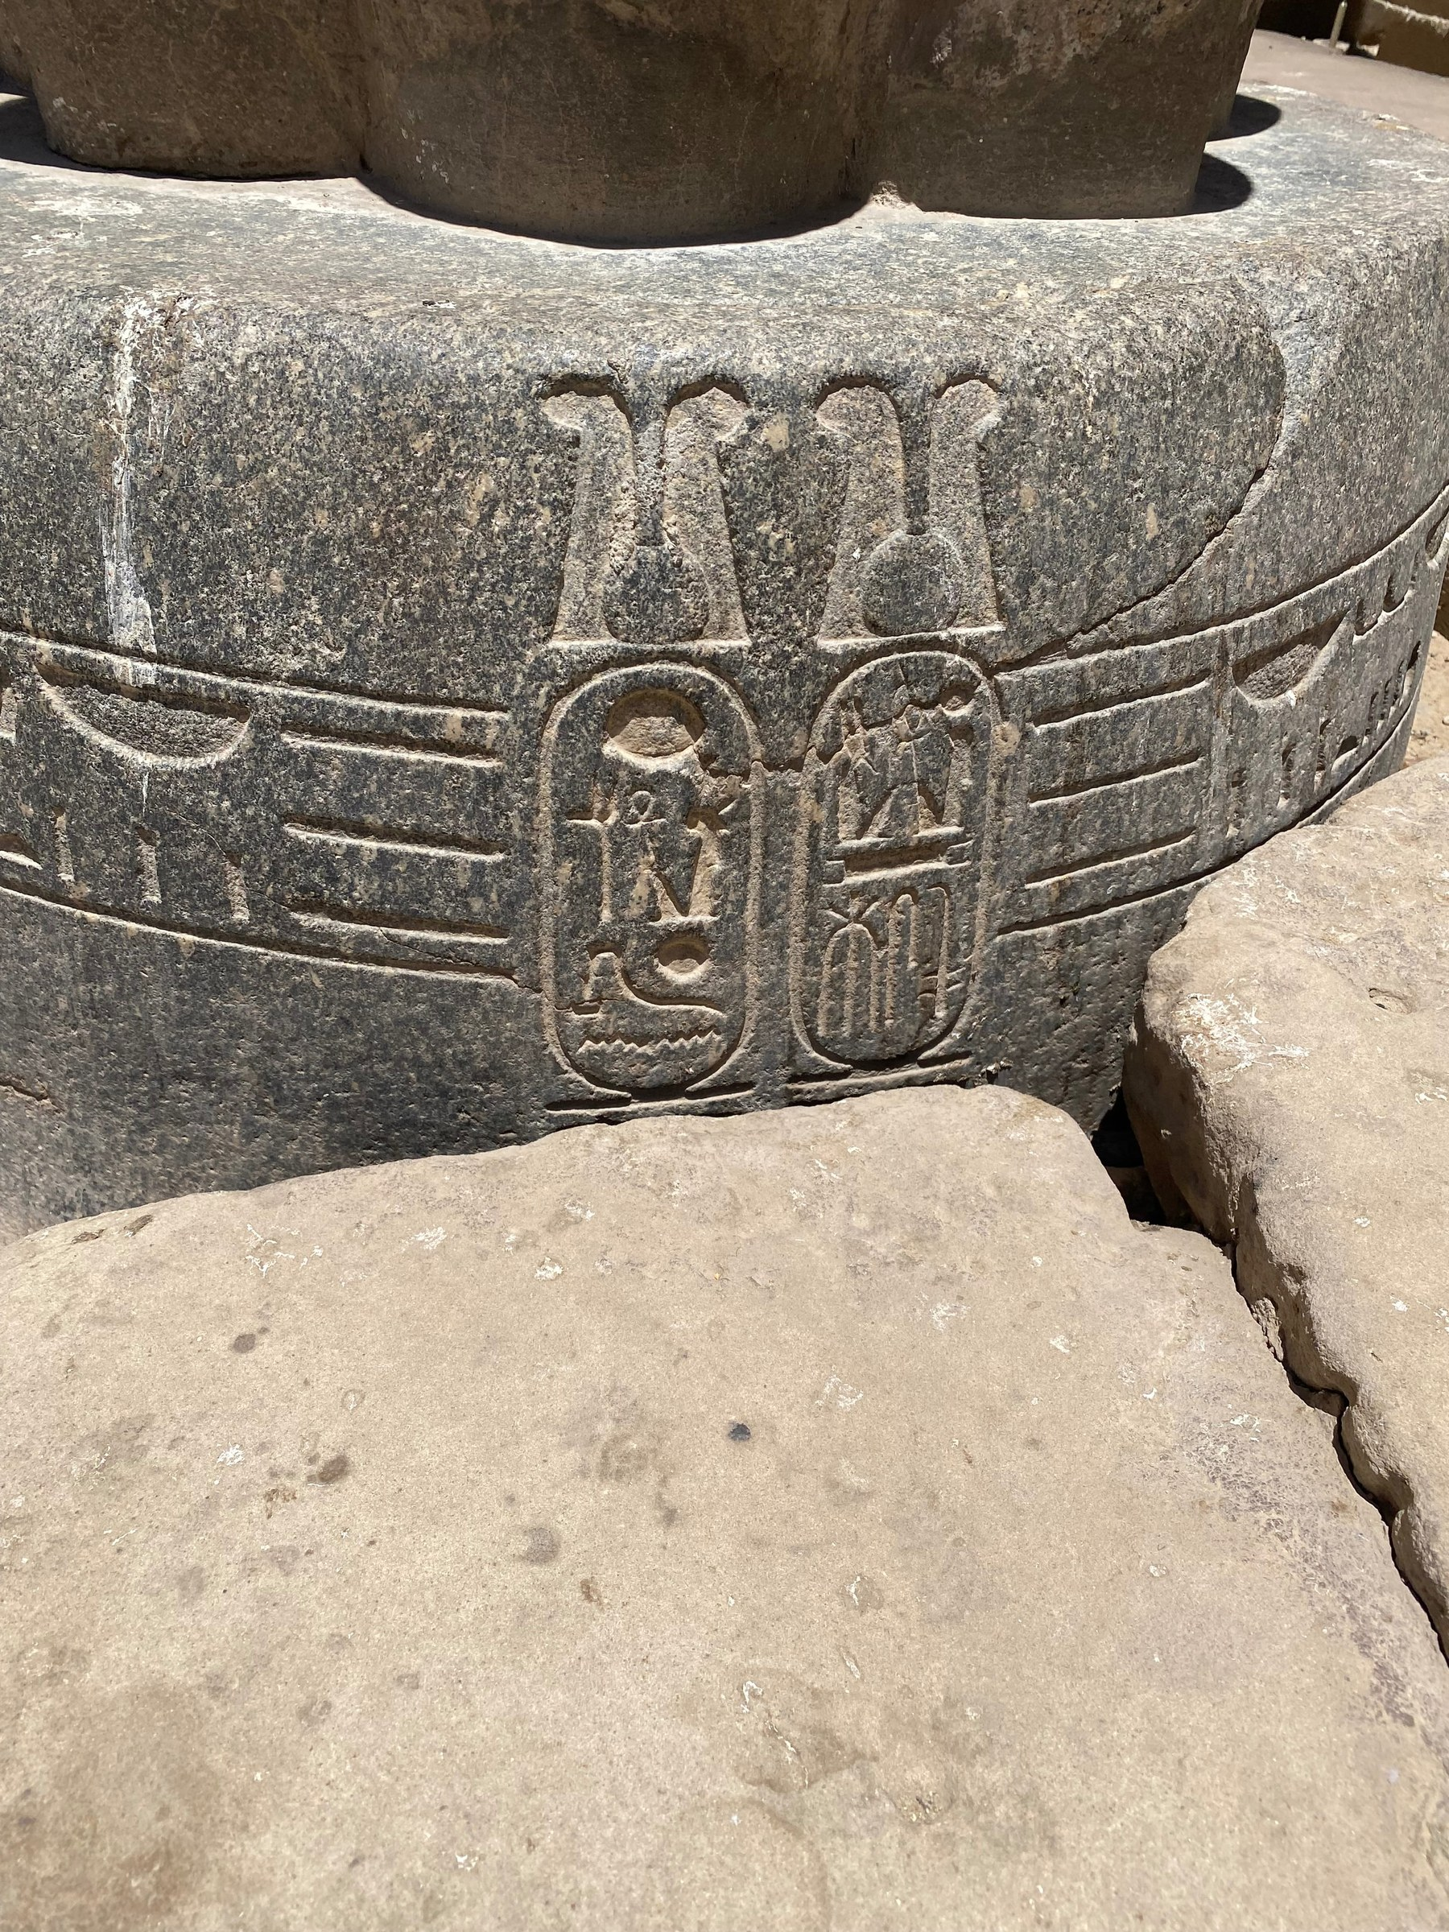
Fig. 12. Double cartouche of Ramesses II on a granite column base, Karnak. Prenomen Usermaatre Setepenre and nomen Ramesses Meryamun within shen-ring framing below a feather headdress.
Karnak Temple, Luxor
6.2 The Cartouche as the Unit of Saturation
The double cartouche documented in Fig. 13 — prenomen Usermaatre Setepenre and nomen Ramesses Meryamun, in the shen-ring framing — is the fundamental symbolic unit of the Ramesside program. In Egyptian symbolic theology, the cartouche is the shen-ring extended into an enclosure: a loop of rope forming a closed oval that protects the royal name from all harm and associates the named individual with the eternal solar circuit (Gardiner, 1961; Faulkner, 1962). Each cartouche inscription simultaneously identifies a surface as Ramesside, performs a protective act for the royal name, and makes a cosmological claim. Multiplied across hundreds of surfaces from Nubia to the Delta, the cartouche program constitutes the entire symbolic geography of Egypt as a single, continuous, Ramesside cosmological claim.

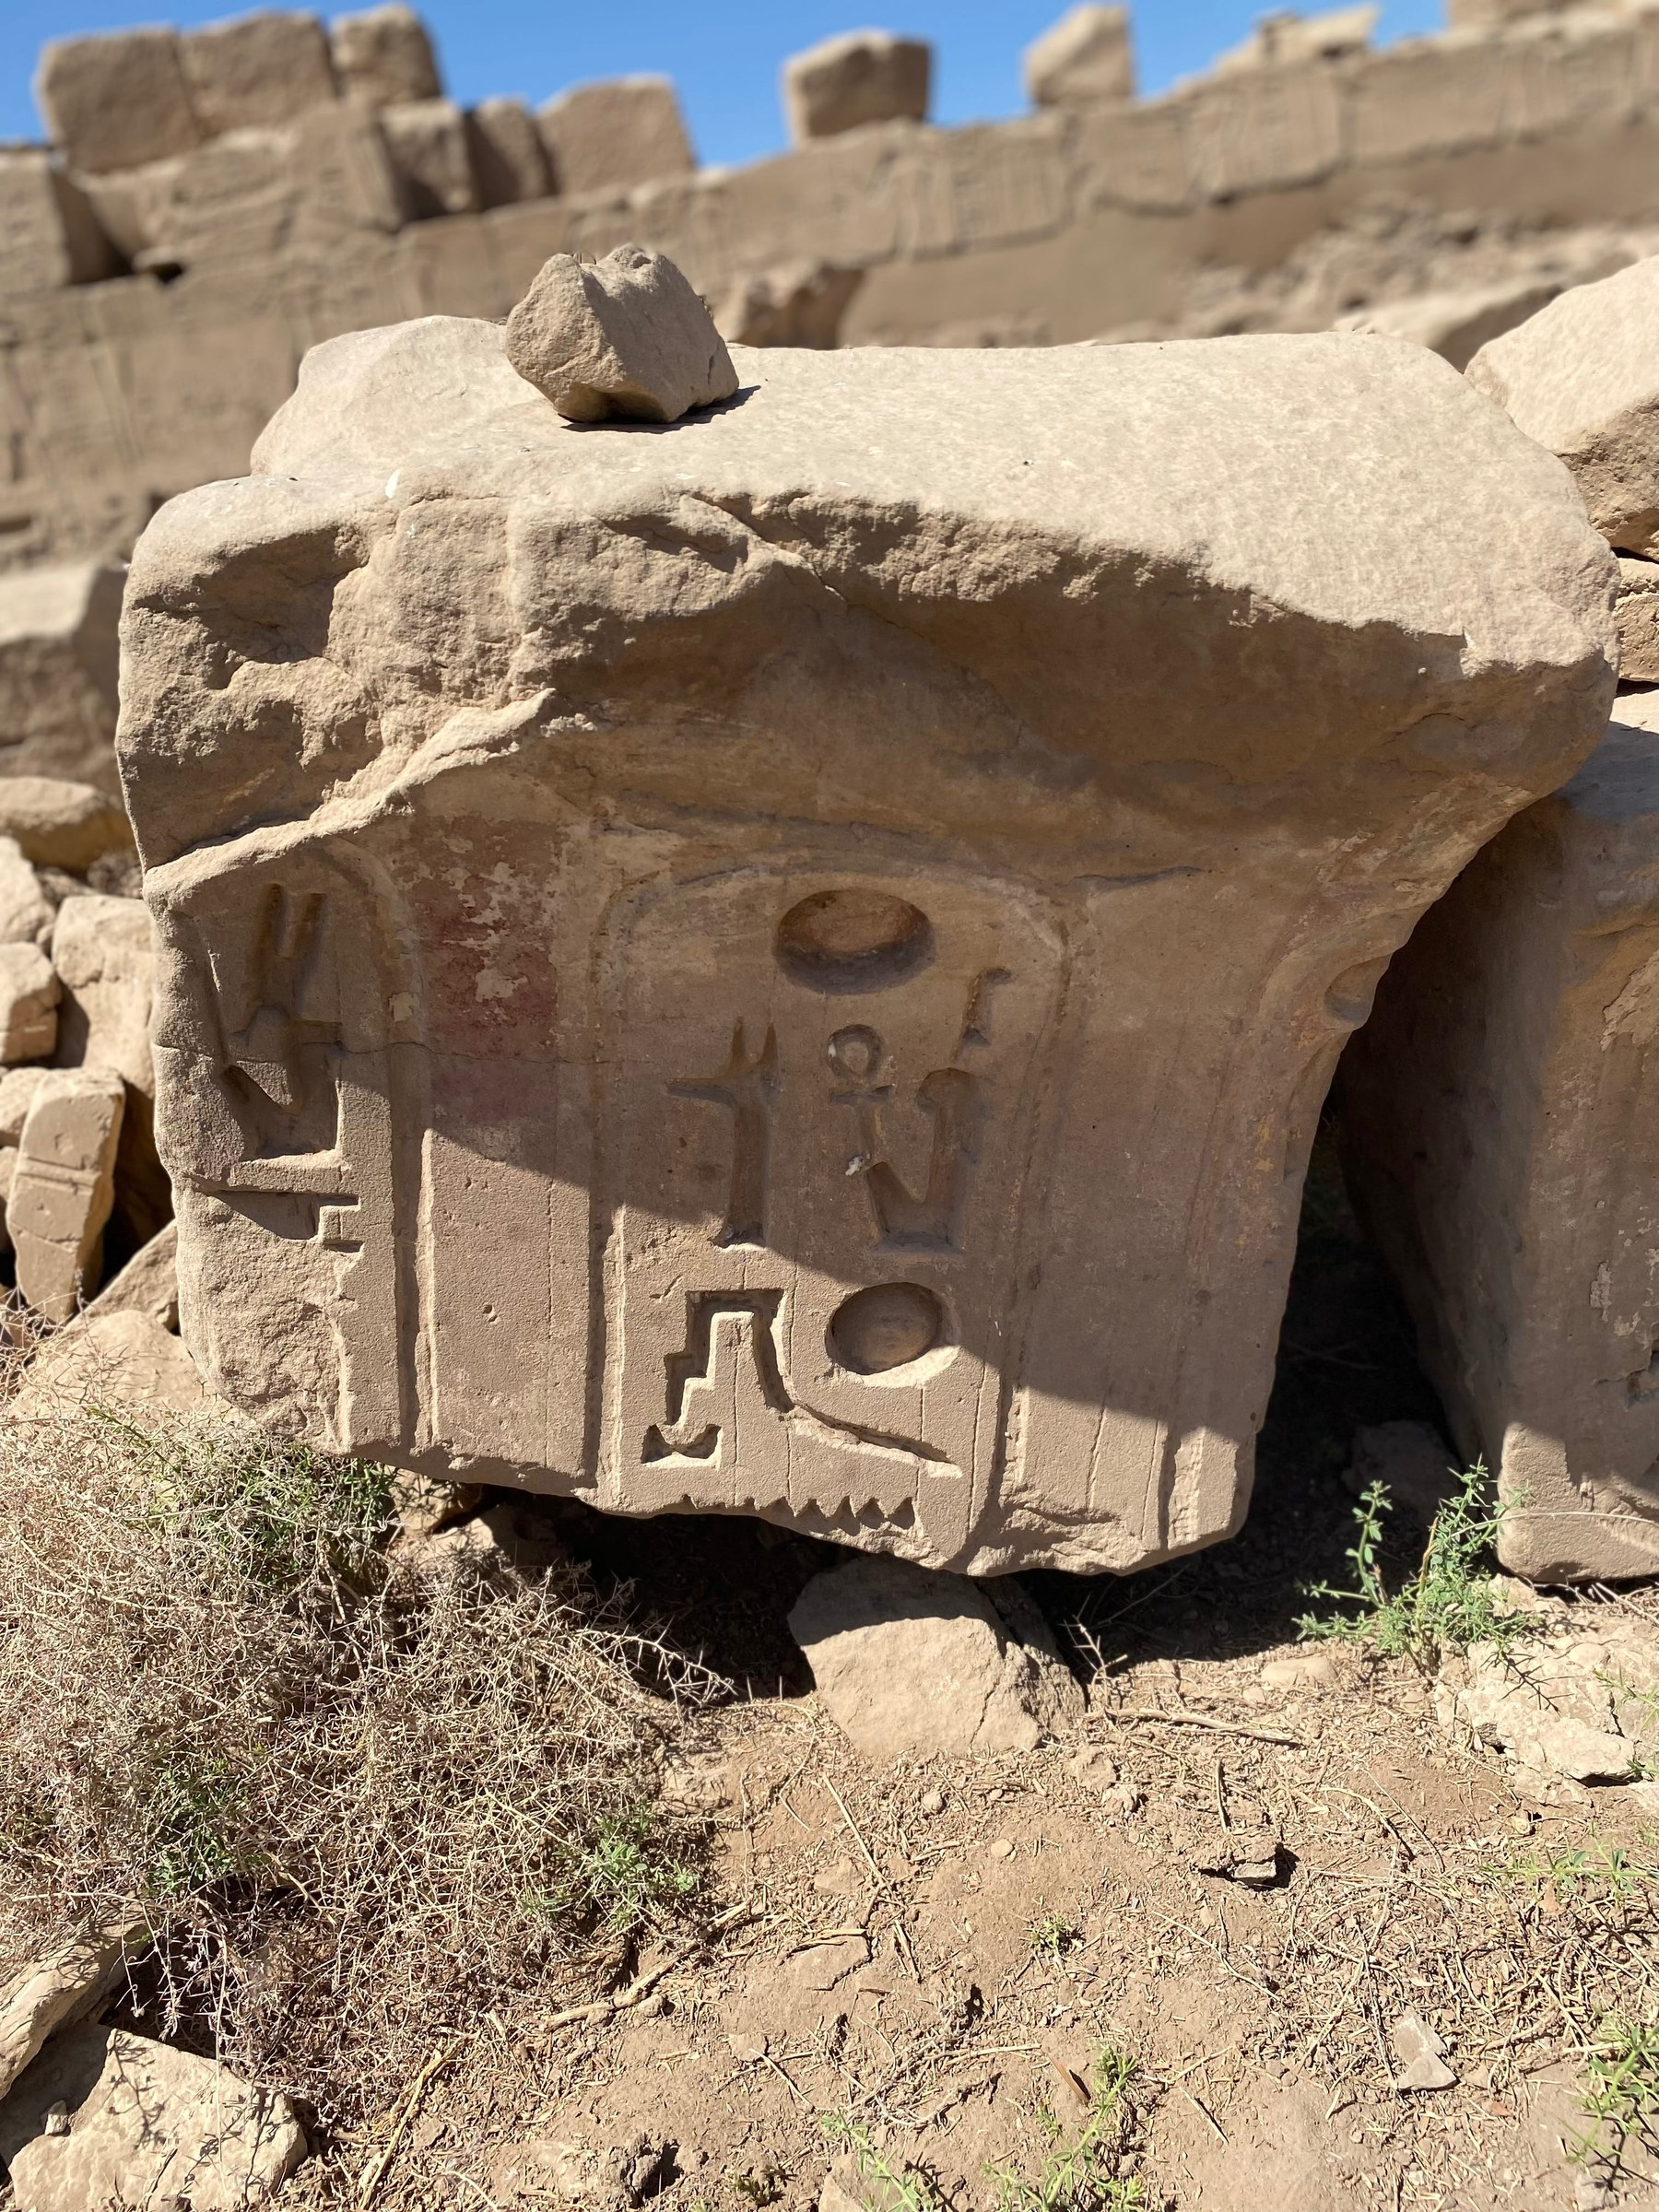
Fig. 13. Cartouche inscribed on the knee of a Ramesside sphinx or statue, Karnak — on a surface accessible only at close range alongside the statue.
Karnak Temple, Luxor

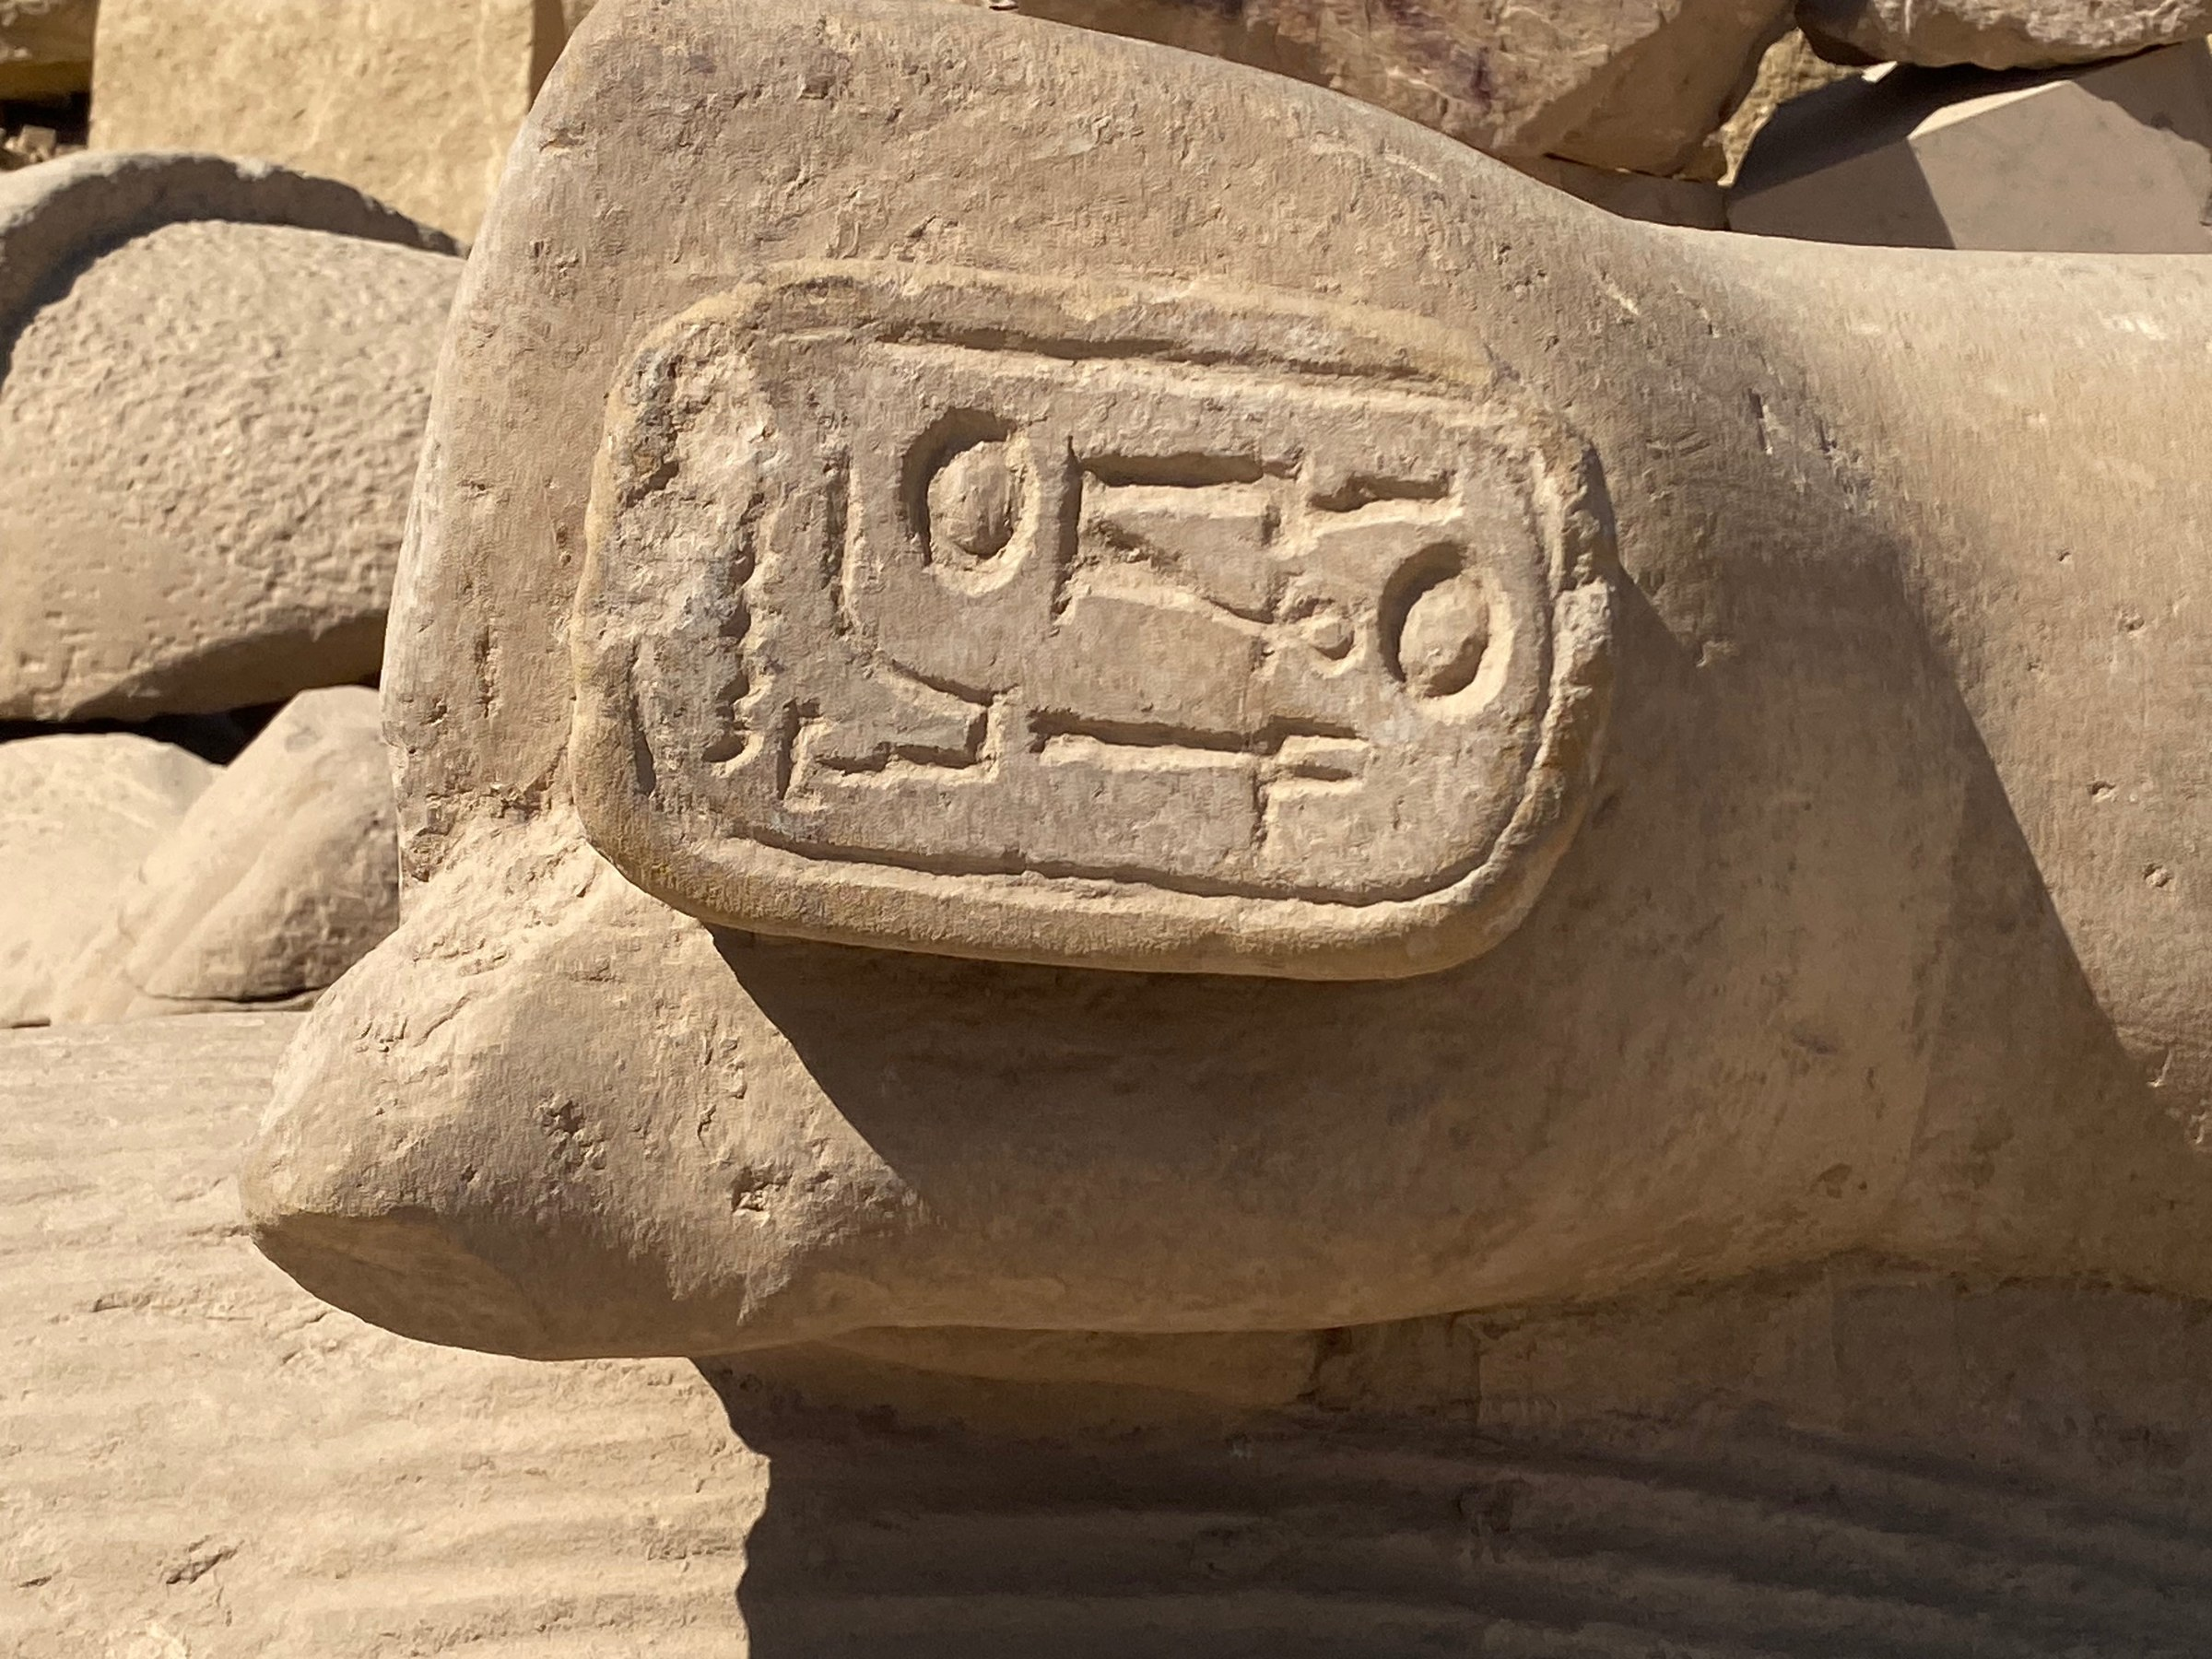
Fig. 14. Ramesses II colossal statue program at Karnak Temple — the pharaoh rendered at monumental scale within the processional architectural complex.
Karnak Temple, Luxor

7. FCP Scoring: Ramesside Symbolic Output
Table 1 presents a preliminary DSSM Field Companion Protocol assessment of Ramesside symbolic output at peak (c. 1270–1213 BCE), scored against the six FCP observables. All scores are the author's preliminary estimates pending systematic multi-rater validation (see Vondoom, 2026c for full FCP protocol).

Observable | E (0–2) | S (0–2) | min(E,S) | Primary evidence
Mnemonic Architectures | 2 | 2 | 2 | Abu Simbel solar alignment; Hypostyle Hall 134-column axial structure; Luxor processional axis and obelisk solar broadcast
Symbolic Stabilization | 2 | 2 | 2 | Cartouche program consistent across 67 years and 8+ temple sites; minimal iconographic variance across media
Externalized Cognition | 2 | 2 | 2 | Kadesh Bulletin-Poem-Treaty complex; Abu Simbel astronomical encoding; administrative papyri
Symbolic Regulation | 2 | 2 | 2 | Living Horus theology; Ramesses-as-Hapi (Fig. 6); shared-throne dyads (Figs. 9–10)
Distributed Symbolic Authority | 2 | 2 | 2 | Geographic program Delta to Nubia; cross-media redundancy across temple wall, stele, papyrus, statue, and column relief
Portable Symbolic Anchors | 2 | 2 | 2 | Stele network (Fig. 5); Kadesh Poem papyrus copies; cartouche-bearing portable objects
TOTAL |  |  | 12/12 | Full Stage 4 saturation

Table 1. DSSM FCP Scoring: Ramesside Symbolic Output at peak (c. 1270–1213 BCE). E = Evidence Strength; S = Symbolic Specificity; min(E,S) = final score per observable. Maximum: 12. Scores are preliminary estimates pending multi-rater validation.
The 12/12 FCP score represents genuine Stage 4 saturation. What distinguishes the Ramesside case is the mechanism: the Egyptian Old Kingdom 12/12 — documented in the companion paper (Vondoom, 2026d) — represents a three-millennium accumulation beginning in the Predynastic, while the Ramesside 12/12 was achieved within a single reign through the sovereign force of one exceptional ruler. This is the competence-based legitimacy pathway: Stage 4 saturation through density and simultaneity rather than gradual accumulation — a testament to what genuine greatness, exercised with total commitment, can accomplish in a single lifetime.

8. Comparative Case I — Akhenaten: Deliberate Symbolic Destabilization and Its Failure

8.1 The Amarna Revolution as DSSM Stress Test
Amenhotep IV, who renamed himself Akhenaten (r. c. 1353–1336 BCE), presents the most analytically significant test case for the DSSM framework in the entire Egyptian record: a ruler who inherited a symbolic substrate at full Stage 4 saturation and deliberately attempted to replace it with a counter-system constructed around the monolatrous worship of the Aten, the solar disk, to the exclusion of the existing polytheistic structure. The attempt was documented, radical, and rapid, and it failed completely within two decades of his death (Aldred, 1988; Hornung, 1999; Assmann, 2014).
Akhenaten's program had three primary structural components. First, the closure of the temples of Amun and the other major state cults, cutting off the institutional and material infrastructure that sustained Stage 3–4 symbolic stabilization. Second, the construction of a new capital, Akhetaten (modern Amarna), purpose-built as a symbolic container for the Aten cult — an attempt to achieve Stage 3 material amplification for a new symbolic system within a single reign. Third, the systematic erasure of Amun's name from temple walls across Egypt — a damnatio memoriae applied to a deity rather than a ruler — an attempt to perform symbolic regulation through forced amnesia (Aldred, 1988; Tyldesley, 1998).

8.2 DSSM Analysis: Why the Athenaton Program Failed
The DSSM framework identifies three structural reasons for the failure of the Amarna program, each corresponding to a specific stage-architectural constraint.
First, Stage 1 and Stage 2 consolidation cannot be overwritten in a single reign. The Egyptian symbolic system had been consolidated through embodied practice and ritualized repetition across millennia — from Badarian through Old Kingdom, as documented in the companion paper (Vondoom, 2026d). The neural consolidation timescales established in the DSSM framework (Vondoom, 2026d, Table 1) require multiple generations — estimated at 200–800 years for Stage 2 full consolidation. Akhenaten's program, however thoroughgoing in its material destruction, operated over approximately seventeen years. It could erase the material amplification layer (Stage 3 artifacts — temple inscriptions, cult images, administrative records) but could not touch the embodied and ritualized substrate (Stages 1 and 2) that remained neurologically consolidated across the Egyptian population.
Second, Akhenaten's counter-system never achieved Stage 3 saturation. The Aten program built at Amarna — temples, boundary stelae, the great Aten temple at Akhetaten — represented a geographically concentrated, politically dependent Stage 2–3 system. It lacked the cross-media redundancy, geographic distribution, and intergenerational consolidation that DSSM requires for Stage 4 saturation. The system existed only where Akhenaten's administrative authority enforced it. When that authority terminated with his death, the material infrastructure of the counter-system had no independent self-sustaining mechanism (Hornung, 1999; Assmann, 2014).
Third, the erasure program created what the DSSM framework would describe as a symbolic vacuum: the deliberate destruction of Stage 3 material amplification artifacts without replacement by a comparably saturated counter-system. The population retained Stages 1 and 2 consolidation for the old system; it was given an inadequate Stage 3 substitute for the new one. The result was not symbolic replacement but symbolic destabilization — and a destabilized Stage 4 system, as DSSM predicts, is inherently vulnerable to restoration by any actor who can demonstrate competence in operating the original system.

8.3 The Restoration and the Ramesside Inheritance
The restoration under Tutankhamun (r. c. 1332–1323 BCE), continued by Ay and Horemheb, followed precisely the DSSM prediction for recovery from symbolic destabilization: re-activation of the existing Stage 1–2 substrate through material amplification (temple restoration, re-opening of Amun's cult infrastructure) and re-inscription of the symbolic record (restoration stelae, the Edict of Horemheb) (Murnane, 1995). The restoration was rapid — achieving measurable Stage 3 re-saturation within two reigns — precisely because it was operating on a substrate that had never been fully dislodged.
The Ramesside inheritance of this situation is directly relevant to the dynasty-building achievement analyzed in Sections 2–7. Seti I’s decision to construct the Abydos king list — deliberately omitting the Amarna pharaohs while affirming continuity with the Eighteenth Dynasty’s legitimate sequence — was not merely political expediency. It was a symbolic strategy for claiming unbroken connection to the pre-Amarna Stage 4 substrate, bypassing the Amarna disruption as if it had never occurred. Ramesses II inherited this strategy and extended it through the unprecedented density of his own inscription program. The DSSM reading of the Ramesside program is therefore inseparable from the Amarna disruption that preceded it: Ramesses II was not simply building a new legitimacy claim but constructing a deliberate over-inscription of the destabilized and partially restored substrate that he had inherited.
The Akhenaten case generates the following DSSM falsification condition for the broader argument of this paper: if competence-based legitimacy construction within an existing saturated substrate is the distinctive Ramesside mechanism, then the Amarna disruption — which removed the substrate’s Stage 3 material layer while leaving Stages 1 and 2 intact — should have created precisely the conditions in which a ruler of Ramesses II’s caliber could achieve the most dramatic and historically distinctive symbolic saturation. The evidence of the Nineteenth Dynasty’s unprecedented inscription density is consistent with this prediction, and consistent with the portrait of a king who seized his historical moment with total sovereign commitment.

9. Comparative Case II — Cleopatra VII: Competence-Based Legitimacy in a Fractured Substrate

9.1 The Ptolemaic Legitimacy Problem
Cleopatra VII Philopator (r. 51–30 BCE) faced a legitimacy challenge structurally comparable to that of Ramesses II’s era but arising from opposite conditions: where Ramesses II had built authority through demonstrated personal sovereignty within a native symbolic framework, the Ptolemaic dynasty had ruled Egypt for approximately 280 years by Cleopatra’s accession as inheritors of foreign conquest. It was a Greek dynasty: its administrative apparatus was Hellenistic, its court language was Greek, its institutional framework was derived from Macedonian precedent, and its relationship to the Egyptian symbolic substrate was, for most of its history, transactional rather than participatory (Chauveau, 2000; Hölbl, 2001).
Ptolemaic rulers had, since at least Ptolemy III, adopted formal pharaonic titles and sponsored temple construction in the Egyptian tradition — the temple at Edfu, the temple of Kom Ombo, the Dendera complex. This represented a Stage 3 investment in the existing symbolic substrate: material amplification aimed at demonstrating formal membership in the pharaonic category (Hölbl, 2001; Tyldesley, 2008). But the investment was largely performative: most Ptolemaic rulers did not speak Egyptian, did not participate in Egyptian religious ritual in the way the native tradition required, and governed through a Greek-speaking administrative elite that was institutionally separated from the Egyptian priestly class.

9.2 Cleopatra's Competence Strategy
Cleopatra VII was, by all ancient accounts, exceptional within the Ptolemaic dynasty in her deliberate engagement with the Egyptian symbolic substrate. She was reportedly the first Ptolemaic ruler to speak Egyptian fluently, alongside Greek, Latin, Aramaic, Hebrew, Ethiopian, and several other languages (Plutarch, Life of Antony, 27.2–3; Duane, 2012). She performed Egyptian religious ritual, was acclaimed as the goddess Isis in Egyptian ceremonial contexts — a direct parallel to the Ramesses-as-Hapi iconographic program — and issued bilingual decrees in both Greek and Egyptian demotic (Hölbl, 2001; Jones, 2006).
Within the DSSM framework, Cleopatra's strategy is recognizable as an accelerated competence-based legitimacy construction program analogous in structure to the Ramesside program: multi-domain demonstration (linguistic competence, ritual performance, theological identification with Isis, administrative engagement with the Egyptian priestly class) combined with symbolic offloading (bilingual decrees, temple inscriptions at Dendera and elsewhere depicting her in pharaonic iconographic conventions). The Dendera reliefs — showing Cleopatra and her son Caesarion in standard pharaonic relief posture, presenting offerings to the Hathor cult — are among the most complete surviving examples of Ptolemaic pharaonic iconographic adoption (Hölbl, 2001).

9.3 DSSM Analysis: The Structural Limits of the Ptolemaic Competence Program
Despite the sophistication of Cleopatra's legitimacy construction program, the DSSM framework identifies two structural constraints that the Ramesside case did not face and that ultimately limited the program's durability.
First, the institutional framework incompatibility. Ramesses II's competence-based program operated within and strengthened the existing Egyptian symbolic substrate: his astronomical, military, and theological demonstrations were conducted within the categories that the substrate recognized as constitutive of pharaonic authority. Cleopatra's program, by contrast, operated across a fundamental institutional division: the Greek administrative apparatus and the Egyptian priestly infrastructure were not integrated symbolic systems. Cleopatra could demonstrate Egyptian competence within Egyptian ritual contexts while simultaneously operating within Hellenistic political frameworks — the alliances with Caesar and Antony, the administration of the kingdom through Greek-speaking officials — that were structurally alien to the Egyptian symbolic substrate. The result was a competence claim that was legible in Egyptian symbolic terms but not backed by the institutional integration that would have been required for Stage 4 offloading (Hölbl, 2001; Chauveau, 2000).
Second, the temporal constraint. Ramesses II's sixty-seven-year reign allowed the competence-based claim to be inscribed across the symbolic substrate at a density approaching that of the inherited dynastic programs his predecessors had accumulated. Cleopatra's reign of twenty-one years, conducted under the constant pressure of Roman political and military intervention, did not provide sufficient time for the symbolic offloading program to achieve the redundancy and geographic distribution that DSSM requires for Stage 4 saturation. The Dendera reliefs, the bilingual decrees, the Isis theology — these are Stage 3 material amplification events, not Stage 4 cognitive offloading at the scale Ramesses II achieved.

9.4 The Egyptian Substrate's Durability After Cleopatra
The DSSM framework predicts that a symbolic substrate saturated at Stage 4 does not collapse with the political extinction of any particular ruler or dynasty; it requires the loss of both the physical inscribed record and the community capable of reading it. The Roman conquest of Egypt in 30 BCE terminated the Ptolemaic dynasty but did not immediately terminate the Egyptian symbolic substrate: Egyptian temple construction continued under Augustus and subsequent emperors (the Dendera zodiac dates to the Augustan period), the Egyptian priestly class continued to function, and the hieroglyphic and demotic writing traditions continued for several more centuries (Beard, North, and Price, 1998; Frankfurter, 1998). The substrate's final collapse came gradually, through the Christianization of the Egyptian administrative and priestly class in the fourth and fifth centuries CE — a process that did terminate the institutional community required to read and reproduce the symbolic system. This trajectory is entirely consistent with DSSM Stage 4 predictions: the substrate outlasted every individual political actor who had attempted to claim, subvert, or replace it.
The Cleopatra case generates the following DSSM contribution to the broader argument: competence-based legitimacy construction within an existing saturated substrate can achieve Stage 3 material amplification rapidly, but Stage 4 offloading requires temporal depth, institutional integration, and geographic density that the Ptolemaic structural position — divided between Hellenistic administration and Egyptian symbolic participation — could not provide. Ramesses II's advantage was not merely that he had more time, but that his competence demonstrations were conducted entirely within the symbolic system he was attempting to saturate, without the structural division between administrative framework and symbolic substrate that constrained every Ptolemaic attempt at pharaonic legitimacy.

10. The Competence-Based Legitimacy Pathway: DSSM Theoretical Contribution
The three cases analysed in this paper — Ramesses II, Akhenaten, and Cleopatra VII — collectively define the theoretical boundaries of a DSSM pathway that has not been explicitly theorized in the corpus: the competence-based legitimacy pathway. In the standard DSSM developmental sequence, Stage 4 saturation is achieved through the cumulative Stage 1–3 progression (Vondoom, 2025; 2026d). This is the Egyptian trajectory from Badarian through Old Kingdom — the structural template for Mesopotamian, Indus, and East Asian civilizational emergence. The three cases in this paper test that template from different directions.
Ramesses II demonstrates that Stage 4 saturation can be achieved within a single reign through density and simultaneity, provided the ruler operates entirely within the existing symbolic system and has sufficient time (sixty-seven years) for the offloading to achieve adequate redundancy. The substrate's pre-existing Stage 1–2 consolidation provides the amplifying medium; the competence demonstrations provide the authorizing claim; the inscription density provides the self-sustaining mechanism.
Akhenaten demonstrates the inverse: that Stage 4 saturation, once achieved, cannot be dismantled within a single reign through material destruction alone. The Amarna disruption succeeded in destroying the Stage 3 material amplification layer of the Amun system and constructing a parallel Stage 3 material layer for the Aten system. It failed because Stages 1 and 2 — neurologically consolidated across the population through millennia of ritualized practice — were not accessible to material erasure on the timescale of a political program. The DSSM framework's neural timescale bridge (Vondoom, 2026d) directly predicts this asymmetry: destruction is faster than consolidation.
Cleopatra VII demonstrates that competence-based legitimacy construction within a saturated substrate is structurally possible across a significant institutional divide, but that the divide itself creates a ceiling on the saturation level achievable: Stage 3 material amplification is accessible; Stage 4 offloading is not, without the institutional integration that converts competence claims into self-sustaining symbolic infrastructure. The Ptolemaic case is therefore a partial Ramesside: the competence-based pathway initiated but not completed, constrained by structural incompatibility between the administrative framework and the symbolic substrate.
Together, these three cases define three distinct positions within the competence-based legitimacy pathway: full saturation (Ramesses II), failed destabilization (Akhenaten), and partial saturation (Cleopatra VII). The theoretical contribution to DSSM is the identification of the competence-based pathway as a distinct and analytically coherent alternative to the gradualist developmental sequence, with its own internal conditions of success and failure that can be specified in advance and tested against the historical record.

11. Three-Millennium Durability: Why the Ramesside Settlement Persisted
Ramesses II died in 1213 BCE. The Nineteenth Dynasty ended in political chaos approximately thirty years later. Egypt subsequently passed through the Intermediate Periods, Libyan and Nubian dynasties, Assyrian invasion, Saite restoration, Persian occupation, and Macedonian conquest. Through all of this, the symbolic program Ramesses II inscribed across the Nile corridor not only survived but remained operationally active: later pharaohs referenced Kadesh; the Ramesside cartouche program was not systematically erased; the Abu Simbel alignment continued to function without institutional maintenance.
The DSSM explanation is straightforward. A symbolic system inscribed at Stage 4 saturation, distributed across the maximum geographic range of the civilization's symbolic substrate, and anchored in autonomous cognitive offloading artifacts does not require institutional continuity to remain operative. The four DSSM stabilization criteria are satisfied at maximum: intergenerational repetition (the cartouche program spans multiple reigns); spatial constraint (the geographic distribution from Delta to Nubia defines a symbolic territory); cross-media redundancy (temple wall, stele, papyrus, statue, and relief are all co-inscribed with the same authority claims); and persistence under stress (the system survived the Amarna disruption, the Sea Peoples crisis, and the end of the New Kingdom). The system depends only on the survival of the inscribed surfaces and the continued existence of an Egyptian symbolic community capable of reading them (Vondoom, 2025; Assmann, 2002).

12. Conclusion
Ramesses II stands, on the evidence of this analysis, as one of history’s most accomplished builders of durable authority — a king who proved that true sovereignty is earned through total commitment and demonstrated excellence rather than bestowed by bloodline. He chose the most demanding path available: to demonstrate competence across every constitutive domain of pharaonic authority simultaneously, then offload that earned authority into the existing symbolic substrate at a density and cross-media redundancy that made it inseparable from the substrate itself and self-sustaining across millennia.
The DSSM framework identifies this as a distinct and previously untheorized pathway: the competence-based legitimacy pathway, in which Stage 4 saturation is achieved through density and simultaneity within an existing saturated substrate. The comparative cases of Akhenaten and Cleopatra VII define the boundary conditions of the pathway: Akhenaten demonstrates the asymmetry between consolidation and destruction that makes Stage 4 systems resilient to rapid revolutionary replacement; Cleopatra demonstrates the ceiling imposed by institutional incompatibility on competence-based programs conducted across a divide between administrative framework and symbolic substrate.
The field photographs that underpin this analysis document, across four sites and two museum collections, the material signature of the Ramesside program: the cartouche inscribed on every available surface (Figs. 12–13), the stele distributed across the symbolic geography of the kingdom (Fig. 5), the colossal statue that makes the divine identification experiential rather than textual (Figs. 7–8), the obelisk that broadcasts solar mediation to every dawn (Figs. 1, 4). These objects are not illustrations of an argument. They are the argument — the material evidence of a symbolic strategy whose success is measured not by the survival of the Nineteenth Dynasty, which did not survive, but by the three-thousand-year persistence of the settlement it created.

References
Aldred, Cyril. Akhenaten: King of Egypt. London: Thames and Hudson, 1988.
Aldred, Cyril. Egyptian Art in the Days of the Pharaohs 3100–320 BC. London: Thames and Hudson, 1980.
Arnold, Dieter. Building in Egypt: Pharaonic Stone Masonry. Oxford: Oxford University Press, 1991.
Assmann, Jan. Cultural Memory and Early Civilization: Writing, Remembrance, and Political Imagination. Cambridge: Cambridge University Press, 2011.
Assmann, Jan. The Mind of Egypt: History and Meaning in the Time of the Pharaohs. New York: Metropolitan Books, 2002.
Assmann, Jan. From Akhenaten to Moses: Ancient Egypt and Religious Change. Cairo: American University in Cairo Press, 2014.
Beard, Mary, John North, and Simon Price. Religions of Rome, Vol. 1: A History. Cambridge: Cambridge University Press, 1998.
Beckman, Gary. Hittite Diplomatic Texts. 2nd ed. Atlanta: Scholars Press, 1996.
Brand, Peter J. The Monuments of Seti I: Epigraphic, Historical and Art Historical Analysis. Leiden: Brill, 2000.
Chauveau, Michel. Egypt in the Age of Cleopatra: History and Society under the Ptolemies. Translated by David Lorton. Ithaca: Cornell University Press, 2000.
Clark, Andy. Supersizing the Mind. Oxford: Oxford University Press, 2008.
Donald, Merlin. Origins of the Modern Mind: Three Stages in the Evolution of Culture and Cognition. Cambridge, MA: Harvard University Press, 1991.
Duane, O. B. Cleopatra: The Queen of Kings. London: Brockhampton Press, 2012.
Faulkner, Raymond O. A Concise Dictionary of Middle Egyptian. Oxford: Griffith Institute, 1962.
Frankfurter, David. Religion in Roman Egypt: Assimilation and Resistance. Princeton: Princeton University Press, 1998.
Gardiner, Alan H. The Kadesh Inscriptions of Ramesses II. Oxford: Griffith Institute, 1960.
Gardiner, Alan H. Egypt of the Pharaohs: An Introduction. Oxford: Clarendon Press, 1961.
Hölbl, Günther. A History of the Ptolemaic Empire. Translated by Tina Saavedra. London: Routledge, 2001.
Hornung, Erik. Akhenaten and the Religion of Light. Translated by David Lorton. Ithaca: Cornell University Press, 1999.
Hornung, Erik. Conceptions of God in Ancient Egypt: The One and the Many. Translated by John Baines. Ithaca: Cornell University Press, 1982.
Hutchins, Edwin. Cognition in the Wild. Cambridge, MA: MIT Press, 1995.
Jones, Prudence J. Cleopatra: A Sourcebook. Norman: University of Oklahoma Press, 2006.
Kitchen, Kenneth A. Pharaoh Triumphant: The Life and Times of Ramesses II. Warminster: Aris and Phillips, 1982.
Kitchen, Kenneth A. Ramesside Inscriptions: Historical and Biographical. 8 vols. Oxford: Blackwell, 1975–1990.
Langdon, Stephen, and Alan H. Gardiner. 'The Treaty of Alliance between Hattusili, King of the Hittites, and the Pharaoh Ramesses II of Egypt.' Journal of Egyptian Archaeology 6, no. 3 (1920): 179–205.
Lichtheim, Miriam. Ancient Egyptian Literature, Volume II: The New Kingdom. Berkeley: University of California Press, 1976.
Malafouris, Lambros. How Things Shape the Mind: A Theory of Material Engagement. Cambridge, MA: MIT Press, 2013.
Murnane, William J. The Road to Kadesh: A Historical Interpretation of the Battle Reliefs of King Sety I at Karnak. 2nd ed. Chicago: Oriental Institute, 1990.
Murnane, William J. Texts from the Amarna Period in Egypt. Atlanta: Scholars Press, 1995.
Plutarch. Life of Antony. In Plutarch's Lives, Vol. IX. Translated by Bernadotte Perrin. Cambridge, MA: Harvard University Press (Loeb Classical Library), 1920.
Quirke, Stephen. Ancient Egyptian Religion. London: British Museum Press, 1992.
Redford, Donald B. Pharaonic King-Lists, Annals and Day-Books: A Contribution to the Study of the Egyptian Sense of History. Mississauga: Benben Publications, 1986.
Regulski, Ilona. A Palaeographic Study of Early Writing in Egypt. Leuven: Peeters, 2010.
Trigger, Bruce G. Understanding Early Civilizations: A Comparative Study. Cambridge: Cambridge University Press, 2003.
Tyldesley, Joyce. Hatchepsut: The Female Pharaoh. London: Penguin, 1998.
Tyldesley, Joyce. Cleopatra: Last Queen of Egypt. New York: Basic Books, 2008.
Tyldesley, Joyce. Ramesses: Egypt's Greatest Pharaoh. London: Penguin, 2000.
Vondoom, Anthony. 'The Deep Symbolic Systems Model (DSSM): A Cognitive–Ritual Framework for Early Monumentality and Cultural Continuity.' OSF, 2025. https://doi.org/10.17605/OSF.IO/MRZFU.
Vondoom, Anthony. 'Deep Symbolic Systems Model (DSSM): Field Companion — Operational Field Protocols for Detecting Symbolic Stabilization.' Figshare, 2026c. https://doi.org/10.6084/m9.figshare.31113951.
Vondoom, Anthony. 'Cognitive Foundations of Early Egyptian Civilization: Insights from the Deep Symbolic Systems Model (DSSM).' Publication in process, Journal of the Archaeological Faculty, Ain Shams University (IWNW), Cairo, 2026d.
Wengrow, David. The Archaeology of Early Egypt: Social Transformations in North-East Africa, 10,000 to 2650 BC. Cambridge: Cambridge University Press, 2006.

SDG Alignment Statement
This research contributes to the following UN Sustainable Development Goals:
SDG 4 — Quality Education: The DSSM framework provides a cognitive-archaeological reframing of pharaonic legitimacy construction and symbolic system dynamics, with direct implications for how New Kingdom Egypt, the Amarna period, and Ptolemaic history are taught across archaeology, Egyptology, and history of religion curricula.
SDG 11 — Sustainable Cities and Communities: The analysis of Ramesside symbolic strategy — specifically the geographic density, cross-media redundancy, and self-sustaining durability of the inscription program — offers principles relevant to understanding how cultural symbolic infrastructures are made durable across political transition and institutional collapse.
SDG 16 — Peace, Justice and Strong Institutions: The Kadesh Treaty analysis as the first documented international diplomatic cognitive offloading artifact contributes to the historical foundations of institutional legitimacy theory. The Akhenaten case study contributes to the analysis of institutional destabilization and recovery.
SDG 17 — Partnerships for the Goals: The paper draws on interdisciplinary synthesis across cognitive archaeology, Egyptology, cognitive neuroscience, political history, and classical studies, exemplifying the cross-disciplinary research collaboration that SDG 17 identifies as foundational to addressing complex global challenges.

Photographic Note
All field photographs in this paper were taken by the author during visits to Karnak Temple, Luxor Temple, the Grand Egyptian Museum (GEM), and the National Museum of Egyptian Civilization (NMEC), Cairo. All images are original and uncropped. Copyright in all photographs is held by Anthony Vondoom. Reproduction of any photograph, in whole or in part, is prohibited without prior written permission from the author. Enquiries: anthony.vondoom@outlook.com

